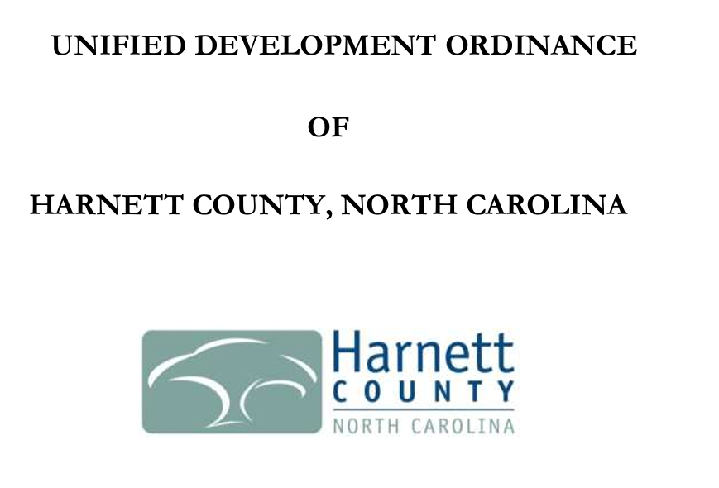

**ARTICLE V. USE REGULATIONS**

**SECTION 1.1 GENERAL APPLICABILITY (ABANDONED MANUFACTURED HOMES)**

**1. Abandoned Manufactured Homes**

**(a.) Unless otherwise provided, manufactured homes that are considered to be abandoned according to the definition for abandoned manufactured homes shall be prohibited in all zoning districts within Harnett County. Once a determination has been made by the Administrator or his authorized agent that a manufactured home is abandoned then the Administrator shall take action to abate the violation using any of the enforcement procedures in Article “Enforcement & Penalties” of this Ordinance.**

**(b.) Harnett County may require the removal of junked or abandoned manufactured homes from public grounds, including but not limited to public or private street right(s)-of-way or private property upon finding that such removal is necessary and desirable to promote or enhance community, neighborhood, or area appearance or to abate public health or safety nuisances.**

**ARTICLE XIV. DEFINITIONS**

**Manufactured Home, Abandoned**

**An abandoned manufactured home or mobile classroom that is:**

**A. Not being occupied as a dwelling and does not provide complete, independent living facilities for one (1) family, including permanent provisions for living, sleeping, eating, cooking, and sanitation or a manufactured home that has not received the proper permits to be located within the County’s jurisdiction; or**

**B. A structure which is a manufactured/mobile home which is a health or safety hazard as a result of the attraction of insects or rodents, conditions creating a fire hazard, dangerous condition constituting a threat to children, or frequent use by vagrants as living quarters in the absence of sanitary facilities; or**

**C. Any structure, which is manufactured/mobile home that was designed and intended for residential or other uses, which has been vacant or not in active use, regardless of purpose or reason, for the past two (2) year period, and has been deemed a nuisance due to public safety or public appearance by the Harnett County Planning Department or Harnett County Department of Public Health.**