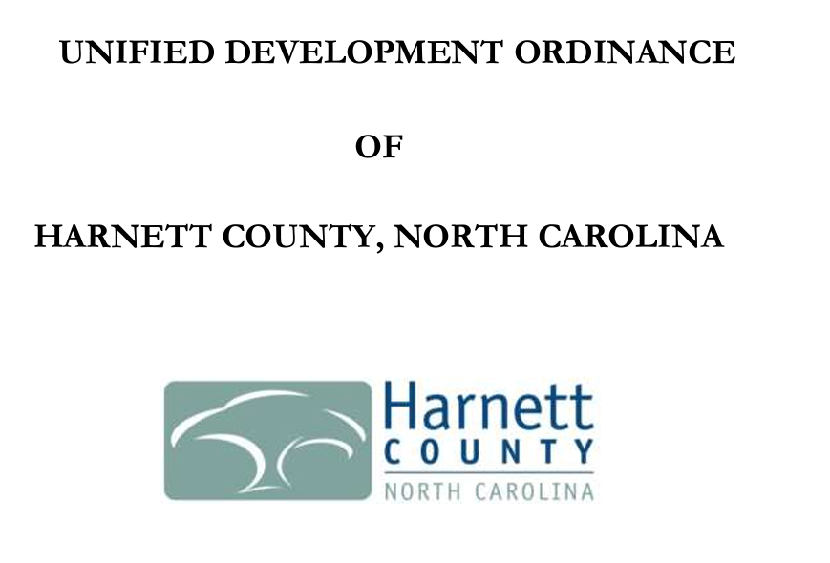

**ARTICLE V. USE REGULATIONS**

**SECTION 1.2 USE TYPES & REGULATIONS (JUNKYARDS)**

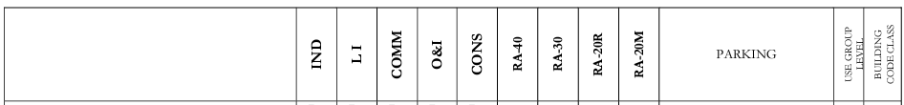

**\*Junkyards are only allowed within an Industrial Zoning District with an approved Special Use Permit\***

**ARTICLE XIV. DEFINITIONS & CERTIFICATIONS**

**SECTION 2.0 GENERAL DEFINITIONS & ACRONYMS**

**Junk**

**Scrap copper, brass, rope, rags, batteries, paper, trash, rubber, debris, waste, or junked, dismantled, or wrecked automobiles, or parts thereof, iron, steel, or other scrap ferrous or nonferrous material and dismantled or used white goods or parts thereof.**

**Junkyard**

**An establishment or place of business, or portion of a property, which is maintained, operated, or used for storing, keeping, buying, or selling junk, or for maintenance or operation of an automobile graveyard. Any lot containing more than three (3) unregistered and non-functional vehicles shall constitute a junkyard for the purposes of this Ordinance.**