December 10, 2019

Delivery Via: Certified Mail # 7011 3500 0000 4769 3747 / First Class Mail

Annie B. Harris
C/O Anshawnti Harris
7114 Sotheby Way FINAL NOTICE OF VIOLATION
Lorton, VA 22079-4546 AND ADMINISTRATIVE ORDER TO COMPLY

Citation Number: CEZO1908-0012

TO: Owner and parties of interest in the property located at 860 Shawtown Road, Lillington, NC also identified as Harnett County Parcel PIN # 0559-04-1173.000.

YOU ARE HEREBY GIVEN FINAL NOTIFICATION that the property referenced above is in violation of the Harnett County Unified Development Ordinance. The violation is related to the presence of an Abandoned Manufactured Home.

YOU ARE FURTHER NOTIFIED that records verify that a previous notification was issued on August 28, 2019 by a Harnett County Zoning Official that advised you that the property was in violation. The notification requested that actions be taken to render compliance with the regulations of the Harnett County Unified Development Ordinance. An inspection performed on December 9, 2019 has verified that compliance actions have not been taken and/or completed. The notification also contained information regarding your rights to appeal the notice of violation and the time frame allowed for such appeal. Current records indicate that you have not filed an official appeal with the Board of Adjustment regarding the actions of the Zoning Administrator.

NOW THEREFORE BE ADVISED that this notification shall serve as the Final Attempt to gain compliance through voluntary actions on behalf of the property owner. Failure to render compliance by the specified date below shall force the Harnett County Development Services to engage in and impose any and all enforcement actions and penalties upon you including civil or criminal actions. Furthermore, in accordance with the Harnett County Unified Development Ordinance, Article XIII Enforcement and Penalties, Section 9.0 Right of Appeal: Any person aggrieved by this notice of violation and order has thirty (30) days to appeal the action of the Zoning Administrator to the Board of Adjustment. Beyond the decision of the Board of Adjustment, recourse shall be to the Courts as provided by law. The application for appeal may be obtained online at www.harnett.org or may be picked up at the Harnett County Development Services building located at 108 E. Front St. Lillington, NC 27546. For further information, staff may be reached by phone at (910) 893-7525 opt. 4.

Compliance Action Ordered:

Remove the abandoned manufactured home from the property.

Compliance Must Be Rendered By: January 31, 2020 Order Issued By: Randy Baker, CZO
Assistant Manager of Planning Services

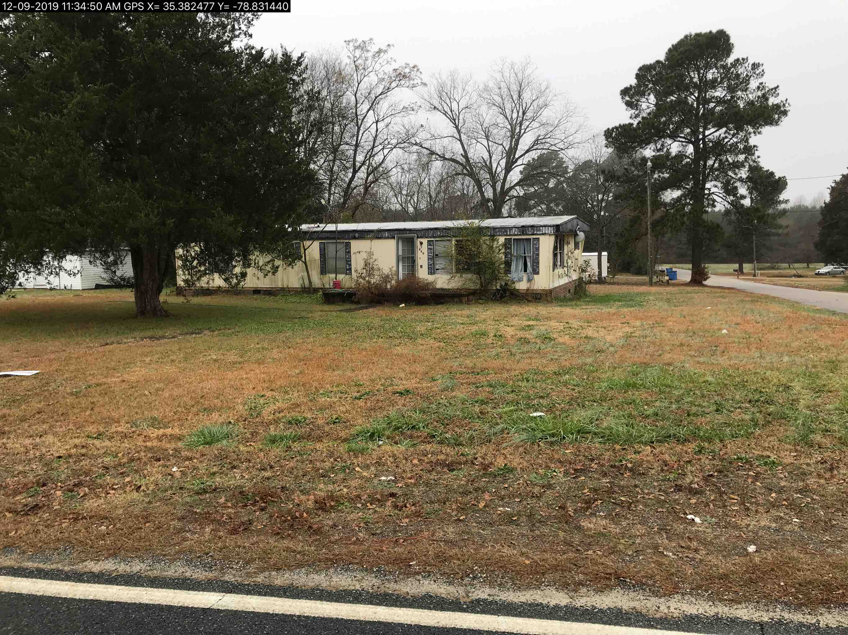
Definitions:
An abandoned manufactured home is defined as a manufactured home that is not being occupied as a dwelling and does not provide complete, independent living facilities for one family, including permanent provisions for living, sleeping, eating, cooking, and sanitation or a manufactured home that has not received the proper permits to be located within the County’s jurisdiction or a structure which is a manufactured /mobile home which is a health or safety hazard as a result of the attraction of insects or rodents, conditions creating a fire hazard, dangerous condition constituting a threat to children, or frequent use by vagrants as living quarters in the absence of sanitary facilities or any structure, which is manufactured /mobile home that was designed and intended for residential or other uses, which has been vacant or not in active use, regardless of purpose or reason, for the past two-year period and has been deemed a nuisance due to public safety or public appearance by the Harnett County Planning Department.

