NOTICE OF VIOLATION
THIS IS AN OFFICIAL NOTIFICATION DECLARING A VIOLATION AGAINST THE
HARNETT COUNTY UNIFIED DEVELOPMENT ORDINANCE.

Citation Number: CEZO1903-0017
Kyle Lei Rankin
19 Andrea Court
Sanford, NC 27332

Delivery Via: Personal Service First Class Certified Mail 7011 3500 0000 4769 1385

Parcel ID Number: 03-9587-0020-61 PIN: 9587-42-8749.000
Property Location: 19 Andrea Court Zoning District: RA-20R

Inspection Details:

Date of Inspection: 03/26/2019 Development Compliance Officer: Randy Baker
Nature of Violation: Land Use Regulations (Junkyard / Junk Vehicles).
Ordinance Reference: Article V, Section 1.0, Sub-Section 1.2 Article V, Section 4.0, Sub-Section 4.2

The Following Measures Must Be Taken In order To Reach Compliance:
Remove all junk motor vehicles from the property in excess of three (3).
Remaining junk motor vehicles must be properly located on the properties and concealed from public view.
Remove all materials that are classified as junk from the property.
All materials must be properly disposed of at a facility that is permitted to accept such materials.

Compliance Must Be Met No Later Than: April 30, 2019

Until compliance is reached, you are hereby charged with a violation against the Harnett County Unified Development Ordinance as described above. Failure to comply with the Harnett County Unified Development Ordinance will force the County to seek remedies through the courts under Chapter 153A, Article IV, Section 153A-123 of the North Carolina General Statues. Violations of the Ordinance shall constitute a misdemeanor and Harnett County has the authority to seek compliance through civil or criminal actions. A civil action shall be punishable by a fine not to exceed one hundred ($100.00) dollars and may be charged as a separate offense for each day the violation continues. A criminal action shall be punishable by imprisonment not to exceed thirty (30) days. Also, the Court will be requested to impose upon you the costs of such proceedings, including any attorney’s fees, which might be authorized by law. Furthermore, in accordance with the Harnett County Unified Development Ordinance, Article XIII Enforcement and Penalties, Section 9.0 Right of Appeal: Any person aggrieved by this notice of violation has thirty (30) days to appeal the action of the Zoning Administrator to the Board of Adjustment. Beyond the decision of the Board of Adjustment, recourse shall be to the Courts as provided by law. The application for appeal may be obtained online at www.harnett.org or may be picked up at the Harnett County Development Services building located at 108 E. Front St. Lillington, NC 27546. For further information, staff may be reached by phone at (910) 893-7525 opt. 4.

Issued By: Randy Baker, CZO Date of Issue: 03/26/2019
Title: Assistant Manager of Planning Services

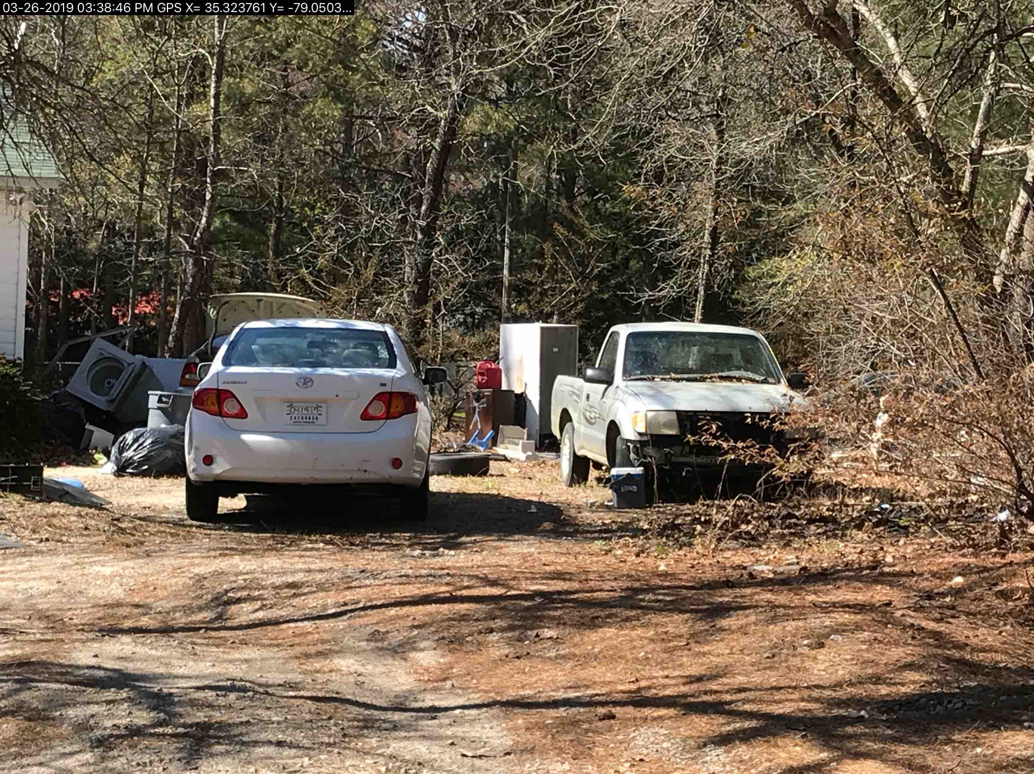
Definitions:

Junk
Scrap copper, brass, rope, rags, batteries, paper, trash, rubber, debris, waste, or junked, dismantled, or wrecked automobiles, or parts thereof, iron, steel, or other scrap ferrous or nonferrous material and dismantled or used white goods or parts thereof.

Junkyard
An establishment or place of business, or portion of a property, which is maintained, operated, or used for storing, keeping, buying, or selling junk, or for maintenance or operation of an automobile graveyard. Any lot containing more than three (3) unregistered and non-functional vehicles shall constitute a junkyard for the purposes of this Ordinance.

Ordinance Reference:

Article V, USE REGULATIONS

SECTION 1.0 USE TYPES & REGULATIONS

1.1 General Applicability

A. Any use not specifically designated as either a permitted or conditional use in a zoning district is prohibited. Uses not listed may be included by following the amendment process described elsewhere in this Ordinance.

1.2 Table of Use Types & Regulations

 | IND | LI | COMM | O & I | CONS | RA-40 | RA-30 | RA-20R | RA-20M | Parking | USE Group Level | Building  Code Class
Junkyards | C* |  |  |  |  |  |  |  |  | 1 Per 2 Employees (Largest Shift) OR 1 Per 500 Sq. Ft.

Junkyards are only allowed in an Industrial Zoned District with Conditional Use Approval.

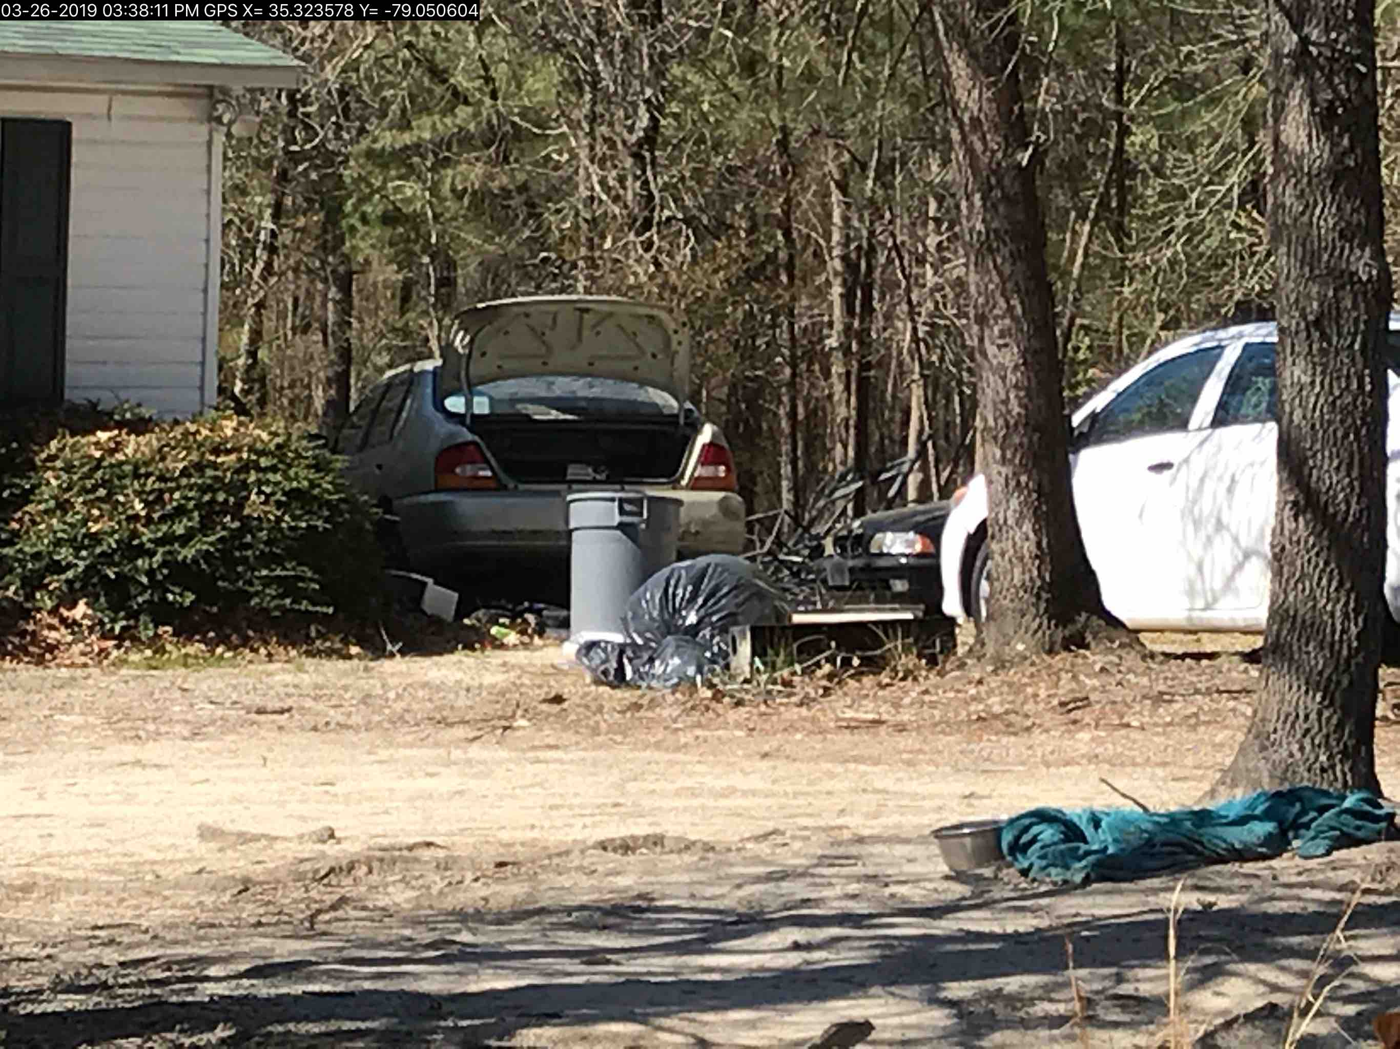
Definitions:

Automobile, Junked
A motor vehicle that is:
A. Partially dismantled or wrecked; or
B. Cannot be self-propelled or moved in the manner in which it was originally intended to move; or
C. Does not display a current license plate.

Ordinance Reference:

Article V, USE REGULATIONS SECTION 4.0 ACCESSORY USES & STRUCTURES

4.2 Junk Motor Vehicles (on private property)

Unless otherwise provided, junked motor vehicles in the RA-40, RA-30, RA-20R, and RA-20M Zoning Districts on private property not associated with a business, shall conform to the following requirements effective November 15, 2004.

A. General Requirements

1. The junked motor vehicles shall not be stored or located within 30 feet of any adjoining property line or side street or right-of-way and shall be situated so that no motor vehicle or parts are visible from the adjoining properties. In no case shall junked motor vehicles be located in the front yard of the primary building of the lot.

2. The junked motor vehicles shall not be a health or safety nuisance, nor shall the area constitute a health or safety nuisance according to the Harnett County Department of Public Health.

3. The junked motor vehicles shall be entirely concealed during all seasons of the year from public view from the public right-of-way and from the adjoining properties. The vehicles may be concealed by an automobile cover or tarpaulin, with the cover adequately secured to prevent removal by wind. The automobile cover or tarpaulin shall remain in good repair and not allowed to deteriorate.

4. In no case shall there be more than three (3) junked motor vehicles located outside any enclosed building unless otherwise specified by this Ordinance. In situations where a person owns multiple tracts of land that are located within 500 feet of each other, the owner of such land shall be limited to three (3) junked motor vehicles located outside any enclosed building unless otherwise specified by this Ordinance for all lots located within the distance requirement.

B. Exceptions for Junked Motor Vehicles

The repair of no more than one (1) motor vehicle per household for personal use is exempt from the screening, concealment, and setback requirements of this Ordinance. However, the vehicle shall be owned by a member of the household and all repairs shall take place within an enclosed building or in the rear yard of the dwelling and shall not constitute a health or safety nuisance and all repairs shall take no longer than 180 days to complete.

