NOTICE OF VIOLATION
THIS IS AN OFFICIAL NOTIFICATION DECLARING A VIOLATION AGAINST THE
HARNETT COUNTY UNIFIED DEVELOPMENT ORDINANCE.

The Violation Is Issued To The Following Property Owner(s):

Citation Number: CEZO1901-0004
Larry Edwards
1606 Ray Road
Spring Lake, NC 28390 - 7754

Delivery Via: Personal Service First Class Certified Mail 7011 3500 0000 4769 0647

Parcel ID Number: 01-0513-0001 PIN: 0513-09-8417.000
Property Location: 1606 Ray Road Zoning District: RA-20M

Inspection Details:

Date of Inspection: 01/11/2019 Development Compliance Officer: Randy Baker
Nature of Violation: Land Use Regulations (Junkyard).
Ordinance Reference: Article V, Section 1.0

The Following Measures Must Be Taken In order To Reach Compliance:

Remove all scrap materials defined as junk from the property.

Compliance Must Be Met No Later Than: February 22, 2019

Until compliance is reached, you are hereby charged with a violation against the Harnett County Unified Development Ordinance as described above. Failure to comply with the Harnett County Unified Development Ordinance will force the County to seek remedies through the courts under Chapter 153A, Article IV, Section 153A-123 of the North Carolina General Statues. Violations of the Ordinance shall constitute a misdemeanor and Harnett County has the authority to seek compliance through civil or criminal actions. A civil action shall be punishable by a fine not to exceed one hundred ($100.00) dollars and may be charged as a separate offense for each day the violation continues. A criminal action shall be punishable by imprisonment not to exceed thirty (30) days. Also, the Court will be requested to impose upon you the costs of such proceedings, including any attorney’s fees, which might be authorized by law. Furthermore, in accordance with the Harnett County Unified Development Ordinance, Article XIII Enforcement and Penalties, Section 9.0 Right of Appeal: Any person aggrieved by this notice of violation has thirty (30) days to appeal the action of the Zoning Administrator to the Board of Adjustment. Beyond the decision of the Board of Adjustment, recourse shall be to the Courts as provided by law. The application for appeal may be obtained online at www.harnett.org or may be picked up at the Harnett County Development Services building located at 108 E. Front St. Lillington, NC 27546. For further information, staff may be reached by phone at (910) 893-7525 opt. 4.

Issued By: Randy Baker, CZO Date of Issue: 01/11/2019
Title: Assistant Manager of Planning Services

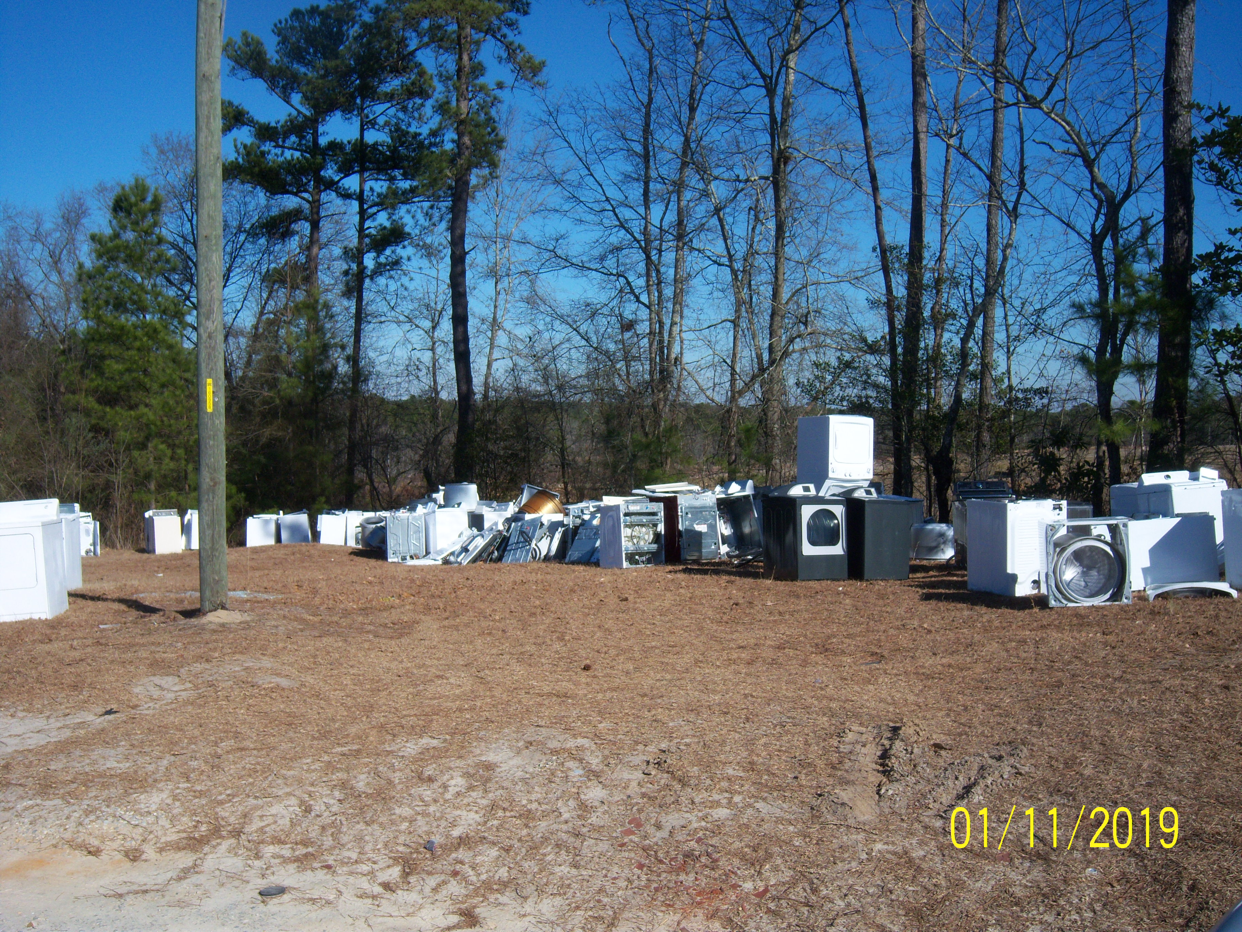
Definitions:

Junk
Scrap copper, brass, rope, rags, batteries, paper, trash, rubber, debris, waste, or junked, dismantled, or wrecked automobiles, or parts thereof, iron, steel, or other scrap ferrous or nonferrous material and dismantled or used white goods or parts thereof.

Junkyard
An establishment or place of business, or portion of a property, which is maintained, operated, or used for storing, keeping, buying, or selling junk, or for maintenance or operation of an automobile graveyard. Any lot containing more than three (3) unregistered and non-functional vehicles shall constitute a junkyard for the purposes of this Ordinance.

Ordinance Reference:

Article V, USE REGULATIONS

SECTION 1.0 USE TYPES & REGULATIONS

1.1 General Applicability

A. Any use not specifically designated as either a permitted or conditional use in a zoning district is prohibited. Uses not listed may be included by following the amendment process described elsewhere in this Ordinance.

1.2 Table of Use Types & Regulations

 | IND | LI | COMM | O & I | CONS | RA-40 | RA-30 | RA-20R | RA-20M | Parking | USE Group Level | Building  Code Class
Junkyards | C* |  |  |  |  |  |  |  |  | 1 Per 2 Employees (Largest Shift) OR 1 Per 500 Sq. Ft.

Junkyards are only allowed in an Industrial Zoned District with Conditional Use Approval.

