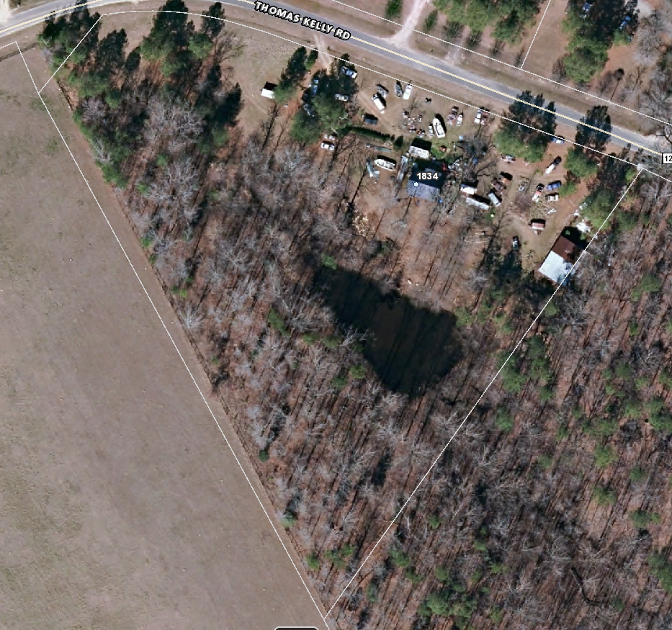

5

3

4

2

1

Compliance Dates

Section1 - February 15, 2019

Section 2 – April 1, 2019

Section 3 – May 15, 2019

Section 4 –July 1, 2019

Section 5 – August 15, 2019