September 28, 2018

Delivery Via: Certified Mail # 7005 1160 0003 6670 0523 / First Class Mail

Collins Park LLC.
PO Box 1187 FINAL NOTICE OF VIOLATION
Smithfield, NC 27577 AND ORDER TO COMPLY

Citation Number: CEZO1808-0017

TO: Owner and parties of interest in the property located at 24 Rey Dan Avenue, Lillington, NC also identified as Harnett County Parcel PIN # 0680-17-5588.000.

YOU ARE HEREBY GIVEN FINAL NOTIFICATION that the property referenced above is in violation of the Harnett County Unified Development Ordinance. The violation is related to the presence of items defined as junk being stored on the property.

YOU ARE FURTHER NOTIFIED that records verify that a previous notification was issued on August 23, 2018 by a Harnett County Zoning Official that advised you that the property was in violation. The notification requested that actions be taken to render compliance with the regulations of the Harnett County Unified Development Ordinance. An inspection performed on September 27, 2018 has verified that compliance actions have not been taken and/or completed. The notification also contained information regarding your rights to appeal the notice of violation and the time frame allowed for such appeal. Current records indicate that you have not filed an official appeal with the Board of Adjustment regarding the actions of the Zoning Administrator.

NOW THEREFORE BE ADVISED that this notification shall serve as the Final Attempt to gain compliance through voluntary actions on behalf of the property owner. Failure to render compliance by the specified date below shall force the Harnett County Development Services to engage in and impose any and all enforcement actions and penalties upon you including civil or criminal actions. Furthermore, in accordance with the Harnett County Unified Development Ordinance, Article XIII Enforcement and Penalties, Section 9.0 Right of Appeal: Any person aggrieved by this notice of violation has thirty (30) days to appeal the action of the Zoning Administrator to the Board of Adjustment. Beyond the decision of the Board of Adjustment, recourse shall be to the Courts as provided by law. The application for appeal may be obtained online at www.harnett.org or may be picked up at the Harnett County Development Services building located at 108 E. Front St. Lillington, NC 27546. For further information, staff may be reached by phone at (910) 893-7525 opt. 4.

Compliance Action Ordered:

Remove all scrap materials and junk vehicles from the property.

Compliance Must Be Rendered By: October 31, 2018 Order Issued By: Randy Baker, CZO
Assistant Manager of Planning Services

Definitions:
Automobile, Junked
A motor vehicle that is:
A. Partially dismantled or wrecked; or
B. Cannot be self-propelled or moved in the manner in which it was originally intended to move; or
C. Does not display a current license plate.
Junk
Scrap copper, brass, rope, rags, batteries, paper, trash, rubber, debris, waste, or junked, dismantled, or wrecked
automobiles, or parts thereof, iron, steel, or other scrap ferrous or nonferrous material and dismantled or used white goods or parts thereof.

Junkyard
An establishment or place of business, or portion of a property, which is maintained, operated, or used for storing, keeping, buying, or selling junk, or for maintenance or operation of an automobile graveyard. Any lot containing more than three (3) unregistered and non-functional vehicles shall constitute a junkyard for the purposes of this Ordinance.

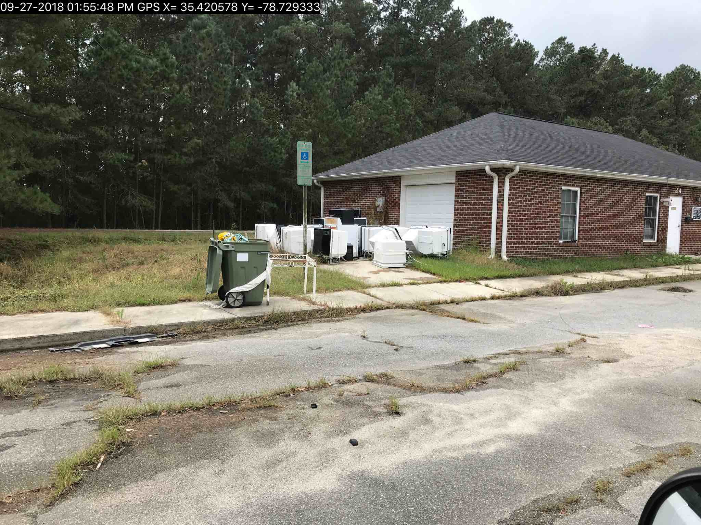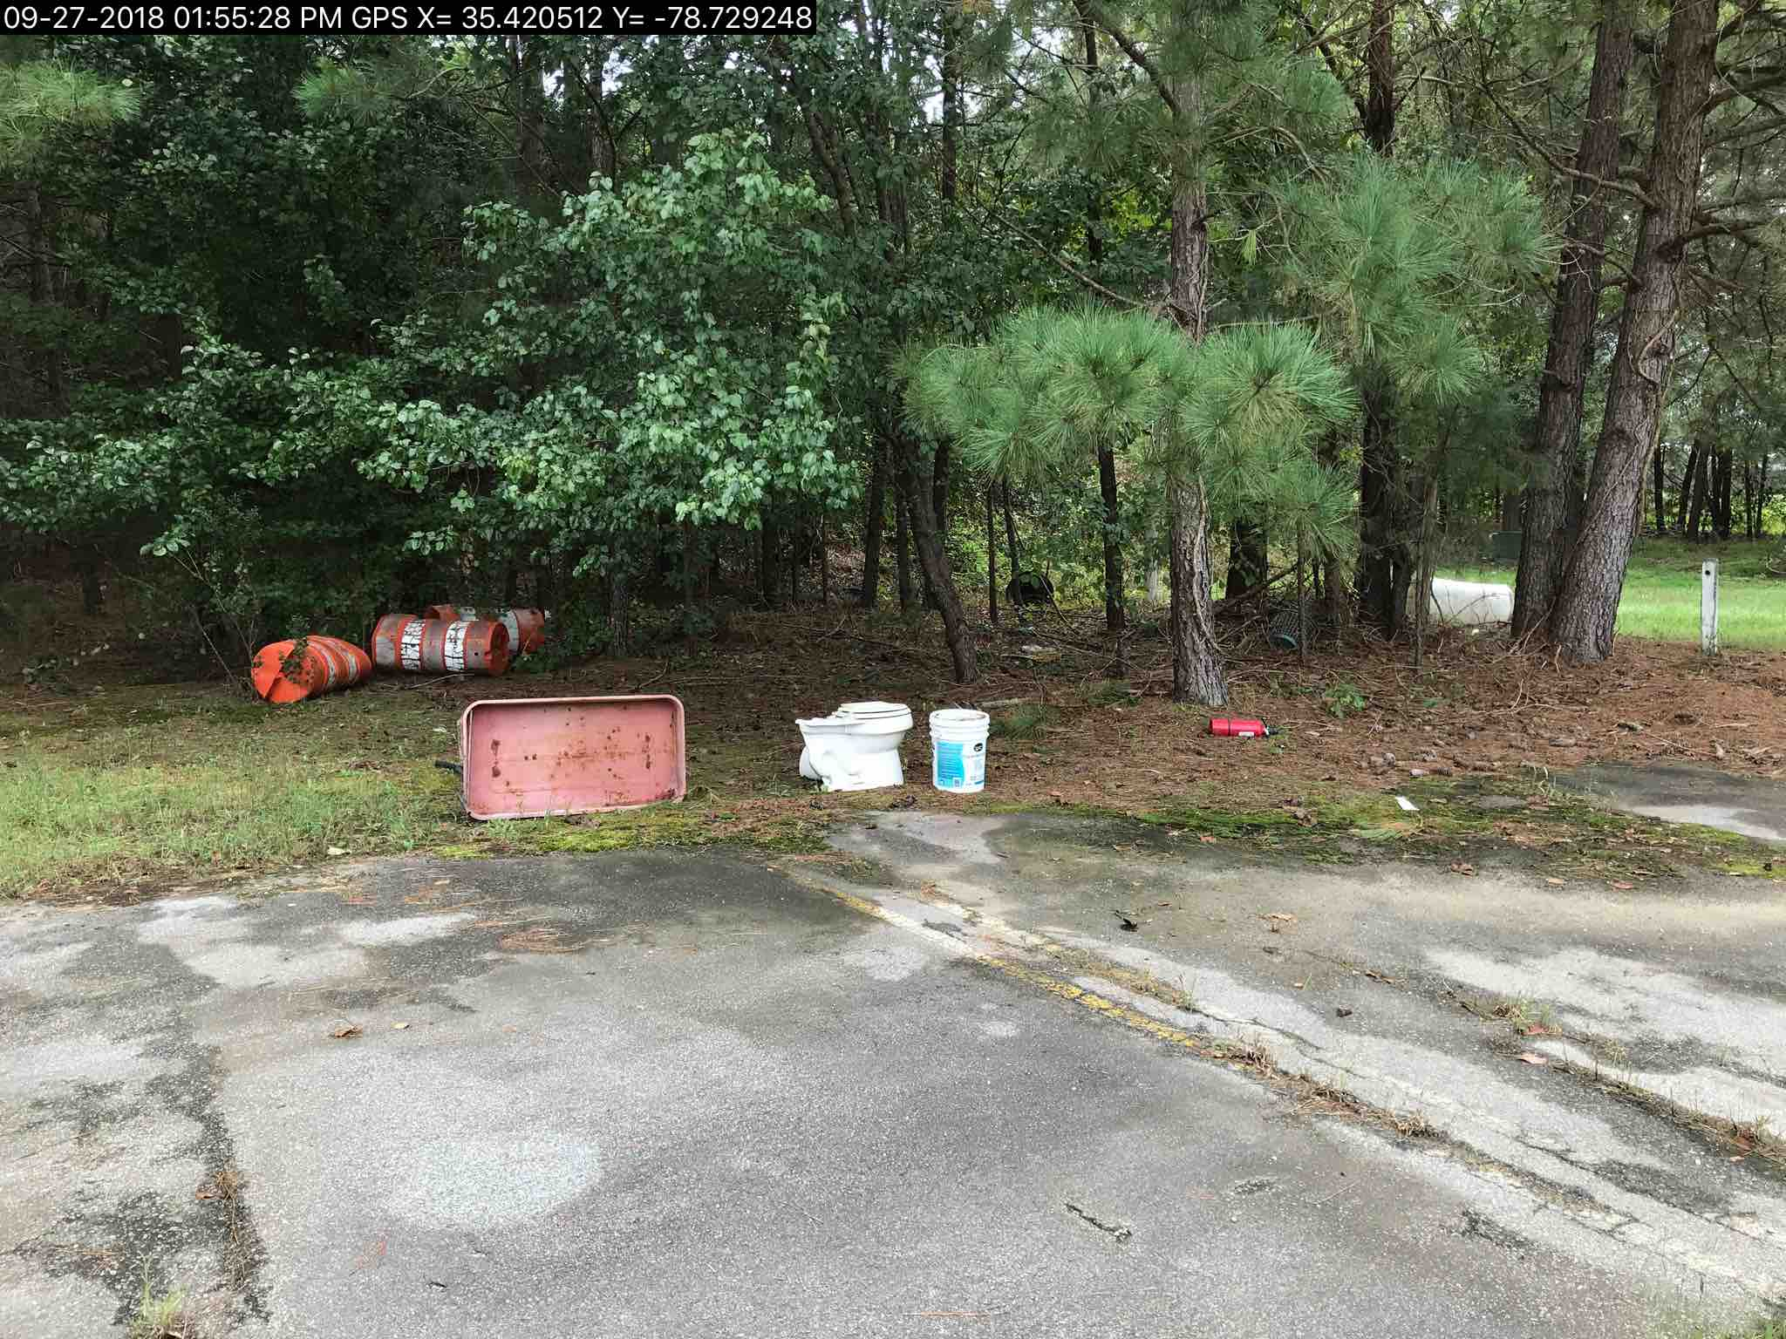
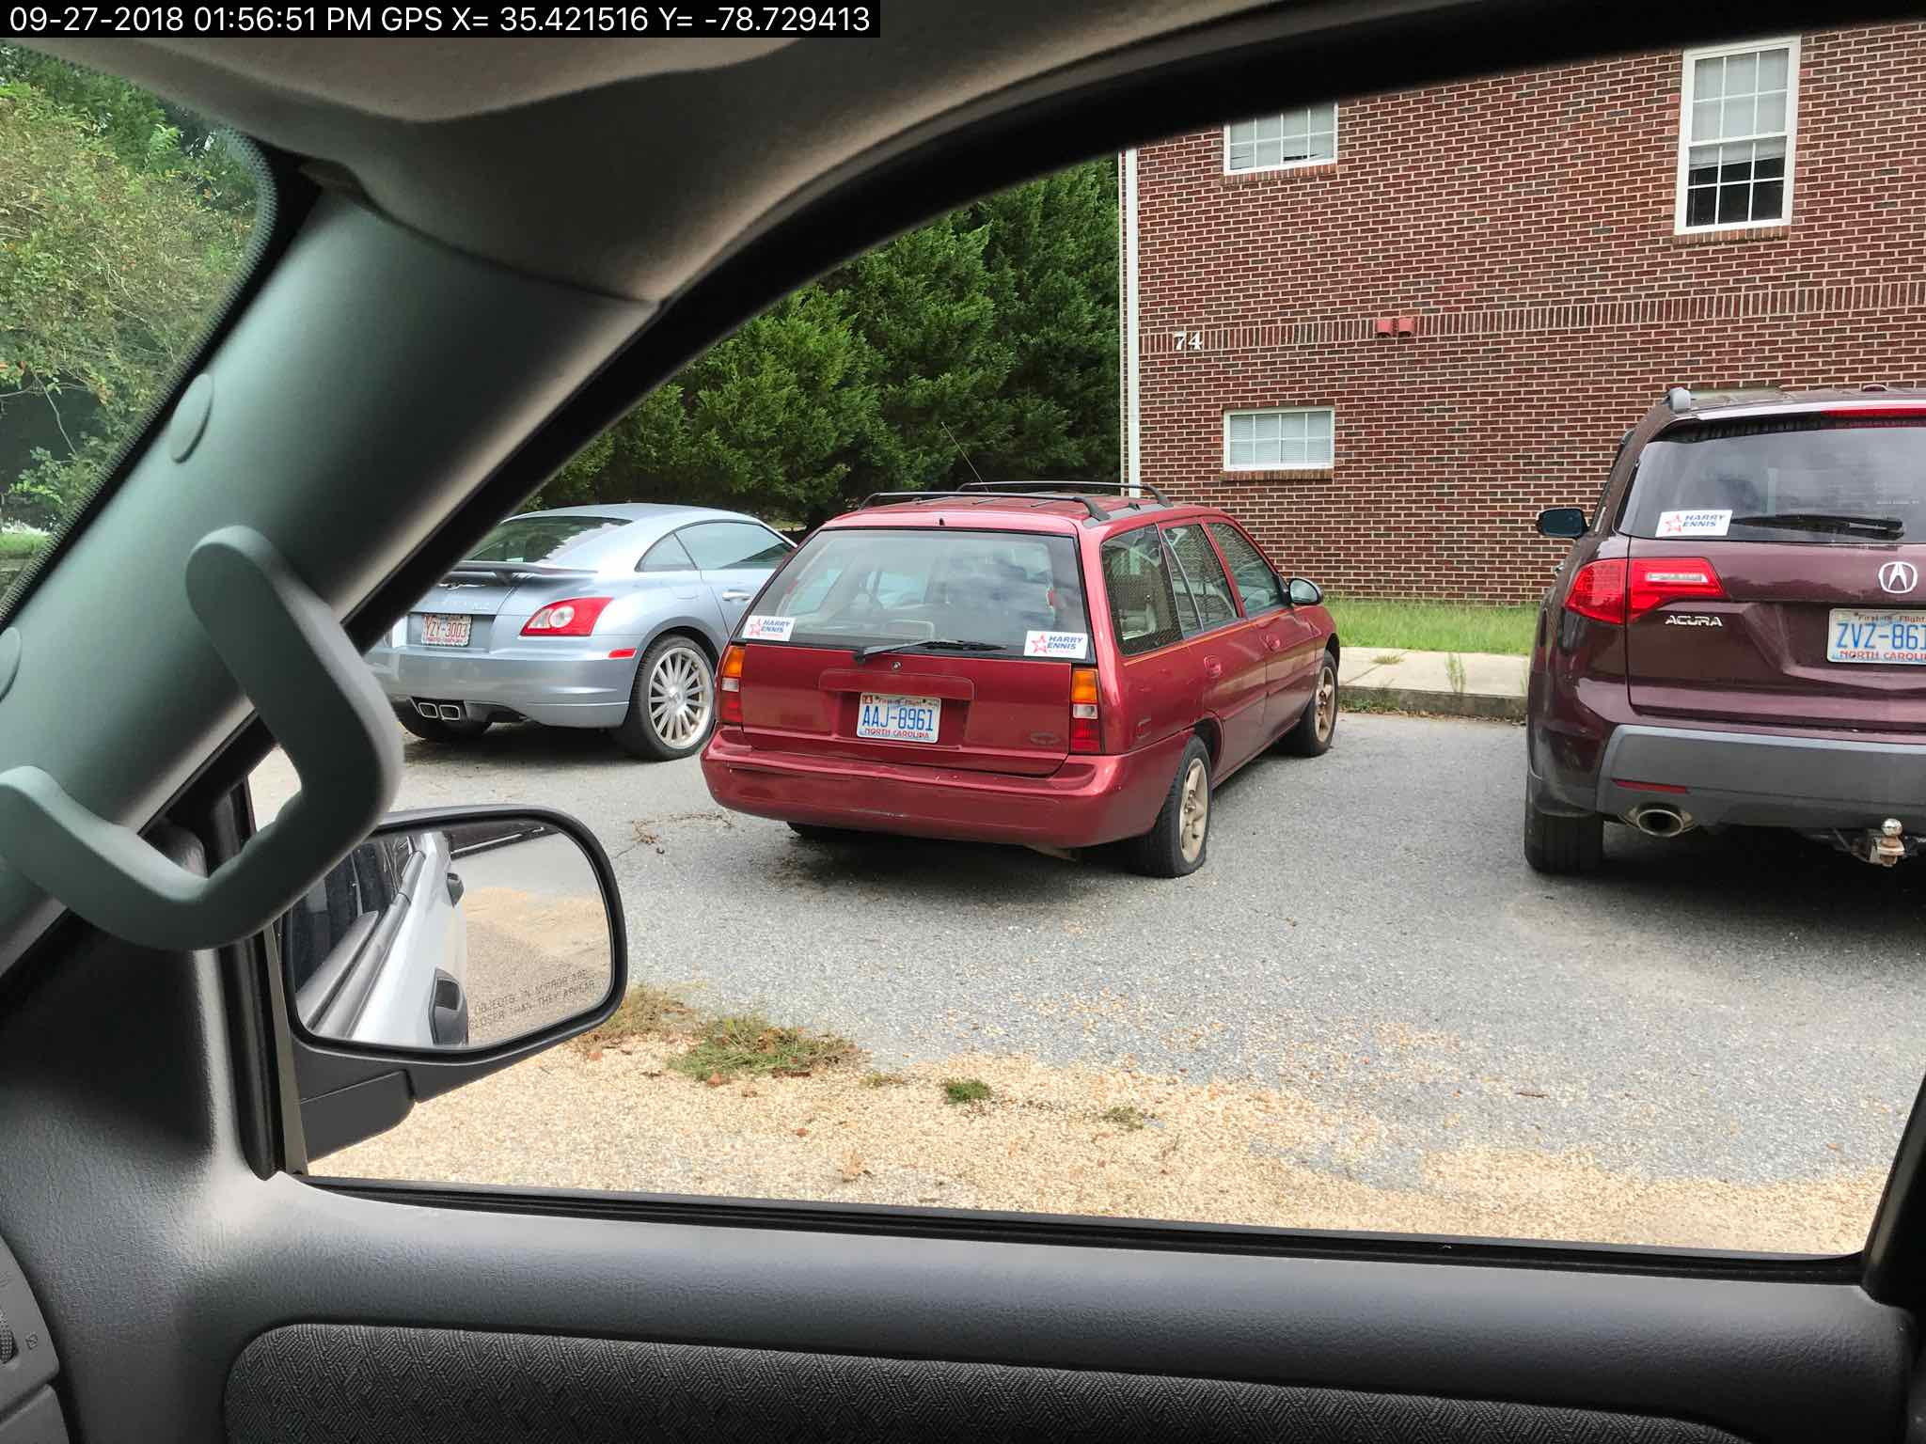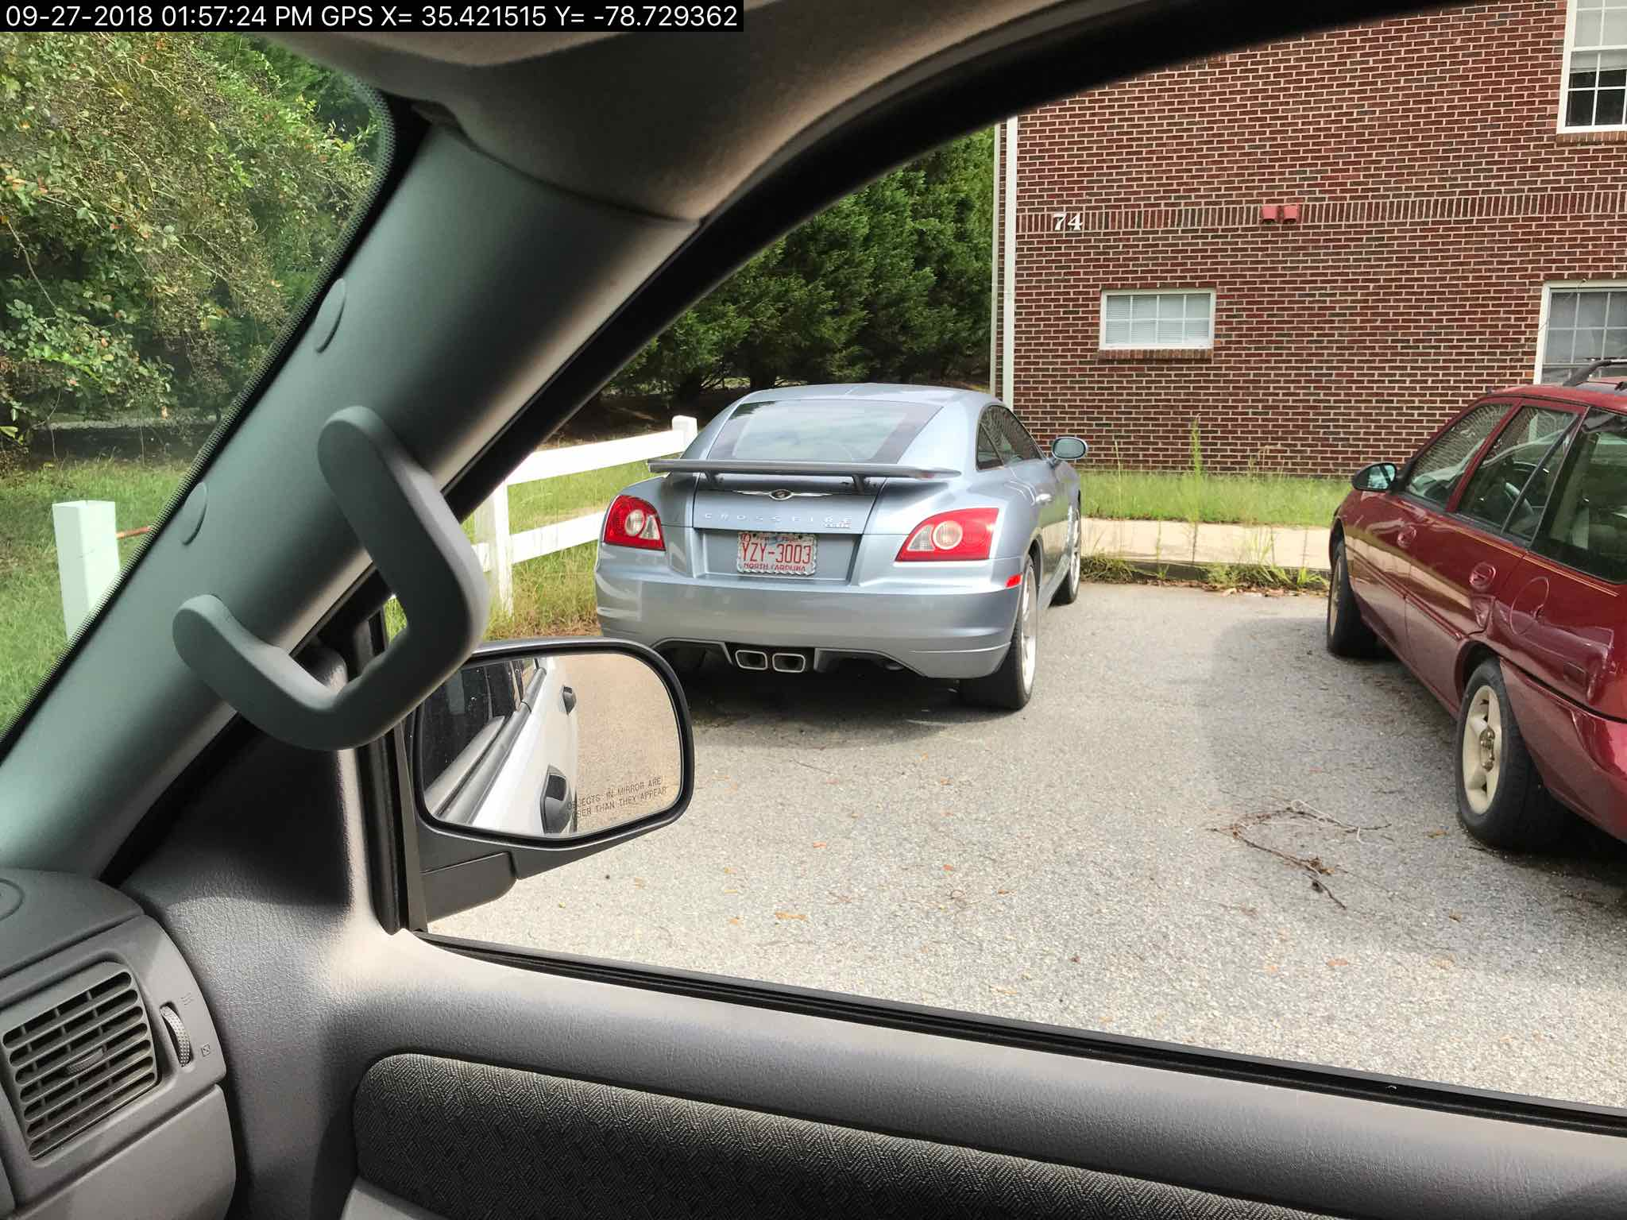
Ordinance Reference:

Article V, USE REGULATIONS

SECTION 1.0 USE TYPES & REGULATIONS

1.1 General Applicability

A. Any use not specifically designated as either a permitted or conditional use in a zoning district is prohibited. Uses not listed may be included by following the amendment process described elsewhere in this Ordinance.

1.2 Table of Use Types & Regulations

 | IND | LI | COMM | O & I | CONS | RA-40 | RA-30 | RA-20R | RA-20M | Parking | USE Group Level | Building  Code Class
Junkyards | C* |  |  |  |  |  |  |  |  | 1 Per 2 Employees (Largest Shift) OR 1 Per 500 Sq. Ft.

Junkyards are only allowed in an Industrial Zoned District with Conditional Use Approval.

