04/03/2018

A complaint was turned in by George Brown III at 441 Anderson Creek School Road for 405 Anderson Creek School Road. The property at 435 Anderson Creek School Road was in worse condition than the property at 405 Anderson Creek School Road. Mr. Brown turned in 405 due to a neighborly dispute regarding property lines. I could not send a Notice of Violation to the owner of 405 without also addressing the neighbor at 435.

04/11/2018

Site inspection performed. Violation of junk materials, junk automobiles and abandoned manufactured home.

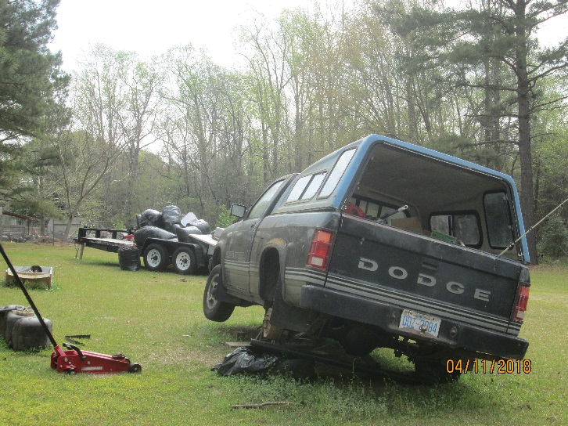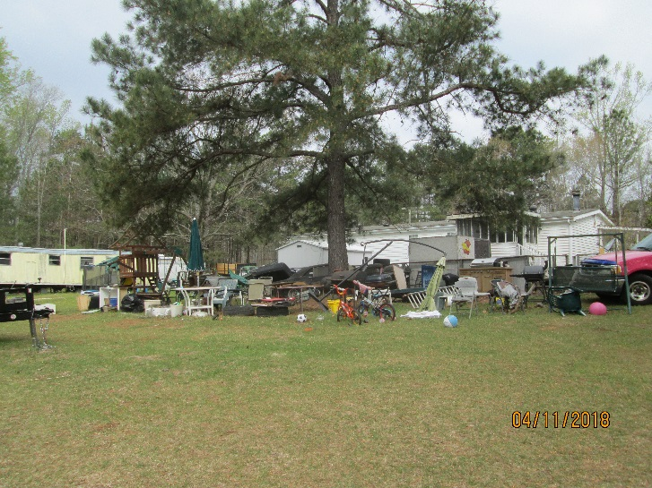

04/26/2018

A Notice of Violation was issued for junk materials, junk automobiles and an abandoned manufactured home with a compliance date of June 28, 2018. Certified mail was returned to the office “unclaimed”, last dated 05/19/18.

06/08/18

Mr. Ray Smith left a message for me that the unlicensed vehicles were no longer on the property, all junk material had been removed and that he will attempt to set up the home.

06/28/2018

Site inspection revealed that owner is still in violation of junk materials, junk automobiles and an abandoned manufactured home. Final notice was issued with a compliance date of 07/30/2018. Certified mail was returned last dated 07/02/2018.

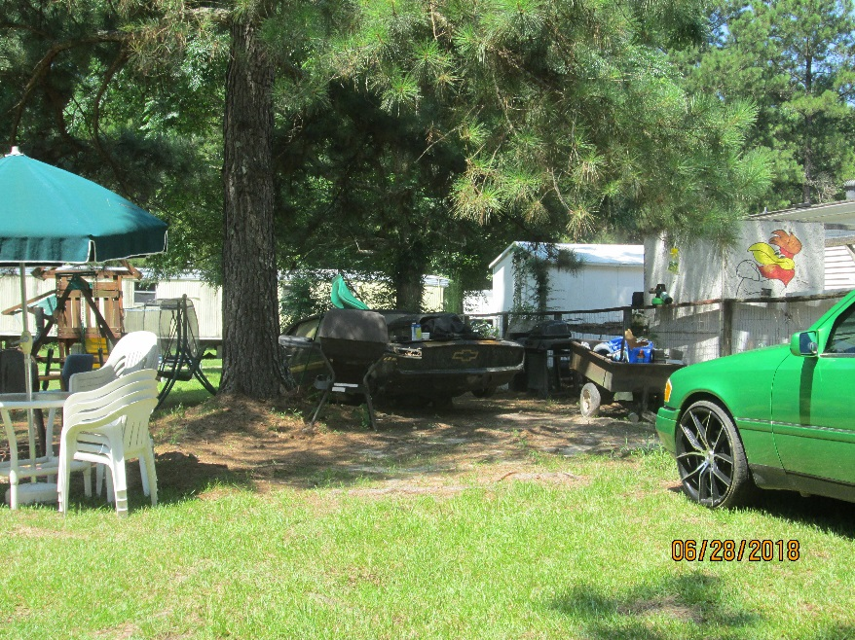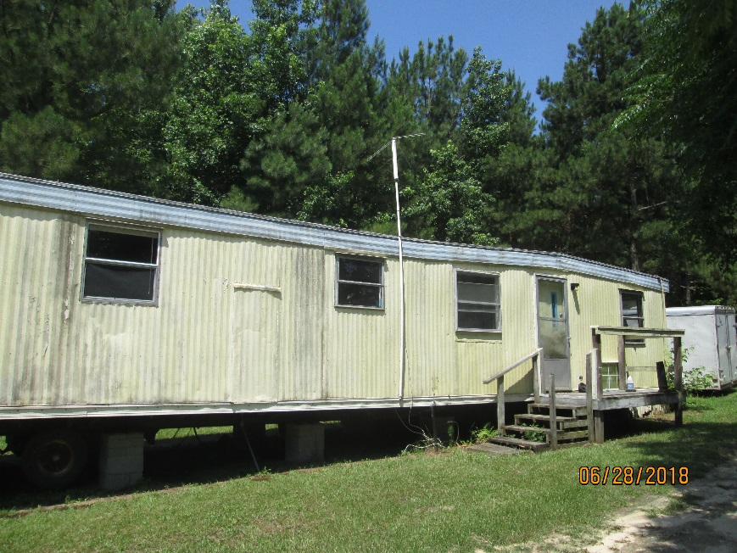

07/11/18

Mr. Smith came into the office to apply for a permit for the home on the property that has been deemed abandoned. He does not have a title, does not know the year of the home and the power has been off for many years. The roof will not meet pitch to be set up on the property zoned RA20R. He has been notified that he has to properly remove, properly demolish or properly permit the home (including providing supporting documentation and properly updating the roof pitch). He has also been notified that the current violation is still in process and will continue until a valid compliance plan is reached. –ad

07/30/18

A site inspection was performed that revealed that the property owner was still in violation.

08/01/18

1st Citation issued to property owner. Certified mail returned “unclaimed” last dated 08/03.

08/17/18

A site inspection was performed. Inspection revealed junk automobiles and an abandoned manufactured home. A woman on site stated that I should not return without first making arrangements to do so and that I can contact the owner’s attorney, Jesse Jones.

08/21/18

A second citation was issued to the property owner.

08/28/18

Received a letter in office from Jesse Jones requesting an appeal to the citation issued on 08/01/2018.

09/07/18

A drive by inspection was performed to check on the status of the property which revealed the owner is still in violation.

