Definitions:

Automobile, Junked

A motor vehicle that is:

A. Partially dismantled or wrecked; or

B. Cannot be self-propelled or moved in the manner in which it was originally intended to move; or

C. Does not display a current license plate.

Junk

Scrap copper, brass, rope, rags, batteries, paper, trash, rubber, debris, waste, or junked, dismantled, or wrecked automobiles, or parts thereof, iron, steel, or other scrap ferrous or nonferrous material and dismantled or used white goods or parts thereof.

Junkyard

An establishment or place of business, or portion of a property, which is maintained, operated, or used for storing, keeping, buying, or selling junk, or for maintenance or operation of an automobile graveyard. Any lot containing more than three (3) unregistered and non-functional vehicles shall constitute a junkyard for the purposes of this Ordinance.

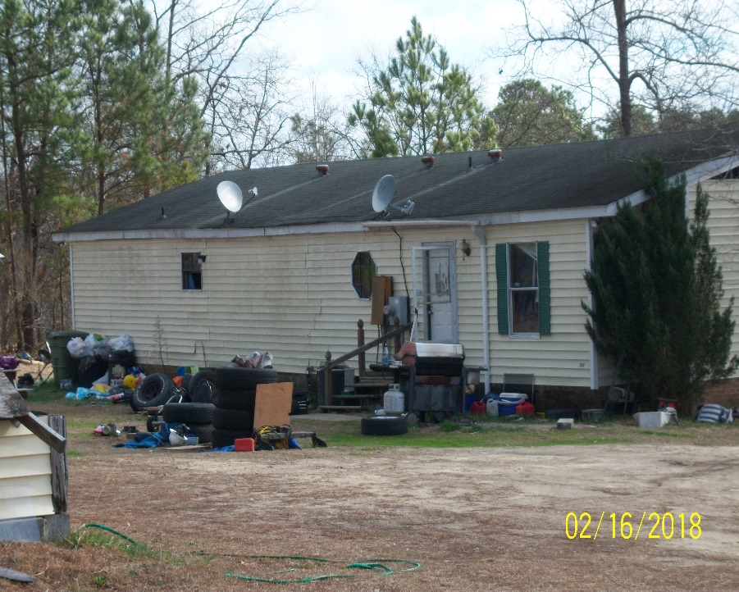

Ordinance Reference:

**Article V, USE REGULATIONS**

SECTION 1.0 USE TYPES & REGULATIONS

1.1 General Applicability

A. Any use not specifically designated as either a permitted or conditional use in a zoning district is prohibited. Uses not listed may be included by following the amendment process described elsewhere in this Ordinance.

1.2 Table of Use Types & Regulations

|  |  |  |  |  |  |  |  |  |  |  |  |  |
| --- | --- | --- | --- | --- | --- | --- | --- | --- | --- | --- | --- | --- |
|  | IND | LI | COMM | O & I | CONS | RA-40 | RA-30 | RA-20R | RA-20M | Parking | USE Group Level | Building  Code Class |
| Junkyards | C* |  |  |  |  |  |  |  |  | 1 Per 2 Employees (Largest Shift) OR 1 Per 500 Sq. Ft. |  |  |

Junkyards are only allowed in an Industrial Zoned District with Conditional Use Approval.

Junk Motor Vehicles (on private property)

Unless otherwise provided, junked motor vehicles in the RA-40, RA-30, RA-20R, and RA-20M

Zoning Districts on private property not associated with a business, shall conform to the following requirements effective November 15, 2004.

A. General Requirements

1. The junked motor vehicles shall not be stored or located within 30 feet of any adjoining property line or side street or right-of-way and shall be situated so that no motor vehicle or parts are visible from the adjoining properties. In no case shall junked motor vehicles be located in the front yard of the primary building of the lot.

2. The junked motor vehicles shall not be a health or safety nuisance, nor shall the area constitute a health or safety nuisance according to the Harnett County Department of Public Health.

3. The junked motor vehicles shall be entirely concealed during all seasons of the year from public view from the public right-of-way and from the adjoining properties. The vehicles may be concealed by an automobile cover or tarpaulin, with the cover adequately secured to prevent removal by wind. The automobile cover or tarpaulin shall remain in good repair and not allowed to deteriorate.

4. In no case shall there be more than three (3) junked motor vehicles located outside any enclosed building unless otherwise specified by this Ordinance. In situations where a person owns multiple tracts of land that are located within 500 feet of each other, the owner of such land shall be limited to three (3) junked motor vehicles located outside any enclosed building unless otherwise specified by this Ordinance for all lots located within the distance requirement.

