**18 South Ida Street**

**PIN: 0690-83-2447.000 Parcel ID: 07-0690-1622-0014 REID: 0017057**

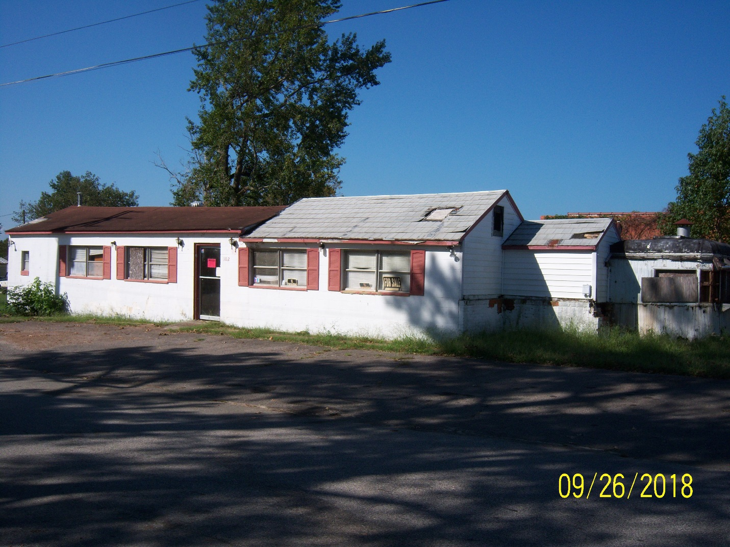

**Michael Voorhees**

**Owner Information: 6117 Heath Hawkins Court**

**Willow Springs, NC 27592**

**Phone Number: (919) 557-7250**

**Deed Information: Book: 3408 Page: 0656 Date: June 08, 2016**

**Condemnation Information**

**Property Posted: September 26, 2018**

**Notice of Hearing Issued: October 10, 2018**

**Hearing Conducted: October 17, 2018 @ 9:00am**

**Hearing Location: 108 East Front Street Lillington, NC 27546**

**Hearing Official: Preston Brad Sutton / Building Codes Administrator**

**Hearing Introduction**

The intent of this Hearing is to allow the owner(s) of the property located at 18 South Ida Street Coats, NC, PIN # 0690-83-2447.000 to be heard in person or by counsel as it relates to the condemnation of the structure located on said property. Authorized individuals may present arguments and/or evidence pertaining to the condemnation and condition of the structure that was posted as unsafe in accordance with North Carolina General Statute 160A-426.

At the conclusion of the hearing, the Building Codes Administrator will review the evidence and findings of fact to determine if the structure is in a condition that constitutes a fire or safety hazard, or is dangerous to life, health or other property. The Building Codes Administrator may issue an **Order** to repair, close, vacate or demolish the structure.

An owner who has received an Order may appeal from the order to the Town of Coats Board of Commissionersby giving written notice of appeal to the Building Codes Administrator and to the Clerk of the Town of Coats Board of Commissioners within 10 days following the day the order is issued. In the absence of an appeal, the order of the Building Codes Administrator is final. The Board of Commissioners shall hear any appeal within a reasonable time and may affirm, modify and affirm, or revoke the order.

If the owner fails to comply with an Order from which no appeal has been taken, or fails to comply with an order of the Board of Commissioners following an appeal, the owner is guilty of a Class 1 misdemeanor. The Towneither in addition to or in lieu of other remedies, may initiate any appropriate action or proceeding to prevent, restrain, correct, or abate the violation or to prevent the occupancy of the building involved.

**Condemnation Hearing**

**Questions / Findings of Fact**

**Are you the legal owner of the property?** Yes

**Are you aware of any other individuals or groups that would have interest in this property or structure?** No

List any other parties with interest:

**Is there a Deed of Trust on file for the property in which the structure is located?** No

List the Deed of Trust Lender:

**Is there any outstanding Taxes due on the property that the structure is located?** No

List the year and amount:

**Are you aware of the current condition of the structure?** Yes

**Is the structure currently occupied?** No

**When was the last time the structure was occupied?** 2004

**Is the structure currently served by an approved Electrical Service?** No

**Is the structure currently supplied with a Potable Water Source?** No

**Is the structure properly connected to a Public Sewer of Private Septic System?** Public Sewer Available

**Does the property have an operating heating system?** No

**Are all access points to the structure properly secured to reduce unauthorized entry? (Examples: Doors, Windows, Crawl Space or Basement)** Yes

**Are you aware of any portion of the structure that displays signs of decay, damage or defective construction?** Yes

**Given the current condition and the deficiencies that have been observed by the Problem Properties Administrator and the Building Codes Administrator, what course of action are you planning to pursue.** Demolish the portion of the structure that displays signs of decay and deterioration. Place a 26 x 36 slab of concrete on the area that is demolished and construct a two bay automotive garage on the site. Owner displayed a hand drawn site plan that illustrated this proposed renovation and construction.

**Hearing Minutes**

* The hearing began at 9:15 am on October 17, 2018.
* The hearing was attended by Michael Voorhees (Property Owner), Brad Sutton (Building Code Official), Randy Baker (Problem Properties Administrator) and Nick Holcomb (Town of Coats Manager).
* Randy Baker began the hearing by reading an introduction that outlined the purpose and intent of the hearing. The introduction included the procedures of the hearing and the ability of appeal by the property owner.
* Mr. Sutton asked the property owner a series of questions that pertained to the property and the current conditions of the structure. Mr. Voorhees responded to these questions as stated in the Finding of Fact questionnaire.
* Mr. Sutton asked for a timeline of repairs and renovations as mentioned by the property owner. Mr. Voorhees stated that he could perform the demolition and securing of the structure within a time frame of 30 to 60 days. The renovation and construction of the garage bays would be based off of financial availability.
* Mr. Voorhees stated that the completed structure would be approximately 1,400 to 1,500 sq. ft. in size.
* Mr. Voorhees illustrated on a photo of the structure were he would perform the demolition of a portion of the structure in order to render it safe and secure, while making the necessary repairs on the remaining portion and utilize it for storage purposes until the new addition could be built.
* Mr. Voorhees was advised of Mr. Sutton’s concerns relating to certain areas of the structure that pose a threat to public safety.
* The hearing was closed and Mr. Voorhees was advised that he would receive a notification of the results of the hearing within the coming days.