Delivery Via: Certified Mail # 7003 0500 0004 8268 6908

Michael Voorhees

6117 Heath Hawkins Ct. **NOTICE OF FINDINGS OF FACT AND ORDER**

Willow Springs, NC 27592 **BY THE BUILDING CODES ADMINISTRATOR**

**UNDER NC GENERAL STATUTE 160A-429**

RE: Condemned Structure

Property Address: 18 S. Ida Street Coats, NC 27521

PIN Number: 0690-83-2447.000

**TO:** Owners and parties of interest in the property located at 18 S. Ida Street, Coats, North Carolina. PIN Number (0690-83-2447.000).

**YOU ARE HEREBY NOTIFIED** that a Hearing before the Building Codes Administrator was conducted in accordance with North Carolina General Statute 160A-428 on October 17, 2018 at 9:00 am regarding the condemned structure as referenced above. A notification was properly issued to the parties who have ownership interest in the subject property as referenced above. At the hearing, the following individuals, owners, persons in interest or their agents or attorneys, were present and participated therein: Brad Sutton (Building Codes Administrator), Randy Baker (Problem Properties Administrator), Nick Holcomb (Manager, Town of Coats ) and Michael Voorhees (Property Owner).

**YOU ARE FURTHER NOTIFIED** that upon further review and examination of inspection results, testimony and evidence submitted by the property owner pertaining to the structure, the Building Codes Administrator reached a determination that the above referenced structure is in a condition that constitutes a hazard and renders it dangerous to life, health and other property.

**IT IS THEREFORE ORDERED** pursuant to North Carolina General Statute 160A-429, the owner(s) of the property referenced above are required to remedy the defective conditions by repairing deteriorating structural components and demolish the dilapidated section of the structure as illustrated in Attachment “A”. Upon completion of the demolition, the structure shall be enclosed utilizing standard construction practices once the required permits are obtained from Harnett County Central Permitting. This shall be completed no later than December 28, 2018.

**YOU ARE FURTHER ADVISED** pursuant to North Carolina General Statute 160A-430, the property owner(s) may appeal the Order to the Town of Coats Board of Commissioners by giving written notice of appeal to the inspector and to the clerk within 10 days following the day the Order is issued. In the absence of an appeal, the Order of the inspector is Final. Failure to comply with this Order is a Class 1 misdemeanor and grants the Town of Coats the ability to initiate any appropriate action or proceeding to prevent, restrain, correct, or abate the violation or to prevent the occupancy of the building involved.

This the 19th day of October 2018.

Cc: Nick Holcomb

25 East Main Street Preston B. Sutton

Coats, NC 27521 Building Codes Administrator

**Attachment “A”**

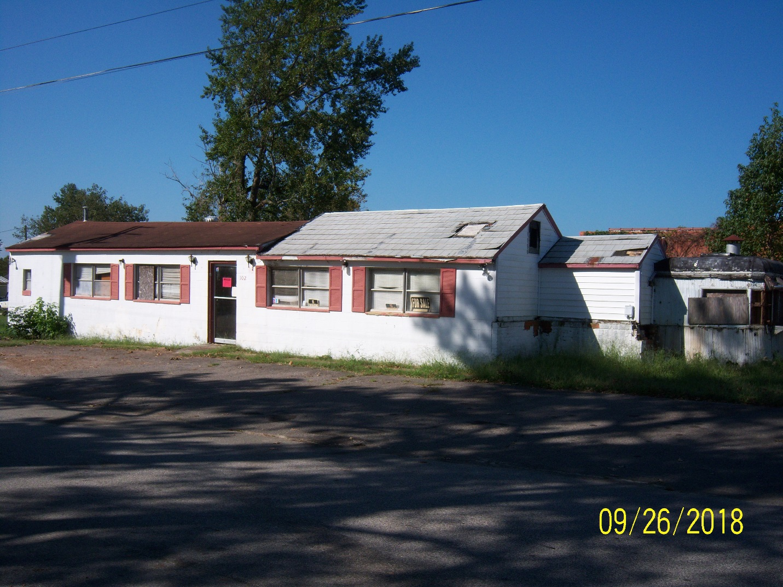

Repair and/or replace all deteriorating structural components. Structure must be in compliance with all code requirements.

Portion of Structure to be Demolished