**21 E. Tryon Court**

**PIN: 0514-26-5034.000 Parcel ID: 01-0505-01-0300-30 REID: 42933**

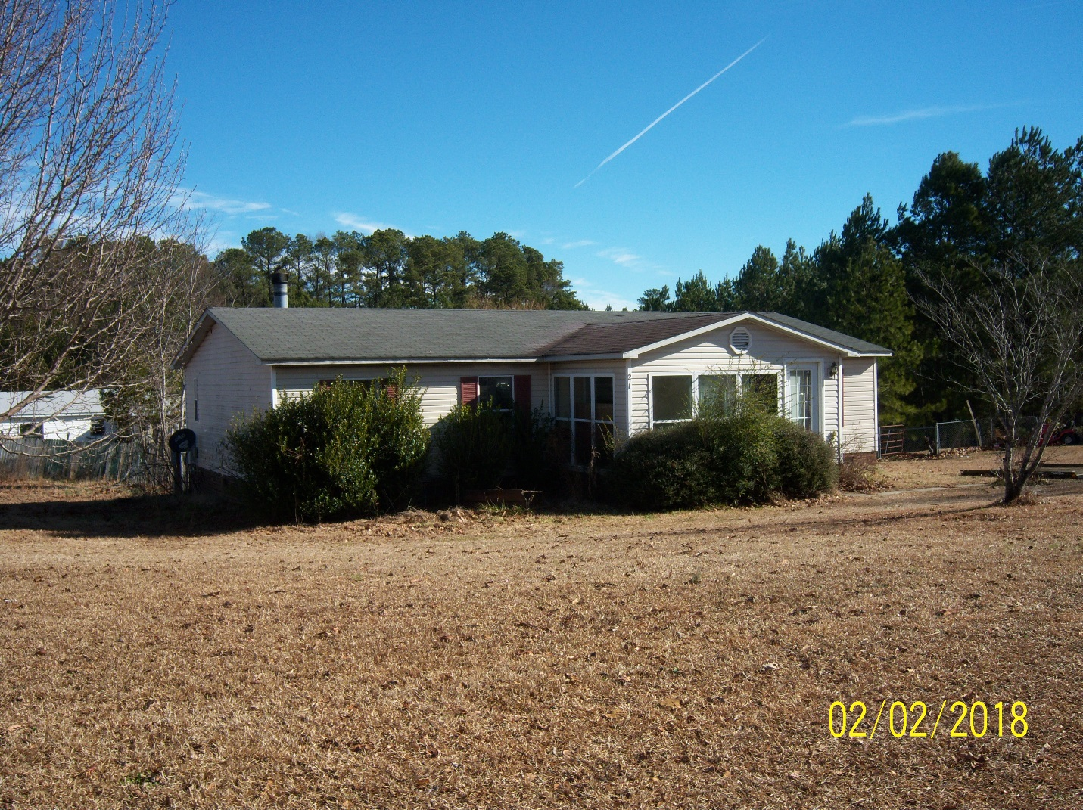

**Karton Properties LLC.**

**C/O Lancanster & Trotter**

**Owner Information: 2017 S. Main Street**

**Graham, NC 27253-4709**

**Phone Number: (336) 264-6501 - Chris Kimbrell**

**Deed Information: Book: 2125 Page: 629 Date: August 22, 2005**

**Condemnation Information**

**Property Posted: February 8, 2018**

**Notice of Hearing Issued: March 1, 2018**

**Hearing Conducted: March 7, 2018 @ 11:00am**

**Hearing Location: 108 East Front Street Lillington, NC 27546**

**Hearing Official: Preston B. Sutton / Building Codes Administrator**

**Hearing Introduction**

The intent of this Hearing is to allow the owner(s) of the property located at **21 East Tryon Court**, PIN # **0514-26-5034.000** to be heard in person or by counsel as it relates to the condemnation of the structure located on said property. Authorized individuals may present arguments and/or evidence pertaining to the condemnation and condition of the structure that was posted as unsafe in accordance with North Carolina General Statute 153A-366.

At the conclusion of the hearing, the Building Codes Administrator will review the evidence and findings of fact to determine if the structure is in a condition that constitutes a fire or safety hazard, or is dangerous to life, health or other property. The Building Codes Administrator may issue an **Order** to repair, close, vacate or demolish the structure.

An owner who has received an Order may appeal from the order to the Harnett County Board of Commissionersby giving written notice of appeal to the Building Codes Administrator and to the Clerk of the Harnett County Board of Commissioners within 10 days following the day the order is issued. In the absence of an appeal, the order of the Building Codes Administrator is final. The Board of Commissioners shall hear any appeal within a reasonable time and may affirm, modify and affirm, or revoke the order.

If the owner fails to comply with an Order from which no appeal has been taken, or fails to comply with an order of the Board of Commissioners following an appeal, the owner is guilty of a Class 1 misdemeanor. The Countyeither in addition to or in lieu of other remedies, may initiate any appropriate action or proceeding to prevent, restrain, correct, or abate the violation or to prevent the occupancy of the building involved.

**Condemnation Hearing**

**Questions / Findings of Fact**

**Are you the legal owner of the property?**

**Are you aware of any other individuals or groups that would have interest in this property or structure?**

List any other parties with interest:

**Is there a Deed of Trust on file for the property in which the structure is located?**

List the Deed of Trust Lender:

**Is there any outstanding Taxes due on the property that the structure is located?**

List the year and amount:

**Are you aware of the current condition of the structure?**

**Is the structure currently occupied?**

**When was the last time the structure was occupied?**

**Is the structure currently served by an approved Electrical Service?**

**Is the structure currently supplied with a Potable Water Source?**

**Is the structure properly connected to a Public Sewer of Private Septic System?**

**Does the property have an operating heating system?**

**Are all access points to the structure properly secured to reduce unauthorized entry? (Examples: Doors, Windows, Crawl Space or Basement)**

**Are you aware of any portion of the structure that displays signs of decay, damage or defective construction?**      

**Given the current condition and the deficiencies that have been observed by the Problem Properties Administrator and the Building Codes Administrator, what course of action are you planning to pursue.**      