Fire Marshal Division

April 6, 2023

Robert E. Lee
Michael’s Amusement Company
9011 Steeplechase Drive
Linden, NC. 28356

Re: 107 Carletta Cagle Drive
Cameron, NC 28326

Application Number – SPLU2304-0001

Mr. Lee,

Thank you for submitting the plans for the carnival. The plans have been carefully reviewed by a qualified code enforcement official to examine for full compliance with the North Carolina Fire Prevention Code and all other fire protection regulatory documents. There are some items that were found during the plan review process that need to be addressed before a final inspection of the new facility can be given. These items are outlined and described below.

- Permits

  - A permit will be issued for the special assembly that will include the event as a whole.
  - A permit may be issued for other tent areas if the individual tent exceeds 700 ft2 or the aggregate area of multiple canopies placed side by side without a fire break clearance of 12’

- Fire Extinguishers
  - Portable fire extinguishers shall be provided within a 30-foot (9144 mm) travel distance of commercial-type cooking equipment. Cooking equipment involving vegetable or animal oils and fats shall be protected by a Class K rated portable extinguisher.
  - 2A-10B:C fire extinguisher shall be placed at tents/canopies with a travel distance not to exceed 100’ from any fire extinguisher.

2411.5 Cooking tents.
  - Tents where cooking is performed shall be separated from other tents, air-supported, air-inflated or tensioned membrane structures, temporary membrane structures or canopies by a minimum of 20 feet (6096 mm).

2411.6 Outdoor cooking.
  - Outdoor cooking that produces sparks or grease-laden vapors shall not be performed within 20 feet (6096mm) from a tent, air-supported, air-inflated or tensioned membrane structure, temporary membrane structure or canopy.
- 2415 Generators
  - Generators and other internal combustion power sources shall be separated from tents, air-supported, air-inflated or tensioned membrane structures, temporary membrane structures or canopies by a minimum of 20 feet (6096 mm) and shall be isolated from contact with the public by fencing, enclosure or other approved means.

2413.3 Refueling.
  - Refueling shall be performed in an approved location not less than 20 feet (6096 mm) from tents, air-supported, air-inflated or tensioned membrane structures, temporary membrane structures or canopies.

- Permits
  - Final inspection will be conducted the day of the event and the permit will be issued after inspection.
Thank you again for submitting the plans for the carnival. Please review the plans and adhere to any notes and alterations that were made in addition to the original drawings. These remarks are for the plans that were submitted and its original intent. These remarks do not apply if the original intent changes or what was submitted on the above date changes. If you have any questions, please do not hesitate to call this office

Again, thank you and we look forward to working with you.

Sincerely,
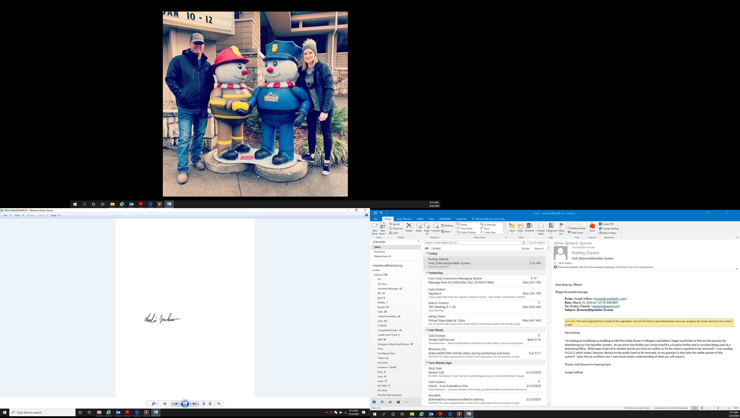

Leslie Jackson
Chief Deputy Fire Marshal
lrjackson@harnett.org
910-893-0740

