

PO Box 65

108 E. Front Street

Lillington, NC 27546

Ph: (910) 893- 7525 opt. 4

Fax: (910) 814-6459

|  |  |  |  |
| --- | --- | --- | --- |
| Date of Submittal | Application Number | Applicant | Landowner |
| 12/18/2023 | SIGN2312-0251 | Blashfield Signs Co Inc. | AGS Land LLC |
|  |  |  |  |

|  |  |  |  |
| --- | --- | --- | --- |
| Contact Person | Jan Wright | Contact Number | 910-485-7200 |
| Sign Location | Fairground Farms | PIN Number | 1518-55-5233.000 |

|  |  |  |  |  |  |  |  |
| --- | --- | --- | --- | --- | --- | --- | --- |
| Proposed Sign | | | | | | | |
| Type | Dimensions | | Location / Setbacks | | Illumination | | |
| Wall  Ground  Monument  Directory  Outdoor  Advertising | **Height**  **69”**  **5.75’**  **Width**  84”  7’  Total Sq. Ft. **: 17.95** | | Intersection of Fairground Rd. and Alderman Ct. | | None  External  Internal  Electronic Message | | |
| Total Length of Wall | **NA** | | Total Size of Project / Parcel | | | | Less Than 1 Acre  Greater Than 1 Acre |
| Total Sq. Ft.  Electronic Message Display | |  | | Pole Style  Ground Sign Encasement | | Material –  **PVC**  Width **Not Provided** | |
|  | |  | |  | |  | |

|  |  |  |  |
| --- | --- | --- | --- |
| Current Signage | | | |
| Current  Wall Signs | Current  Ground Signs | Distance Between  Signs On Property | Distance Between  Outdoor Advertising Signs |
| **0** | 0 | NA |  |

|  |  |  |
| --- | --- | --- |
| Reviewed By: | Date of Review | Review Results |
| Sarah Arbour |  | Approved  Denied  More information needed |

|  |  |
| --- | --- |
| Comments | **10.6.1 Pole Style Ground Signs**  10.6.1 Pole Style Ground Signs  All pole style ground signs with support(s), upright(s), bracing(s), or framework(s) that  include a pole encasement shall meet the following requirements. Pole style ground  signs for street signs, manufactured home park signs, interstate signs, historical  identification signs, shall be exempt from the requirements of this Section.  A. Said support(s), upright(s), bracing(s), or framework(s) shall be encased in an ornamental  shell of stone, brick, ornamental metal, or similar materials, and shall be a minimum width  of one quarter (¼) of the width of the sign face; or  B. Said sign shall be constructed of an external support structure including stone, brick,  ornamental metal or similar materials, provided that the maximum number of supports,  uprights, bracings, or frameworks extending between grade and the base of the sign face  shall not exceed two (2).  2. The location of the sign is not included on the site plan. Please show the proposed location of the sign and include the distance from the sign to each ROW. 20’ from each ROW is required at intersections. |

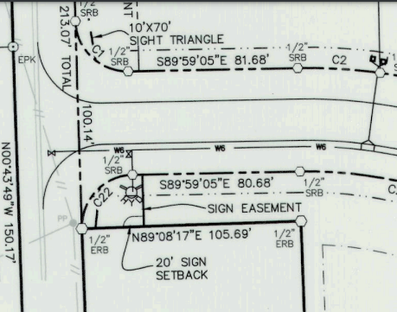

**Site Plan**

**Sign**