

PO Box 65

108 E. Front Street

Lillington, NC 27546

Ph: (910) 893- 7525 opt. 4

Fax: (910) 814-6459

|  |  |  |  |
| --- | --- | --- | --- |
| Date of Submittal | Application Number | Applicant | Landowner |
| 3/29/2023, denied by NCDOT and incorrect information provided first application  **Resubmitted** 5/9/2023 | SIGN2303-0003 | Lamar Advertising | Burline McLamb Heirs |

|  |  |  |  |
| --- | --- | --- | --- |
| Contact Person | Brian Johnson | Contact Number | 252-382-0354 |
| Sign Location | West Side of Saddler Rd. approx.. .8 mile N. of I-95/Jonesboro Rd. interchange | PIN Number | 1527-83-7998.000 |

|  |  |  |  |  |  |  |  |
| --- | --- | --- | --- | --- | --- | --- | --- |
| Proposed Sign | | | | | | | |
| Type | Dimensions | | Location / Setbacks | | Illumination | | |
| Wall  Ground  Monument  Directory  Outdoor  Advertising | **Overall Height**  30’  **Width**  36’  **Length**  10’ 6”  Total Sq. Ft. **378** | | 34’ from edge of ROW Saddler Rd. | | None  External  Internal  Electronic Message | | |
| Total Length of Wall |  | | Total Size of Project / Parcel | | | | Less Than 1 Acre  Greater Than 1 Acre |
| Total Sq. Ft.  Electronic Message Display | | **0** | | Pole Style  Ground Sign Encasement | | Material  **Steel**  Width **No encasement required** | |

|  |  |  |  |
| --- | --- | --- | --- |
| Current Signage | | | |
| Current  Wall Signs | Current  Ground Signs | Distance Between  Signs On Property | Distance Between  Outdoor Advertising Signs |
|  | 1 other outdoor advertising sign located on the property to the S. approx.. 500’ away |  | 500’ +/- |

|  |  |  |
| --- | --- | --- |
| Reviewed By: | Date of Review | Review Results |
| Sarah Arbour | First Review – 4/5/2023  Second Review- 5/17/2023 after confirmation from NCDOT | Approved  Denied  More information needed |

|  |  |
| --- | --- |
| Comments | 1. The outdoor advertising sign located on the property is being rebuilt under modernization GS.  2. The sign may NOT be relocated from US 70 per NCDOT.  3. NCDOT verified that the sign permit I-095 043054 is in good standing.  4. Nonconforming Outdoor Advertising / Billboard signs  1. As per G.S. 136-133.2, existing nonconforming outdoor advertising signs shall be allowed to be repaired or reconstructed so long as the square footage of its advertising surface area is no increased. This also includes the changing of an existing multipole outdoor advertising structure to a new monopole structure.  2. All nonconforming outdoor advertising signs that are required to be permitted by the North Carolina Department of Transportation, shall maintain all required permits in good standing for the life of the nonconformity. If at any point the NCDOT revokes these permits, the nonconforming sign shall come into compliance with current regulations or be removed. |

**Sign Building Plans –**

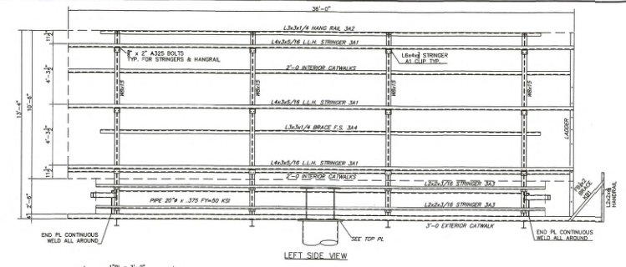

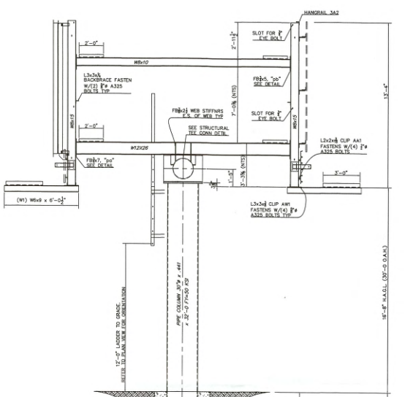

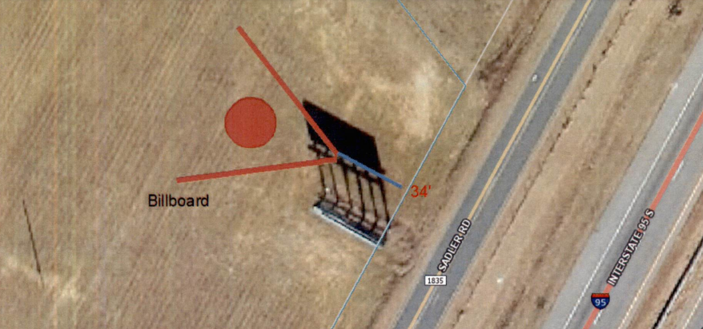**Sign Location –**

**NCDOT Permit Information --**