This t-pole is located to the right of the property. There is a grassy mound between the foundation and the t-pole. Please see 2d photo for orientation below.

Up-close t-pole photo

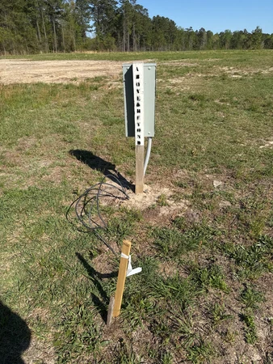

2d photo: This photo was taken on the left side of the foundation. You can see toward the top of the photo a grassy mound on the right side of the foundation. The t-pole is on the other side of it.

