GREG BAGLEY ENGINEER

Engineering + Planning Design

805 Cokesbury Road Fuquay Varina, NC 27526

Phone: 919-609-0300

Email: gdb.greg@gmail.com

6-5-23

Adam Raynor

Raynor Builders, Inc.

725 N Raleigh St, Angier, NC 27501

Ref: 11 Mattie Grace Lane

Lot 1

Dear Mr. Raynor:

We inspected the work that has been completed at the above location. We verified the size of the reveal for the reveal for the questioned pier needed to be modified to meet code. By adding additional footing of 18” x 4” and by installing 4- #4 rebars to the existing piers as discussed, the construction now meets 2018 Code. The work as performed is acceptable.

If you have questions regarding this matter, please do not hesitate to contact this office.

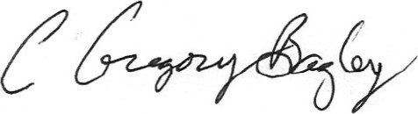Sincerely,

C. Gregory Bagley, PE