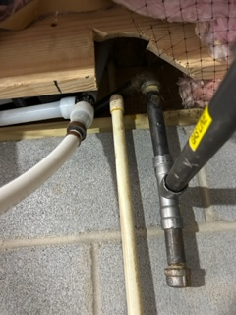

Under the house below water heater. Cut floor joist attempting to conceal with plywood and only partial insulation above

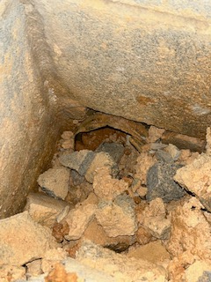

Foundation drain never completed/extended. Located in corner right hand side rear, only stubbed out

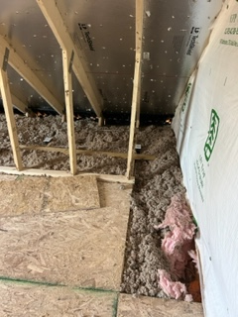

Flood light wiring was added in attic last week. Interpretation of “accessible”, really surprised a licensed company did it this way. Always been a “no no” to me

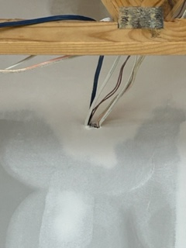

Sheetrock replaced in garage, should be fire caulk?

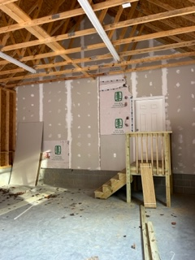

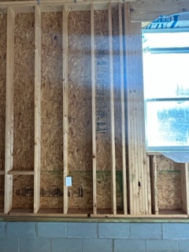

2x6 not nailed properly to right of outlet, garage front wall

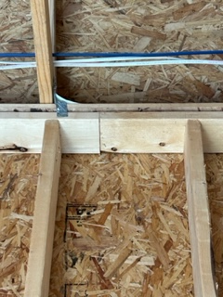

2x6 missing in garage back wall

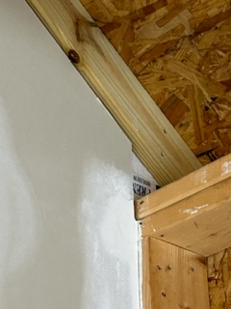

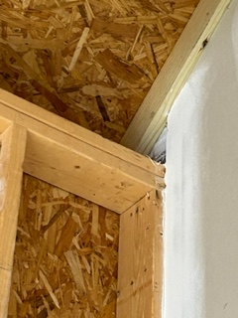

Garage not completely sealed from attic

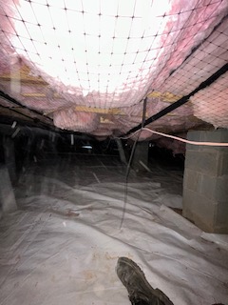

Low voltage wiring in crawl not supported properly

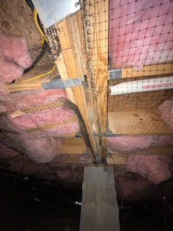

Missing insulation and mate line not sealed properly

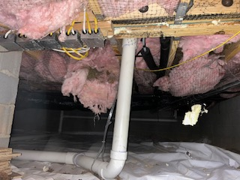

Insulation hanging / missing in crawl numerous areas

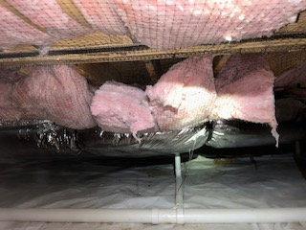

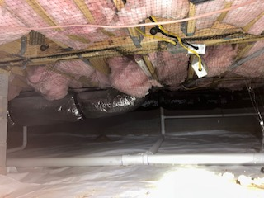

Insulation and hanging junction boxes

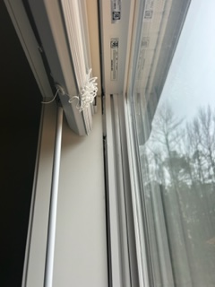

Multiple windows on rear of house were improperly installed with large uneven air gaps

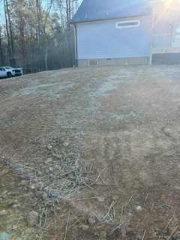

Substantial grading took place and entire septic line was removed and replaced after orig inspection

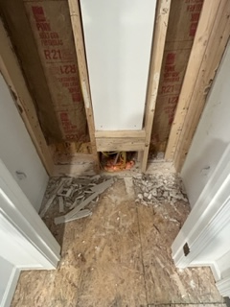

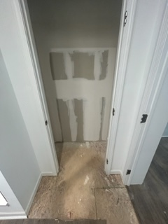

Major leak from defective water heater, local restoration company was involved but unaware of exactly how was put back together by our contractor

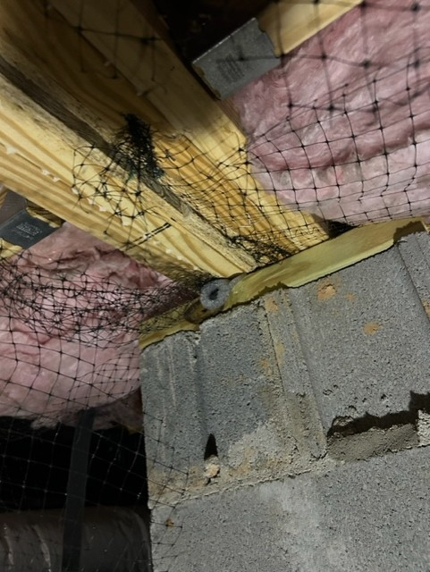

Factory insulation barrier compromised in numerous areas, mate line not sealed

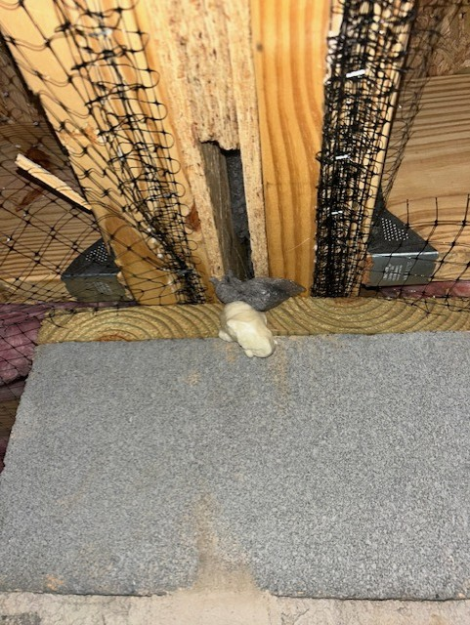

Factory insulation barrier compromised in numerous areas, mate line not sealed

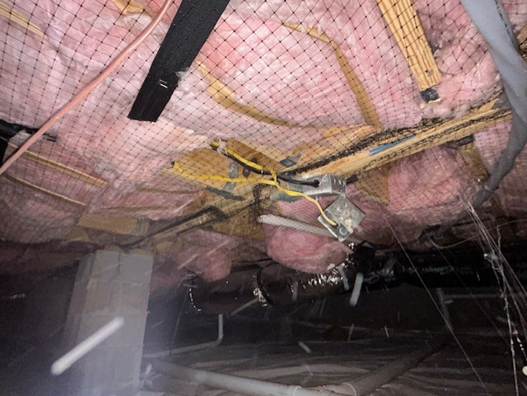

None of the insulation has been installed properly, surly not making full contact with bottom of floor decking. See below from factory installation manual

