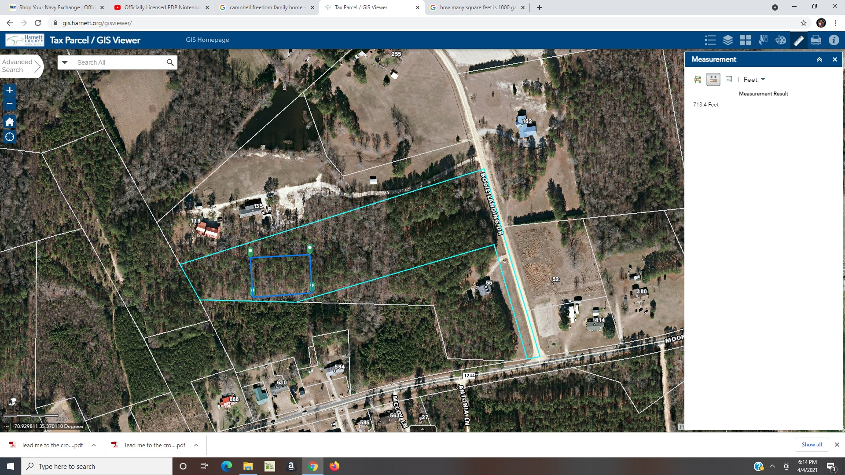

270 ft

54 ft ft

Corner A

**Notes:**

* The dark blue line with the dimensions of 216 ft x 144 ft is the clearing limits for the placement of the house.
* The document titled “Layout of the house on the 0.75 acres” provides the location of the house within the lot
* Driveway will be 24 ft wide
* Flags/stakes will be placed at the four corners of the lot to be cleared

189 ft

5 ft

144 ft

5 ft

54 ft

216 ft