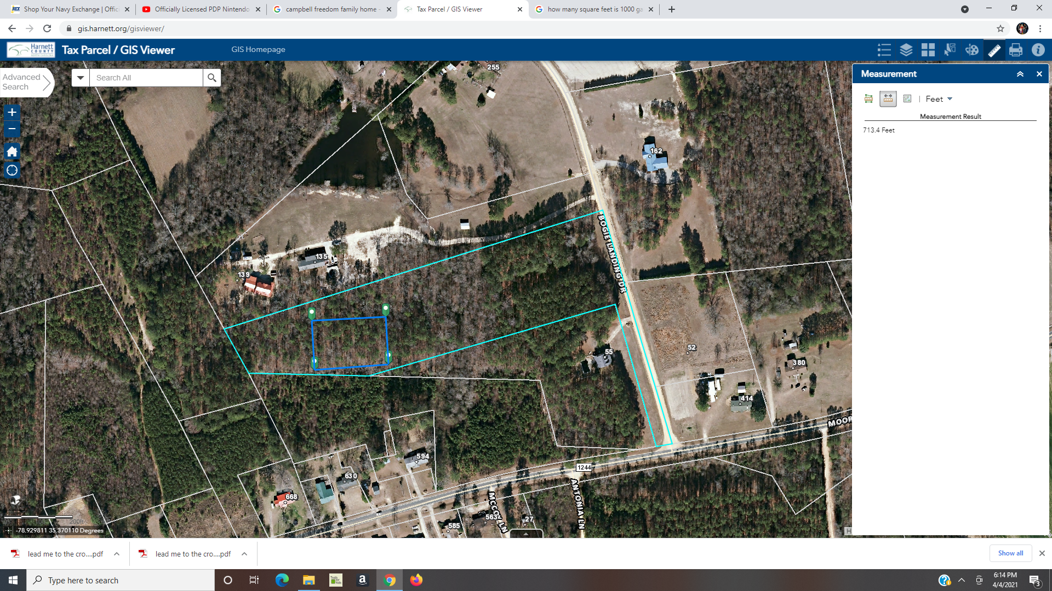

House

Driveway

216 ft

270 ft

189 ft

5 ft

54 ft