Application #

*Each section below must be filled out by whoever is performing the work. Must be owner or licensed contractor. Address, company name & phone must match information on state license.

Harnett County Central Permitting

420 McKinney Pkwy Lillington, NC 27546

PO Box 65 Lillington, NC 27546

910-893-7525 ext. 1 Fax 910-893-2793 [www.harnett.org/permits](http://www.harnett.org/permits)

**COMMERCIAL**

# Application for Building and Trades Permit

Owner’s Name:

Campbell 421 Boiler Plant Improvement Project

Date:

9/5/24

Site Address: 260 Leslie Campbell Ave, Buies Creek, NC 27506

Phone:

336-362-4422

Directions to job site from Lillington:

Campbell University campus - Bob Barker Hall

Subdivision: Lot:

Description of Proposed Work:

Installation of 2 HHW boilers and 2 DHW boilers for 100% redundancy on

external skid closure

Heated SF Unheated SF

**General Contractor Information:** Building Cost $

Building Contractor’s Company Name Telephone

Address Email Address

Signature of Owner/Contractor/Officer(s) of Corporation License #

**Electrical Contractor Information:** Electrical Cost $

82,940.00

Description of Work new electrical sub panel Service Size:

Amps #T-Poles

Brady Trane Service Inc 336-646-3567

Electrical Contractor’s Company Name Telephone

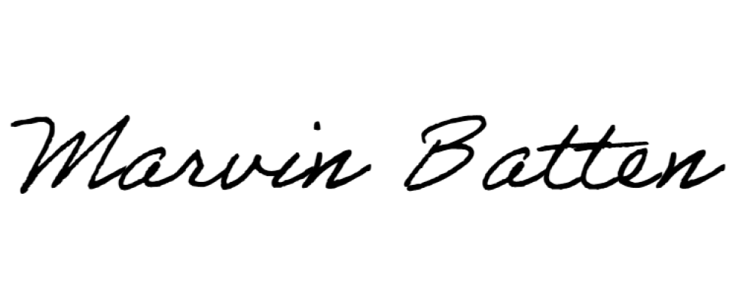2025 16th St, Greensboro, NC 27405 [marvin.batten@bradyservices.com](mailto:marvin.batten@bradyservices.com)

Address Email Address

16761-U

Signature of Owner/Contractor/Officer(s) of Corporation License #

**Mechanical Contractor Information:** Mechanical Cost $ 173,654.00

Description of Work Install 2 HHW & 2 DHW boilers

# Units 4

Brady Trane Service Inc 336-362-0981

Mechanical Contractor’s Company Name

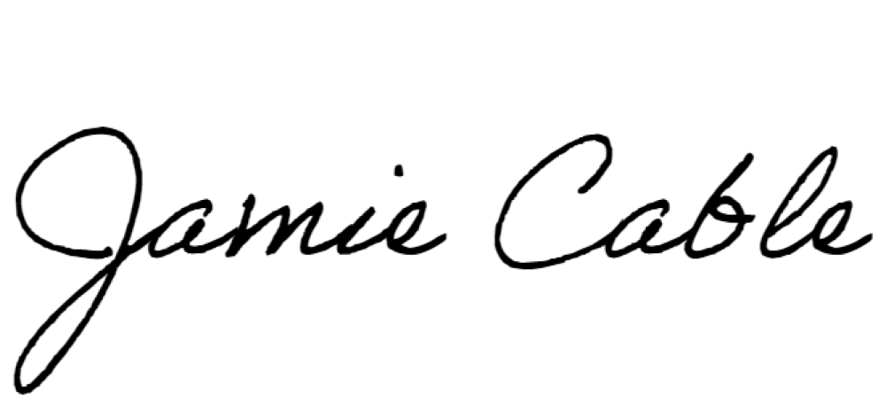2025 16th St, Greensboro, NC 27405

Telephone

[jamie.cable@bradyservices.com](mailto:jamie.cable@bradyservices.com)

Address Email Address

20378

Signature of Owner/Contractor/Officer(s) of Corporation License #

**Plumbing Contractor Information:** Plumbing Cost $

Description of Work # Baths

Plumbing Contractor’s Company Name Telephone

Address Email Address

Signature of Owner/Contractor/Officer(s) of Corporation License #

# Insulation Contractor Information

_

Insulation Contractor’s Company Name & Address Telephone

# *NOTE: General Contractor must fill out and sign the second page of this application

I hereby certify that I have the authority to make necessary application, that the application is correct and that the construction will conform to the regulations in the Building, Electrical, Plumbing and Mechanical codes, and the Harnett County Zoning Ordinance. I state the information on the above contractors is correct as known to me and if **any** changes occur including listed contractors, site plan, number of bedrooms, building and trade plans, Environmental Health permit changes or proposed use changes, I certify it is my responsibility to notify the Harnett County Central Permitting Department of any and all changes.

**Sprinkler Contractor Information**

Sprinkler Contractor’s Company Name Telephone

Address

Email Address

Signature of Officer(s) of Corporation License #

**Fire Alarm Contractor Information**

Fire Alarm Contractor’s Company Name

Telephone

Address

Email Address

Signature of Officer(s) of Corporation

License #

**Driveway Access** - NC Department of Transportation Driveway Access/Permit? Yes No

**Expired Permit Fees** - 6 months to 2 years permit re-issue fee is $150.00. After 2 years re-issue fee is charged at full price per current fee schedule.

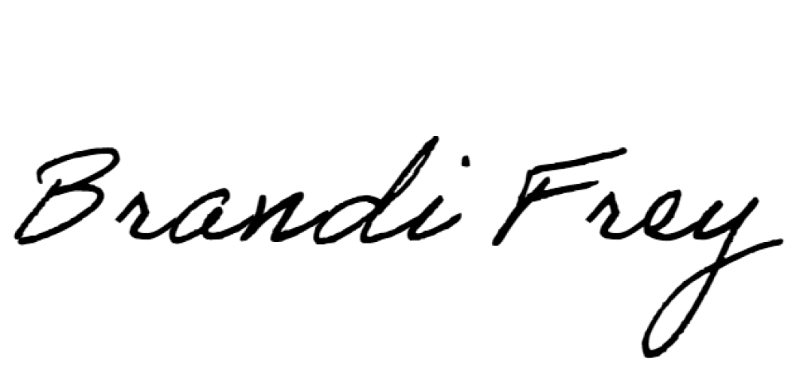9/5/24

Signature of Owner/Contractor/Officer(s) of Corporation Date

**Affidavit for Worker’s Compensation N.C.G.S. 87-14**

The undersigned applicant being the:

General Contractor Owner

X Officer/Agent of the Contractor or Owner

Do hereby confirm under penalties of perjury that the person(s), firm(s) or corporation(s) performing the work set forth in the permit:

X Has three (3) or more employees and has obtained workers’ compensation insurance to cover them.

Has one (1) or more subcontractors(s) and has obtained workers’ compensation insurance to cover

them.

X Has one (1) or more subcontractors(s) who has their own policy of workers’ compensation insurance

covering themselves.

Has no more than two (2) employees and no subcontractors.

While working on the project for which this permit is sought it is understood that the Central Permitting Department issuing the permit may require certificates of coverage of worker’s compensation insurance prior to issuance of the permit and at any time during the permitted work from any person, firm or corporation carrying out the work.

Company or Name: Brady Trane Services Inc

Sign w/Title: Date: 9/5/24