**Fire Marshal Division**

**September 2, 2025**

**Iglesia Restauracion**

**320 S Powell Avenue**

**Dunn, NC 28334**

To Whom It May Concern,

Thank you for submitting the plans for the change of use. The plans have been carefully reviewed by a qualified code enforcement official to examine for full compliance with the North Carolina Fire Prevention Code and all other fire protection regulatory documents. There are some items that were found during the plan review process that need to be addressed before a final inspection of the new facility can be given. These items are outlined and described below.

* **Fire Extinguishers**
* Fire Extinguishers shall be 2A:10BC and shall be placed with a travel distance to not exceed 75 feet.
* Fire extinguishers are to be mounted no higher than five feet above the finished floor.
* **Illumination Required**
* The exit discharge shall be illuminated at all times the building spaces served by the means of egress is occupied.
* Illumination level in all areas of the means of egress shall not be less than 1 foot-candle at the walking surface and shall have emergency power supply.
* **Exit Signs**
* Exit signs shall be installed at all required exits. Exit signs shall meet all provisions of the N.C. Fire Code.
* **Physical Address**
* Address numbers must be posted to the street front of the building and letters must be at least six inches in height.
* **Panic Hardware**
* Panic hardware is required on all exit doors due to the occupant load being over 50.
* **Knox Box**
* Keys for the front entrance door shall be provided in a knox box for the premises. The Knox box shall be installed near the front entrance on the outside of the building.
* **Notes**
* A final inspection will be needed once the building is ready for use. Please schedule the inspection through the Harnett County Planning Office.

Thank you again for submitting the plans for the change of use. Please review the plans and adhere to any notes and alterations that were made in addition to the original drawings. These remarks are for the plans that were submitted and its original intent. These remarks do not apply if the original intent changes or what was submitted on the above date changes. If you have any questions, please do not hesitate to call this office

Again, thank you and we look forward to working with you during the construction period!

Sincerely,

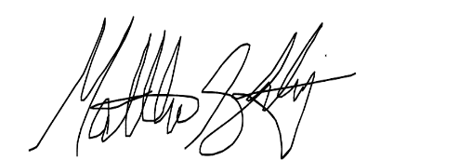

Matthew Starling

Deputy Fire Marshal

910-893-0742

[mstarling@harnett.org](mailto:mstarling@harnett.org)