May 23, 2025

Shelby Blackmon
PO Box 47
Angier, NC 27501

Re: Crepe Myrtle Celebration
19 West Depot St.
Angier, NC 27501

Application Number – FMFW2505-0010

To whom may concern

Thank you for submitting the plans for the Crepe Myrtle Celebration. The plans have been carefully reviewed by a qualified code enforcement official to examine for full compliance with the North Carolina Fire Prevention Code and all other fire protection regulatory documents. There are some items that were found during the plan review process that need to be addressed before a final inspection of the new facility can be given. These items are outlined and described below.

- Permits
  - A permit will be issued for the special assembly that will include the event as a whole.
  - A permit may be issued for other tent areas if the individual tent exceeds 800 ft2 or the aggregate area of multiple canopies placed side by side without a fire break clearance of 12’
- Fire Extinguishers
  - Portable fire extinguishers shall be provided within a 30-foot (9144 mm) travel distance of commercial-type cooking equipment. Cooking equipment involving vegetable or animal oils and fats shall be protected by a Class K rated portable extinguisher.
  - 2A-10B:C fire extinguisher shall be placed at tents/canopies with a travel distance not to exceed 100’ from any fire extinguisher

Outdoor cooking.
  - Outdoor cooking that produces sparks or grease-laden vapors shall not be performed within 20 feet (6096 mm) from a tent, air-supported, air-inflated or tensioned membrane structure, temporary membrane structure or canopy
  - Tents utilized for cooking should be flame resistant.

- Generators
  - Generators and other internal combustion power sources shall be separated from tents, air-supported, air-inflated or tensioned membrane structures, temporary membrane structures or canopies by a minimum of 20 feet (6096 mm) and shall be isolated from contact with the public by fencing, enclosure or other approved means.

Refueling.
  - Refueling shall be performed in an approved location not less than 20 feet (6096 mm) from tents, air-supported, air-inflated or tensioned membrane structures, temporary membrane structures or canopies.

- Permits
  - Final inspection will be conducted that day of the event and the permit will be issued
- Combustible materials.
- Hay, straw, shavings or similar combustible materials shall not be located within any tent or air-supported structure containing an assembly occupancy, except the materials necessary for the daily feeding and care of animals. Sawdust and shavings utilized for a public performance or exhibit shall not be prohibited provided the sawdust and shavings are kept damp. Combustible materials shall not be permitted under stands or seats at any time. The areas within and adjacent to the tent or air-supported structure, shall be maintained clear of all combustible materials or vegetation that could create a fire hazard within 20 feet (6096 mm) from the structure. Combustible trash shall be removed at least once a day from the structure during the period the structure is occupied by the public.
- Setup
  - You may contact our office for a representative to meet on site during setup for any additional questions that may arise. (910-893-0740)

Thank you again for submitting the plans for Crepe Myrtle Celebration. Please review the plans and adhere to any notes and alterations that were made in addition to the original drawings. If you have any questions, please do not hesitate to call this office.

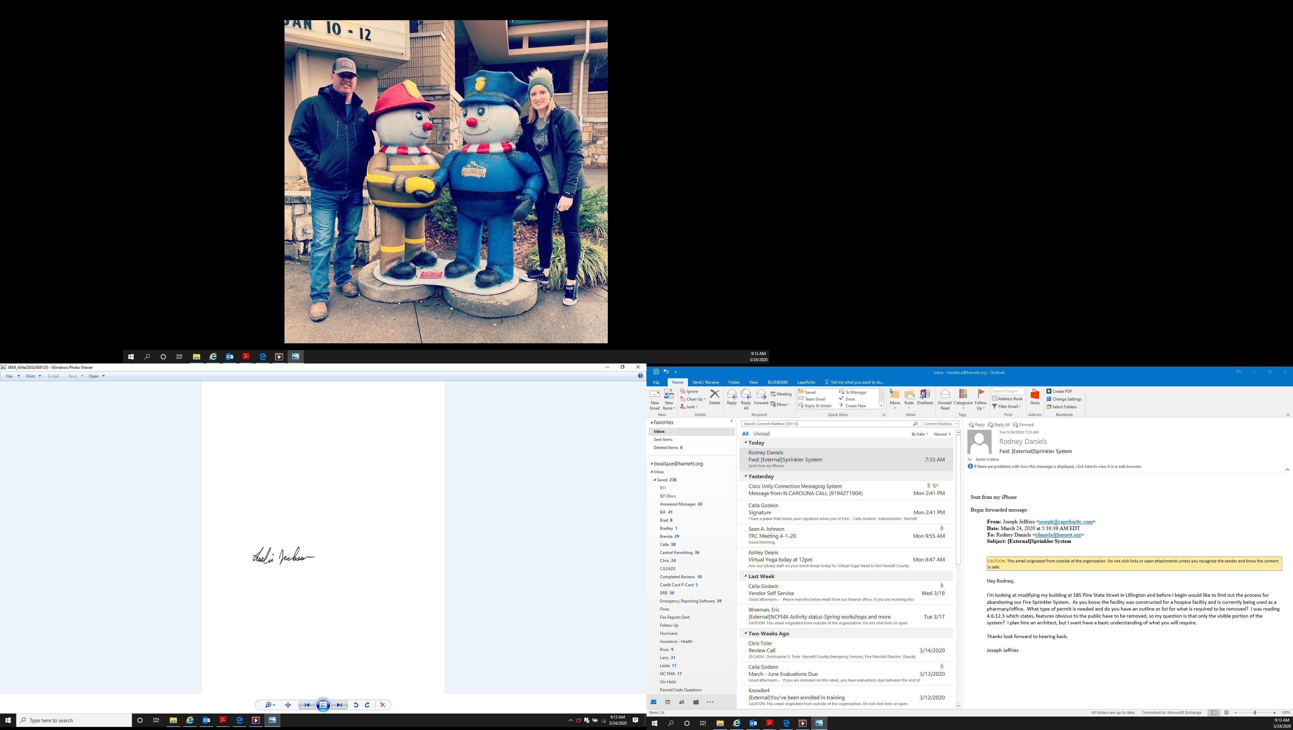
Sincerely,

Leslie Jackson
Chief Deputy Fire Marshal
lrjackson@harnett.org

