Fire Marshal Division

May 7, 2025

American Promotional Events Inc.
Dannett Crowe
PO Box 4625
Wilmington, NC 28403

RE: TNT Fireworks
1665 Buffalo Lake Rd.
Sanford, NC 27332

To Whom It May Concern,

Thank you for submitting the plans for the fireworks tent. The plans have been carefully reviewed by a qualified code enforcement official to examine for compliance with the North Carolina Fire Prevention Code and all other fire protection regulatory documents. There are some items that were found during the plan review process that need to be addressed before a final inspection of the new facility can be given. These items are outlined and described below.

- Fire Extinguishers
- Properly install/hang the required fire extinguishers.
- Fire extinguishers shall have a minimum rating of 2A10:BC and (1) water extinguisher.
- Fire extinguishers shall be tagged by a fire extinguisher company.

- Exits
- Exits shall be clearly identified by approved exit signs.
- The required exits shall be maintained at all times to the public way.

- Label
- The tent shall have permanently affixed label bearing the identification of size and material type.

- Certification
- Documentation that attest to the flame propagation performance criteria of the tent fabric shall be retained onsite.

- Smoking
- Smoking shall not be allowed in the tent.
- Approved “NO Smoking” signs shall be conspicuously posted in tent.

- Open Flames
- No open flame devices are allowed under the tent.

- Combustible Vegetation
- Combustible vegetation that could create a fire hazard shall be removed from the area.
- Minimum clearance of 30 feet is required.

- Combustible waste
- Areas under the tent shall be kept free of combustible waste/material that could create a fire hazard.
- Waste should be stored in approved containers and removed daily while the tent is occupied by the public.

- Access
- Tent shall be placed to allow approved fire apparatus access in the event of an emergency.

- Notes
- Please contact the Fire Marshal’s Office for all fire inspections 910-893-0740.
- A site/tent inspection is required before sales can begin.
- The require tent permit will be issued onsite.

Thank you again for submitting the plans for the fireworks tent. Please review the plans and adhere to any notes and alterations that were made in addition to the original drawings. These remarks are for the plans that were submitted and its original intent. These remarks do not apply if the original intent changes or what was submitted on the above date changes. If you have any questions, please do not hesitate to call this office.

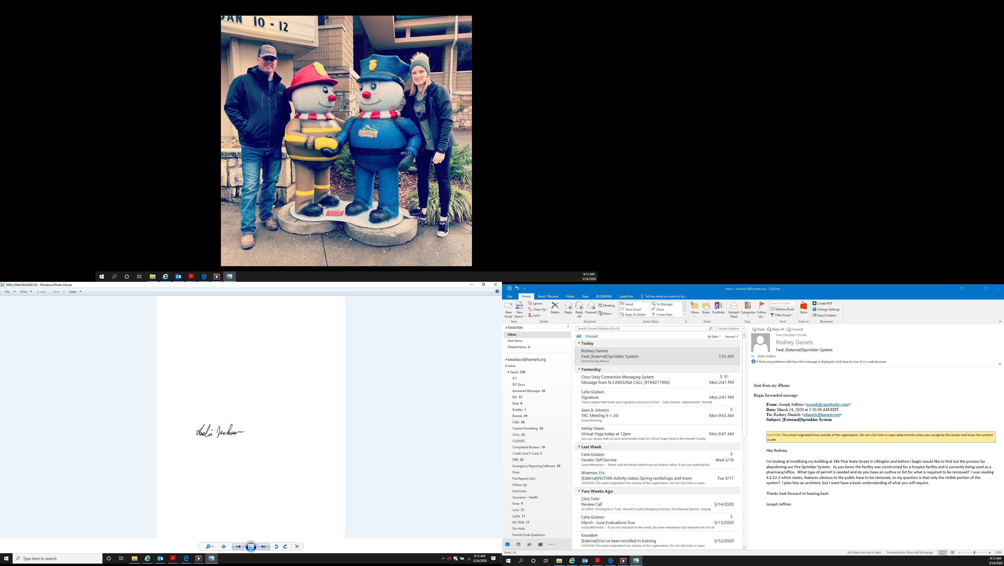
Sincerely,

Leslie Jackson
Chief Deputy Fire Marshal
lrjackson@harnett.org

