Fire Marshal Division

September 6, 2024

Fire Protection
1048 Bragg Blvd.
Fayetteville, NC 28301

Re: Cape Fear Conference
25 Beaver Rd.
Erwin, NC 28339

Application Number – FMFW2409-0001

To Whom It May Concern,

Thank you for submitting the plans for the hood system. The plans have been carefully reviewed by a qualified code enforcement official to examine for compliance with the North Carolina Fire Prevention Code and all other fire protection regulatory documents. There are some items that were found during the plan review process that need to be addressed before a final inspection of the new facility can be given. These items are outlined and described below.

- Commercial cooking equipment.
  - Portable fire extinguishers shall be provided within a 30-foot travel distance of commercial-type cooking equipment. Cooking equipment involving vegetable or animal oils and fats shall be protected by a Class K rated portable extinguisher.
- Acceptance Test
- An acceptance test will be conducted by the Fire Marshal’s office once system has been installed and pre-tested.
- Installation shall be per architectural and system submittals and compliant with NFPA-17A.
- Manual system operation
  - A manual actuation device shall be located at or near a means of egress from the cooking area, a minimum of 10 feet and a maximum of 20 feet from the kitchen exhaust system. The manual actuation device shall be located a minimum of 42in and a maximum of 4 above the floor. The manual actuation shall require a maximum force of 40 pounds (178 N) and a maximum movement of 14 inches to actuate the fire suppression system.
- System Interconnection
  - The actuation of the fire suppression system shall automatically shut down the fuel or electrical power supply to equipment under the hood system. The fuel and electrical supply reset shall be manual.
- Notes
- Please schedule all fire inspections through the Fire Marshal’s Office.
- Contact Number 910-893-0740.
- Please provide system certification certificate from installing contractor.

Thank you again for submitting the plans for the hood system. Please review the plans and adhere to any notes and alterations that were made in addition to the original drawings. These remarks are for the plans that were submitted and its original intent. These remarks do not apply if the original intent changes or what was submitted on the above date changes. If you have any questions, please do not hesitate to call this office.

Again, thank you and we look forward to working with you during the construction period!

Sincerely,
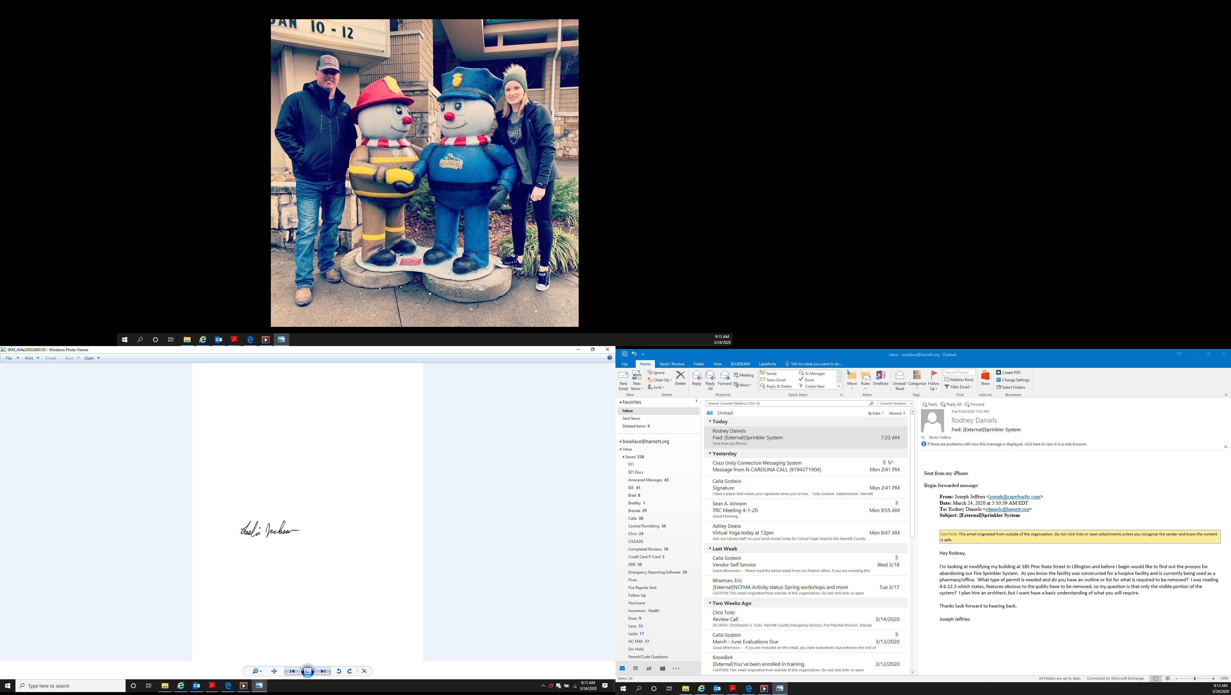

Leslie Jackson
Chief Deputy Fire Marshal
lrjackson@harnett.org

