Fire Marshal Division

December 6, 2023

Ashley Rosado
Interplan LLC
220 East Central Parkway, Suite 4000
Altamonte Springs, FL 32701

Re: Food Lion #595
8 The Square at Lillington
Lillington, NC 27546

Application Number – FMFW2310-0004

To whom may concern,

Thank you for submitting the plans for the Food Lion renovations. The plans have been reviewed by a qualified code enforcement official to examine for compliance with the North Carolina Fire Prevention Code and all other fire protection regulatory documents. There are some items that were found during the plan review process that need to be addressed before a final inspection of the new facility can be given. These items are outlined and described below.

If any devices listed below are relocated or new equipment is installed specs and drawings will need to be summitted for review.

Fire Alarm Systems
- Provide shop drawings from the installing contractor if there are any modifications to the system.
- Shop drawings shall include all information listed in section of the North Carolina Fire Prevention Code.
- System additions and modifications shall be in accordance with NFPA 72.

Sprinkler Systems
- Provide sprinkler shop drawings from the installing contractor if there is any modifications to the system.
- System additions and modifications shall be in accordance with NFPA 13.

Fixed Fire Suppression Systems
- Provide system design/drawings for the hood suppression system from the installing contractor for any modifications under the hood system.
- System design and performance shall be in accordance with NFPA 17A.
- A system test and mechanical performance test is required if applicable.

Fire Extinguishers
- Fire extinguishers shall be installed per the N.C. Fire Code and NFPA 10.
- A class K extinguisher is required in the deli/bakery area.

Notes
- Please call 910-893-0740 to schedule all Fire Marshal inspections.
- If life safety systems are required to be disabled during the project please notify the Fire Marshal’s office.

Thank you again for submitting the plans for the Food Lion. Please review the plan review notes and if you have any questions, please do not hesitate to call this office.

Sincerely,
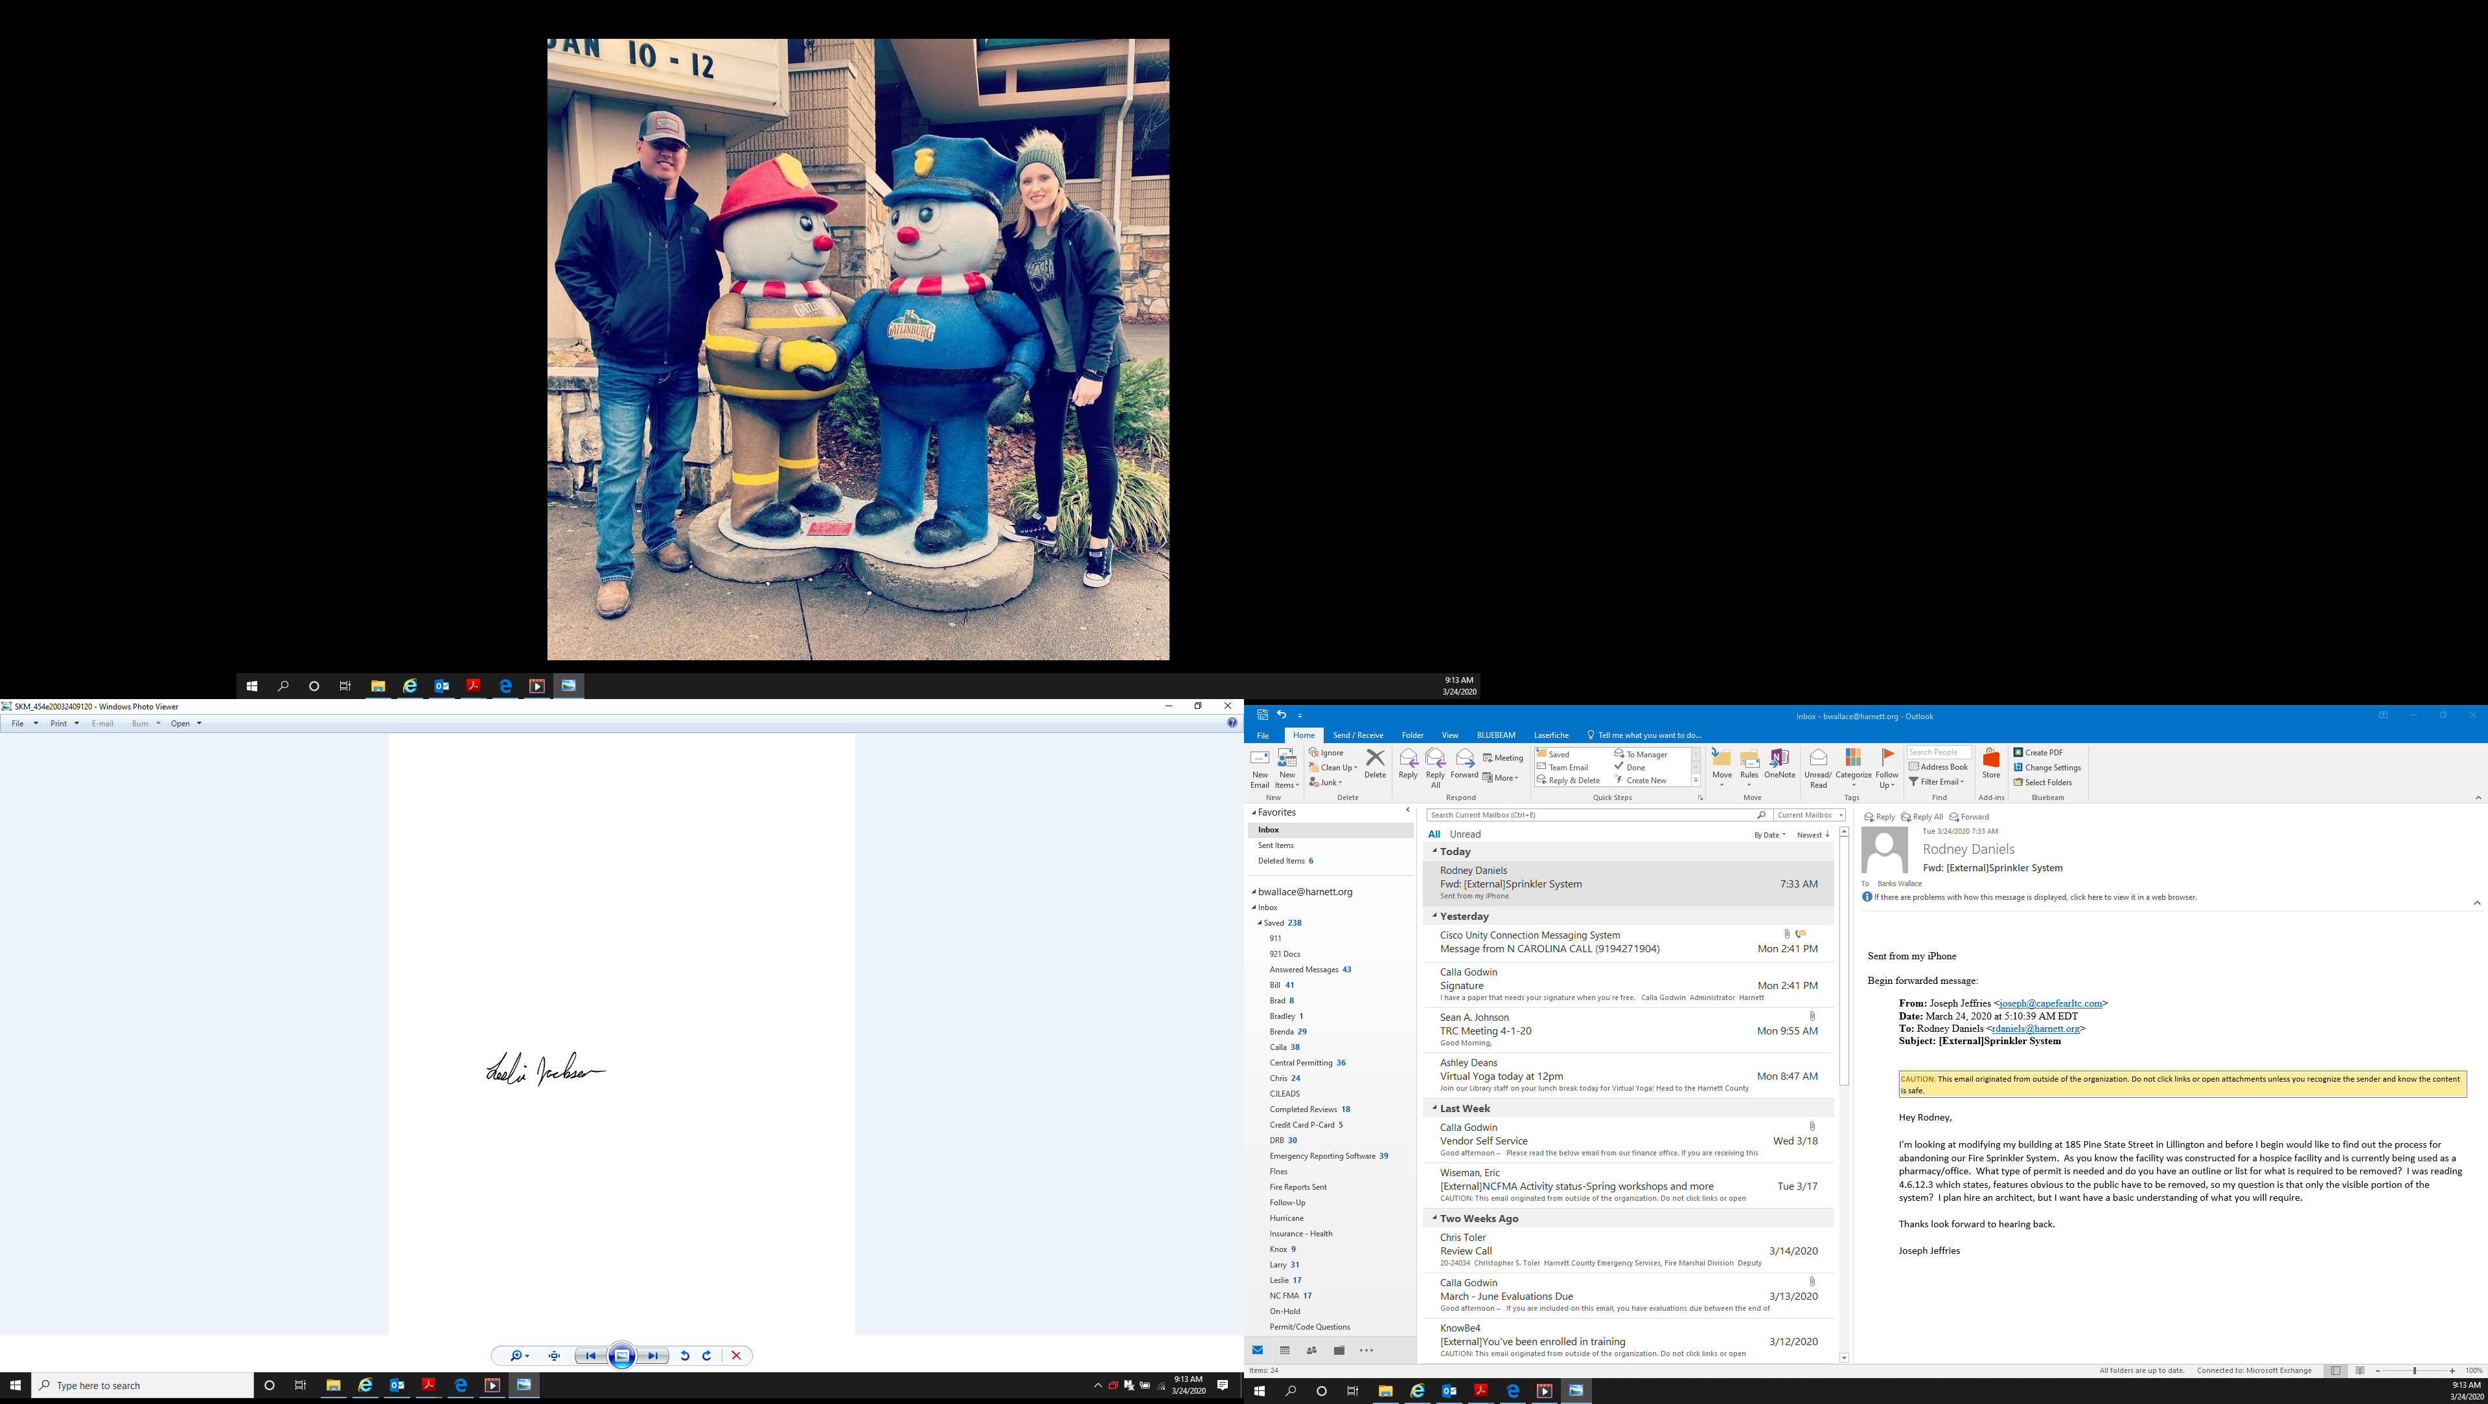

Leslie Jackson
Chief Deputy Fire Marshal
lrjackson@harnett.org

