Fire Marshal Division

October 7, 2022

SR&R Environmental
4920 US Highway 421 N
Wilmington, NC 28401

Re: 4798 US 55
Angier, NC 27501

Application Number: FMFW2210-0002

To Whom It May Concern,

Thank you for submitting the plans for the 2 tank removal. The plans have been carefully reviewed by a qualified code enforcement official to examine for compliance with the North Carolina Fire Prevention Code and all other fire protection regulatory documents. There are some items that were found during the plan review process that need to be addressed before a final inspection of the new facility can be given. These items are outlined and described below.

- Guidance
  - The removal of the tanks shall follow the applicable requirements in NFPA 30 (Annex C.5), API 2015, NFPA 226, and the Fire Code.

- Procedures
  - Combustible liquids shall be removed from the tank and connected piping.
  - Piping at tank openings that is not to be used further shall be disconnected.
  - Piping shall be removed from the ground (if applicable).
  - Tank openings shall be capped or plugged, leaving a _{1/8} to ¼ inch gap for pressure equalization.
  - Tanks shall be purged of vapor and inerted prior to removal, until an LEL of 10 % or lower is achieved
  - All tanks shall be marked indicating type of product that was stored, date of removal, and the word “EMPTY”

- Closure Report
  - A closure report shall be submitted to the Fire Marshal’s Office after the removal of the tanks. The closure report shall detail any possible contamination of the property resulting from the tanks and the appropriate response. The destination of the removed tanks must also be noted.

Tanks to be Removed (2 tank total):
1 – 3,000 Gallons
1 – 6,000 Gallons

General Notes
Contact our office at (910) 893-0740 to witness the removal of the tanks and the tests associated with the tanks and piping attached to tanks. A Fire Inspector must be onsite to perform these tests.

Thank you again for submitting the plans for 2 tank removals. Please review the plans and adhere to any notes and alterations that were made in addition to the original drawings. These remarks are for the plans that were submitted and its original intent. These remarks do not apply if the original intent changes or what was submitted on the above date changes. If you have any questions, please do not hesitate to call this office.

Again, thank you and we look forward to working with you during the construction period!

Sincerely,
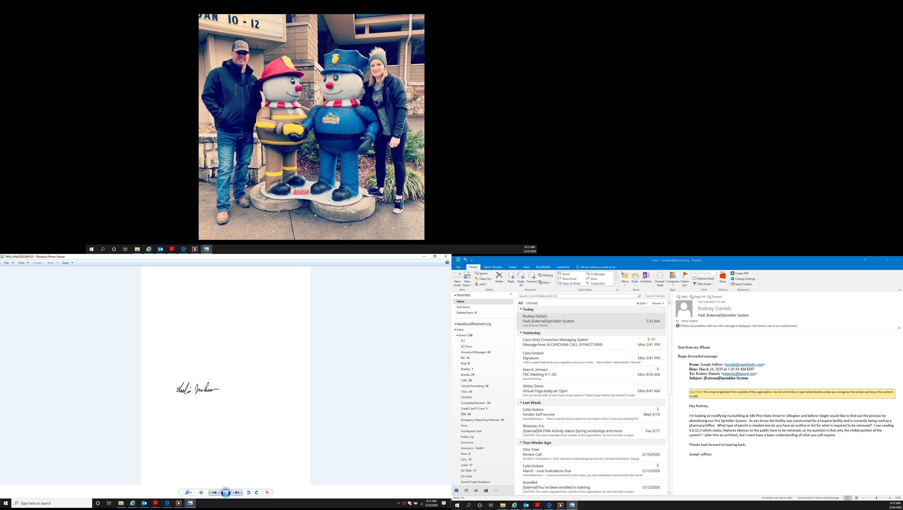

Leslie Jackson
Chief Deputy Fire Marshal
lrjackson@harnett.org

