Fire Marshal Division
March 16, 2022

Re: Flat Branch FD
2098 Elliott Bridge Rd.
Bunnlevel, NC 28323

Application Number FMFW2203-0005

To Whom It May Concern,

Thank you for submitting the plans for the tank installation. The plans have been carefully reviewed by a qualified code enforcement official to examine for compliance with the North Carolina Fire Prevention Code and all other fire protection regulatory documents. There are some items that were found during the plan review process that need to be addressed before a final inspection of the new facility can be given. These items are outlined and described below.

After permit is issued and before final approval:
- 3404.2.3.1 Smoking and Open Flames
  - Signs shall be posted in storage and dispensing areas. Signs shall comply with Section 3403.5

- 3404.2.9.6.5 Vehicle Impact Protection
  - Where any portions of the fuel storage or dispensing components are subject to vehicular impact, they shall be protected therefrom, either by having the impact protection incorporated into the system design in compliance with the impact test protocol of UL 2085, or by meeting the provisions of Section 312 NCFC , or where necessary, a combination of both. Where guard posts or other approved barriers are provided.

- Testing of Dispensers
  - After initial pipe testing and setting of dispensers, the dispensers will be examined and tested.

- Installation shall be in accordance with all North Carolina Fire prevention codes and NFPA 30 standards.
- All hydrostatic and pressure tests for tanks and piping shall be witnessed by the Fire Marshal’s Office.
- Contact the Fire Marshal’s Office to witness the setting of tanks.
- A final Fire inspection is required at the end of the project.
- Call (910) 893-0740 to schedule all fire inspections.

Tanks to be Installed (1 tank total):
1000 Gallon Diesel

Thank you again for submitting the plans for the tank installation. Please review the plans and adhere to any notes and alterations that were made in addition to the original drawings. These remarks are for the plans that were submitted and its original intent. These remarks do not apply if the original intent changes or what was submitted on the above date changes. If you have any questions, please do not hesitate to call this office.

Again, thank you and we look forward to working with you during the construction period!

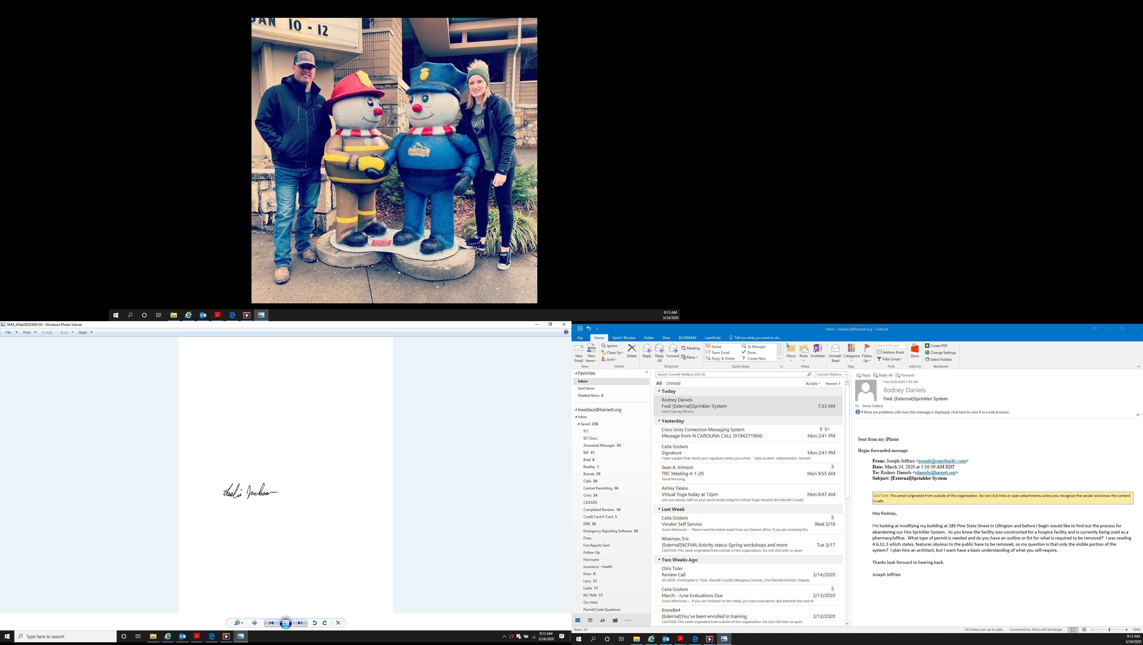
Sincerely,

Leslie Jackson
Chief Deputy Fire Marshal

