Fire Marshal Division

April 5, 2022

Southeastern Construction
PO Box 4200
Buies Creek, NC 27506

Re: John Heister
940 N Main St.
Lillington, NC 27546

Application Number FMFW2202-0007

To Whom It May Concern,

Thank you for submitting the plans for the addition at John Heister. The plans have been carefully reviewed by a qualified code enforcement official to examine for compliance with the North Carolina Fire Prevention Code and all other fire protection regulatory documents. There are some items that were found during the plan review process that need to be addressed before a final inspection of the new facility can be given. These items are outlined and described below.

Plan Review Notes

- Fire Extinguishers
- All fire extinguishers shall be properly mounted and tagged by a fire extinguisher company.

- Knox Box
- If there is not a complex Knox Box a Knox Box will need to be installed on the building.

- Address Numbers
- Install physical address numbers on the building.
- The numbers are to be visible from the street.

- Duct Smoke detectors/ Smoke Detectors
- Smoke detectors installed in ducts shall be listed for the air velocity, temperature and humidity present in the duct. Duct smoke detectors

shall be connected to the building’s fire alarm control unit when a fire alarm system is required

- 907.1.2 Fire Alarm System Design
- Provide fire alarm shop drawings from the installing fire alarm company.
- Plans should be submitted prior to installation.
- A fire alarm construction permit is required.
- A fire alarm acceptance test for all new devices is required.

Notes

- All new duct detectors will be required to be tested.
- All fire inspection request should be made through the Fire Marshal’s Office.
- (910) 893-0740

Thank you again for submitting the plans for the addition at John Heister. Please review the plan review notes and if you have any questions, please do not hesitate to call this office.

Sincerely,
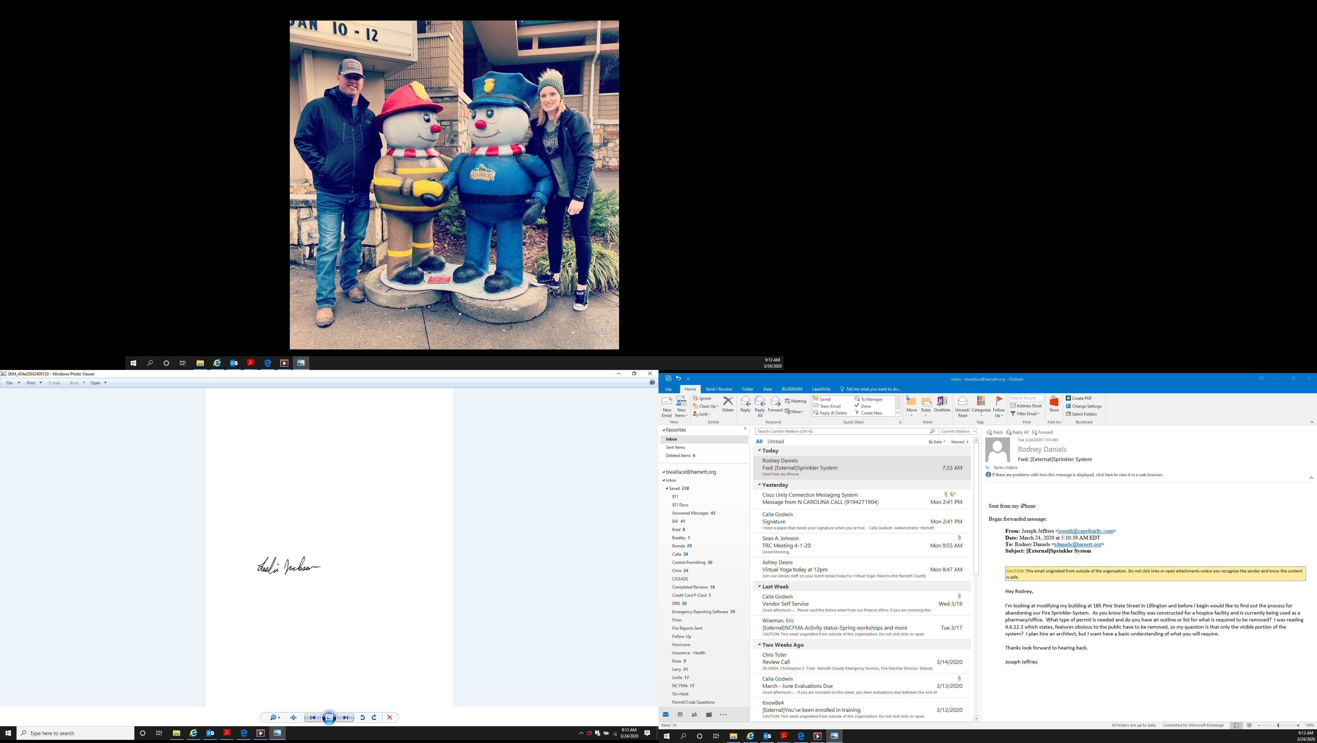

Leslie Jackson
Chief Deputy Fire Marshal
lrjackson@harnett.org

