Fire Marshal Division

October 26, 2021

Re: Carolina Charter Academy Gym
8529 NC 55 Hwy
Angier, NC 27501

Application Number FMFW2110-0007

To Whom It May Concern,

Thank you for submitting the plans for the Carolina Charter Academy Gym. The plans have been carefully reviewed by a qualified code enforcement official to examine for compliance with the North Carolina Fire Prevention Code and all other fire protection regulatory documents. There are some items that were found during the plan review process that need to be addressed before a final inspection of the new facility can be given. These items are outlined and described below.

- 906.1 Fire Extinguishers
- 2A10:BC fire extinguisher shall be installed not to exceed 75’ distance of travel. All Fire extinguishers shall be properly mounted and tagged by a fire extinguisher company.
- 1006.1 Means of Egress Illumination
- The means of egress, including the exit discharge, shall be illuminated at all time the building space is served by the means of egress is occupied.
  - Means of egress consist of three separate and distinct parts: the exit access, the exit and the exit discharge.
- The means of egress illumination shall not be less than 1 foot-candle at the walking surface.

- 105.7.5 Fire alarm construction permits.
  - A construction permit is required for the fire alarm installation. Submit complete shop drawings consistent with the architectural design documents and specifications. Shop drawings shall include detail as described in Section 907.1.2 of the NC State Fire Code. Contractor must obtain the construction permit for the fire alarm system before commencement of any work.
    - A rough in inspection is required.
    - A final acceptance test is required. (100%)

- 901.2.1 State of Compliance.
  - Before requesting final approval of the installation, where required by the fire code official, the installing contactor shall furnish a written statement to the fire code official that the subject fire protection system has been installed in accordance with the manufacture’s specifications and the appropriate installation standard. Any deviations from the design standards shall be noted and copies of the approvals for such deviations shall be attached to the written statement.

- 907.4.1 Duct Smoke detectors.
  - Smoke detectors installed in ducts shall be listed for the air velocity, temperature and humidity present in the duct. Duct smoke detectors shall be connected to the building’s fire alarm control unit when a fire alarm system is required by Section 907.2. Activation of a duct smoke detector shall initiate a visible and audible supervisory signal at a constantly attended location and shall perform the intended fire safety function in accordance with this code and the International Mechanical Code. Duct smoke detectors shall not be used as a substitute for required open area detection.

- 703.5 Identification
- Walls and partitions required to have protected openings shall be permanently identified with signs or stencils. (Example “2- hour Fire Barrier Protect All Openings”)

- Notes
- A final fire inspection is required.
- Schedule all fire inspections through the Fire Marshal’s Office.
(910) 893-0740

Thank you again for submitting the plans for the Carolina Charter Academy Gym. Please review the plans and adhere to any notes and alterations that were made in addition to the original drawings. These remarks are for the plans that were submitted and its original intent. These remarks do not apply if the original intent changes or what was submitted on the above date changes. If you have any questions, please do not hesitate to call this office.

Sincerely,
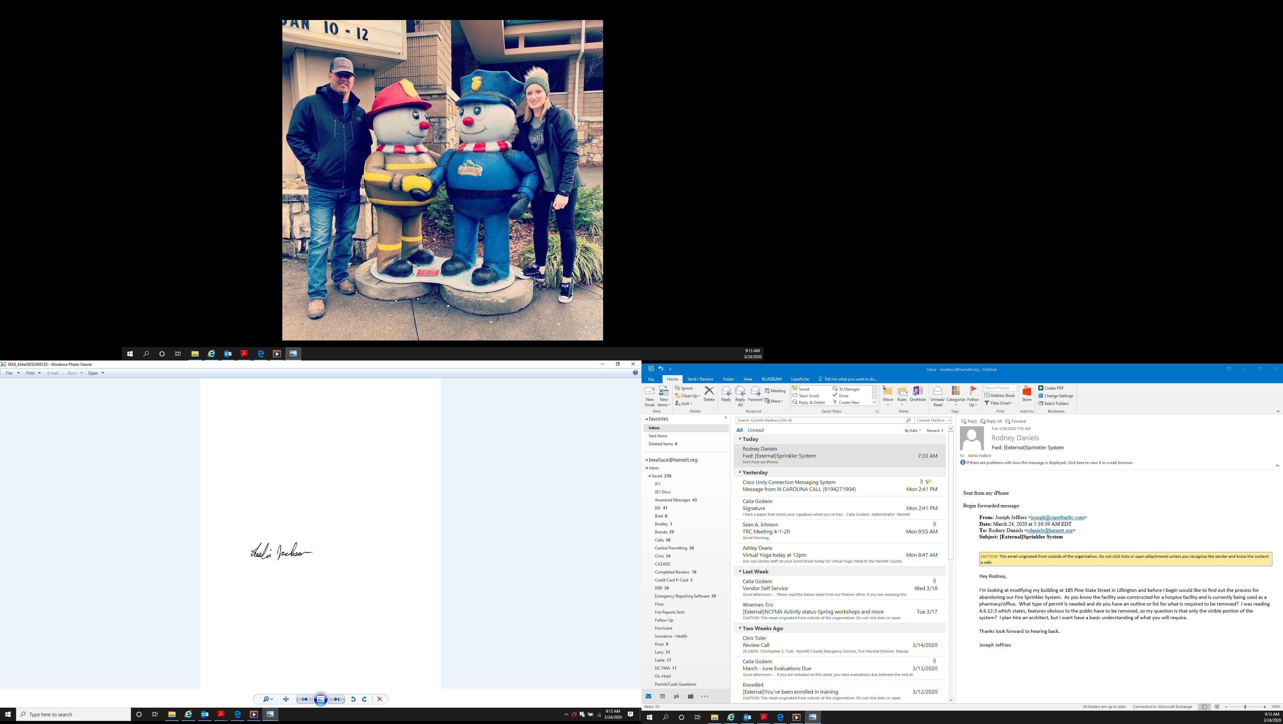

Leslie Jackson
Chief Deputy Fire Marshal

