Fire Marshal Division

October 22, 2021

Gill Security
818 Rasmsey St.
Fayetteville, NC 28301

Re: Kidzzone
600 Kivett Rd.
Lillington, NC 27546

Application Number FMFW2110-0005

To Whom It May Concern,

Thank you for submitting the fire alarm system upgrade. The request for change has been carefully reviewed by a qualified code enforcement official to examine for compliance with the North Carolina Fire Prevention Code and all other fire protection regulatory documents. There are some items that need to be addressed before a final inspection of the new panel can be given. These items are outlined and described below.

- Fire Alarm System Upgrade Notes

All items in notes are to be completed at the time of final.
- Provide a record of completion.
- The Fire marshal’s office will complete an acceptance test at completion of project.
- Provide a copy of account history after the acceptance test is completed and approve.
- Provide an accurate zone map at the FACP and remote annunciator panel.
- All work/installation shall be compliant with the NCSFC and NFPA 72.
- Call Fire Marshal’s office to schedule the fire alarm acceptance test. (910-893-0740)

Thank you again for submitting the fire alarm system upgrade. Please review and adhere to any notes. These remarks are for the paperwork that was submitted and its original intent. These remarks do not apply if the original intent changes or what was submitted on the above date changes. If you have any questions, please do not hesitate to call this office.

Again, thank you and we look forward to working with you during the construction period!

Sincerely,
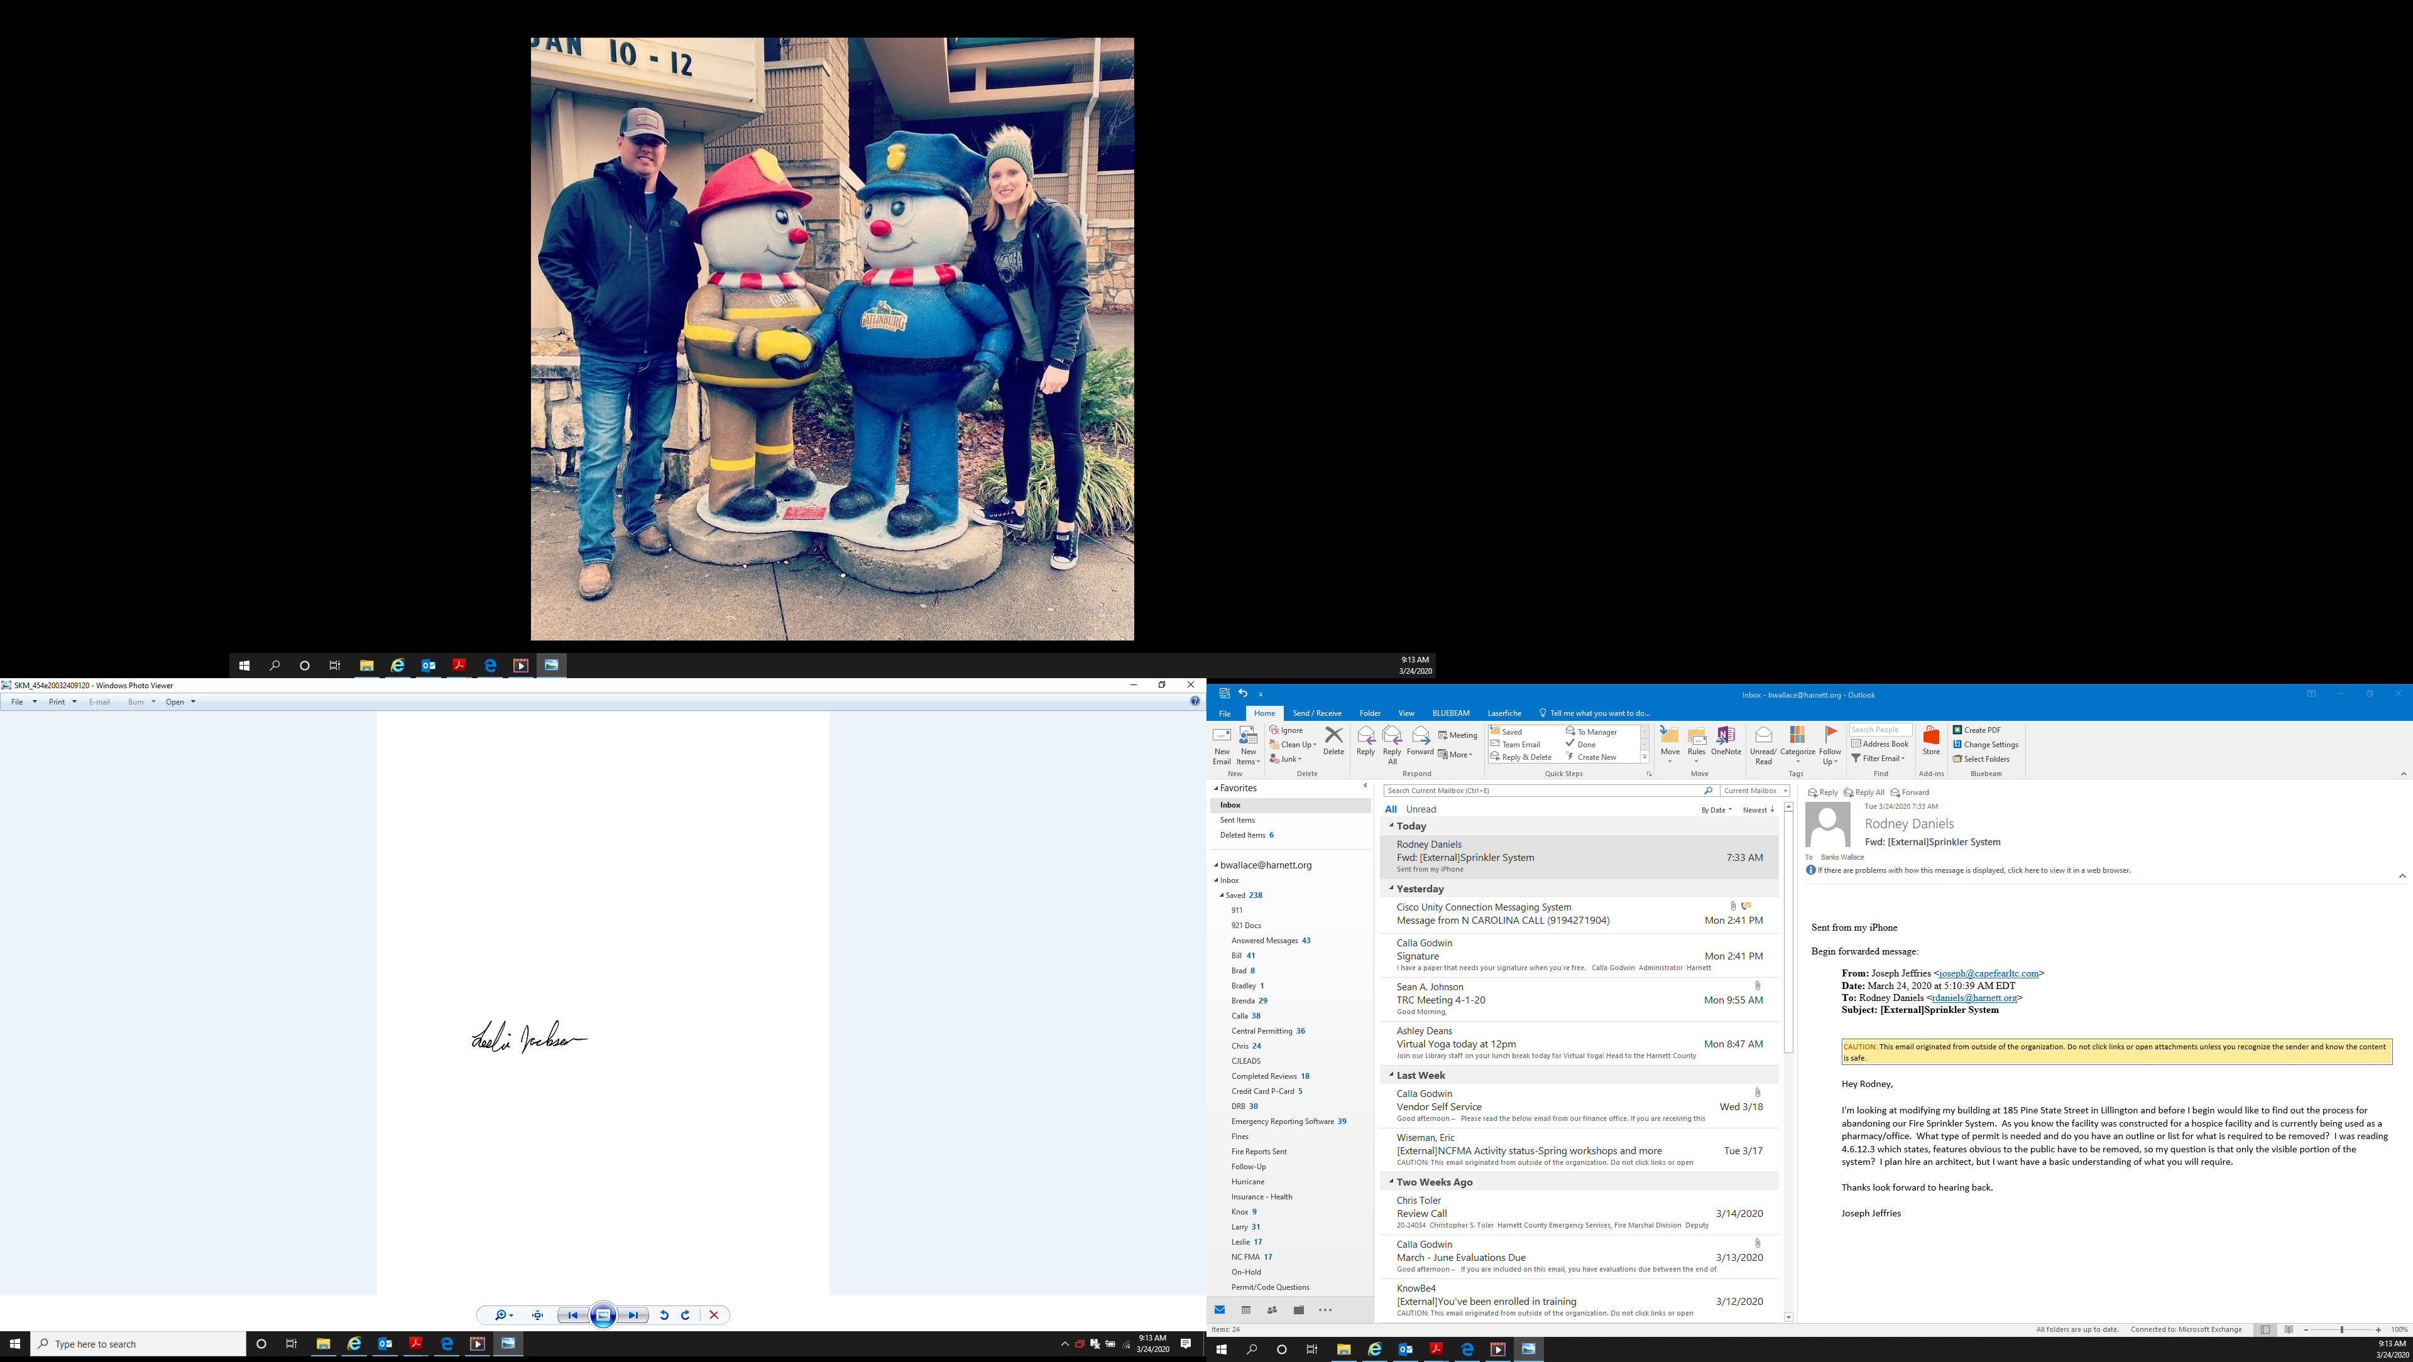

Leslie Jackson
Chief Deputy Fire Marshal

