Fire Marshal Division

August 16, 2021

Karen Parkes
Campbell University
95 Dr. McKoy Rd., Suite 2
Buies Creek, NC 27506

Re: Campbell University Street Fair
56 Main St.
Buies Creek, NC 27506

Application Number: FMFW2108-0003

Mrs. Parkes,

Thank you for submitting the plans for the street fair. The plans have been carefully reviewed by a qualified code enforcement official to examine for compliance with the North Carolina Fire Prevention Code and all other fire protection regulatory documents. There are some items that were found during the plan review process that need to be addressed before a final inspection of the new facility can be given. These items are outlined and described below.

- Permits
  - A permit will be issued for the special assembly that will include the event as a whole.
  - A permit may be issued for other tent areas if the individual tent exceeds 700 ft2 or the aggregate area of multiple canopies placed side by side without a fire break clearance of 12’

- Fire Extinguishers
  - Portable fire extinguishers shall be provided within a 30-foot (9144 mm) travel distance of commercial-type cooking equipment. Cooking equipment involving vegetable or animal oils and fats shall be protected by a Class K rated portable extinguisher.
  - 2A-10B:C fire extinguisher shall be placed at tents/canopies with a travel distance not to exceed 100’ from any fire extinguisher

2411.6 Outdoor cooking.
  - Outdoor cooking that produces sparks or grease-laden vapors shall not be performed within 20 feet (6096 mm) from a tent, air-supported, air-inflated or tensioned membrane structure, temporary membrane structure or canopy.
- 2415 Generators
  - Generators and other internal combustion power sources shall be separated from tents, air-supported, air-inflated or tensioned membrane structures, temporary membrane structures or canopies by a minimum of 20 feet (6096 mm) and shall be isolated from contact with the public by fencing, enclosure or other approved means.

2413.3 Refueling.
  - Refueling shall be performed in an approved location not less than 20 feet (6096 mm) from tents, air-supported, air-inflated or tensioned membrane structures, temporary membrane structures or canopies.

- Permits
  - Final inspection will be conducted that day of the event and the permit will be issued.
- 2406.4 Combustible materials.
  - Hay, straw, shavings or similar combustible materials shall not be located within any tent or air-supported structure containing an assembly occupancy, except the materials necessary for the daily feeding and care of animals. Sawdust and shavings utilized for a public performance or exhibit shall not be prohibited provided the sawdust and shavings are kept damp. Combustible materials shall not be permitted under stands or seats at any time. The areas within and adjacent to the tent or air-supported structure, shall be maintained clear of all combustible materials or vegetation that could create a fire hazard within 20 feet (6096 mm) from the structure. Combustible trash shall be removed at least once a day from the structure during the period the structure is occupied by the public.

Thank you again for submitting the plans for Street Fair. Please review the plans and adhere to any notes and alterations that were made in addition to the original drawings. These remarks are for the plans that were submitted and its original intent. These remarks do not apply if the original intent changes or what was submitted on the above date changes. If you have any questions, please do not hesitate to call this office.

Again, thank you and we look forward to working with you during the special event!

Sincerely,
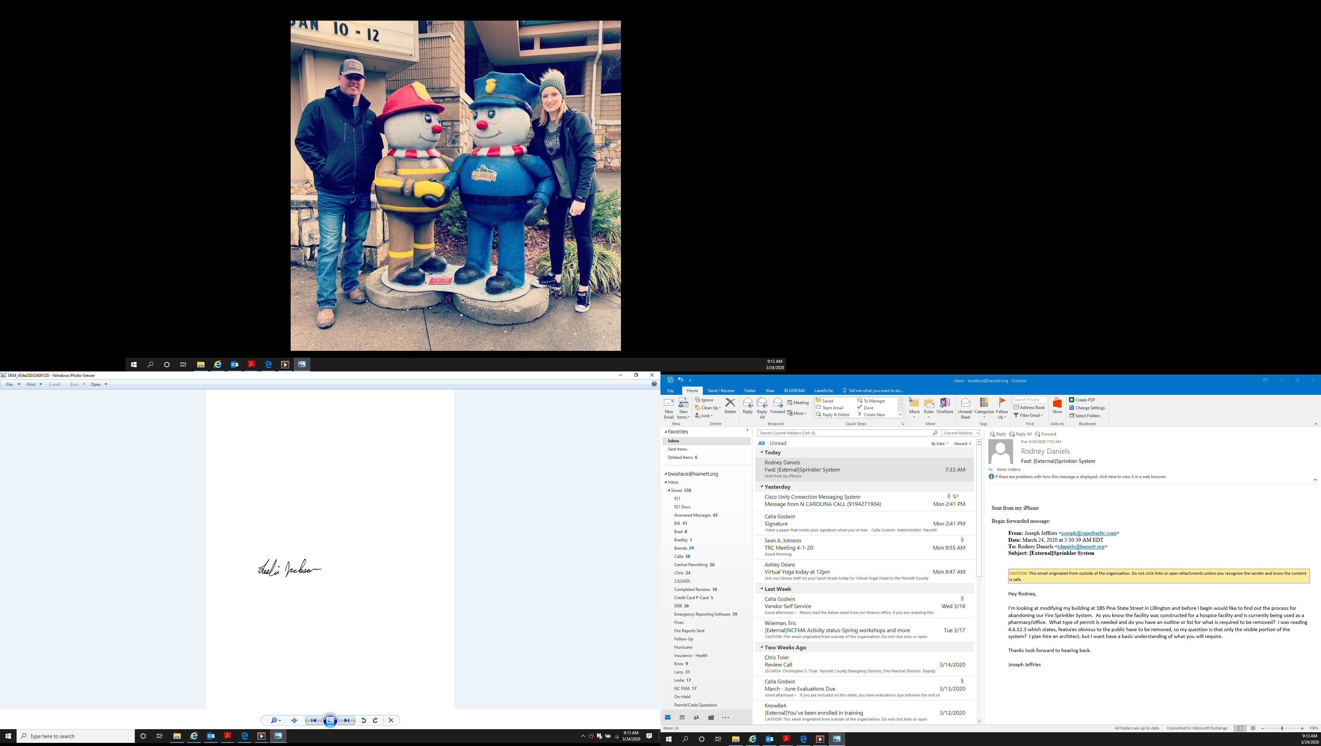

Leslie Jackson
Chief Deputy Fire Marshal

