Fire Marshal Division

July 20, 2021

Chris Simmons

Re: Simmons Boxing
1446 James Norris Rd.
Angier, NC 27526

Application Number FMFW2107-0003

To Whom It May Concern,

Thank you for submitting the plans for the renovation. The plans have been carefully reviewed by a qualified code enforcement official to examine for compliance with the North Carolina Fire Prevention Code and all other fire protection regulatory documents. There are some items that were found during the plan review process that need to be addressed before a final inspection of the new facility can be given. These items are outlined and described below.

- 906.1 Fire Extinguishers
  - Minimum of (1) 2A10:BC fire extinguisher shall be installed not to exceed 75’ distance of travel.
  - All Fire extinguishers shall be properly mounted and tagged by a fire extinguisher company.
- 1006.1 Means of Egress Illumination
- The means of egress, including the exit discharge, shall be illuminated at all time the building space is served by the means of egress is occupied.
  - Means of egress consist of three separate and distinct parts: the exit access, the exit and the exit discharge.
- The means of egress illumination shall not be less than 1 foot-candle at the walking surface.

- Notes
- A final fire inspection is required.
- Schedule all fire inspections through the Fire Marshal’s Office.
(910) 893-0740

Thank you again for submitting the plans for the renovation. Please review the plans and adhere to any notes and alterations that were made in addition to the original drawings. These remarks are for the plans that were submitted and its original intent. These remarks do not apply if the original intent changes or what was submitted on the above date changes. If you have any questions, please do not hesitate to call this office.

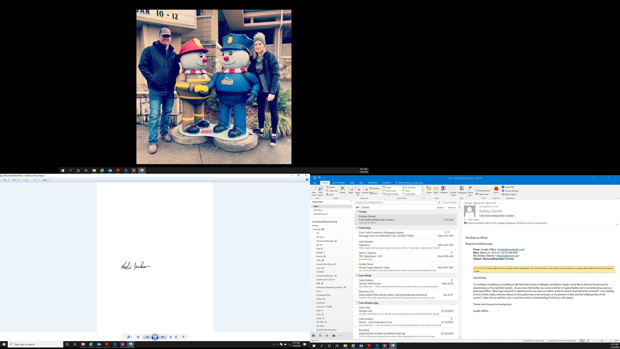
Sincerely,

Leslie Jackson
Deputy Fire Marshal

