Fire Marshal Division
June 3, 2021

Jerry Hebert
Carolina Drilling INC.
326 Railroad St.
Mocksville, NC 27028

Re: Ryan Homes at Quail Glen
43 Bark Way
Angier, NC 27501

Application Number – FMFW2106-0001

To Whom It May Concern,

Thank you for submitting the application for the blast permit for the period of 6/7/2021 thru 9/7/2021

Permit Notes

- Blast operations shall comply with any applicable portions of section 3307 of the NC Fire Prevention Code and NFPA 495.
- Blasting operations shall be conducted only by approved competent operators trained in the hazards involved.
- Please provide training/certifications for personnel conducting blast.
- Precautions shall be taken to prevent any accidental discharge of any electrical/non-electrical detonators.
- The blast site shall be secured and only authorized persons engaged in blast operations are allowed to enter area.
- A site inspection shall be completed by the Fire Marshal’s Office prior to the blast.
- Please call 910-893-0740 to schedule any fire inspections.

Thank you again for submitting the information and permit application. Please review the permit notes and if you have any questions, please do not hesitate to call this office.

Sincerely,
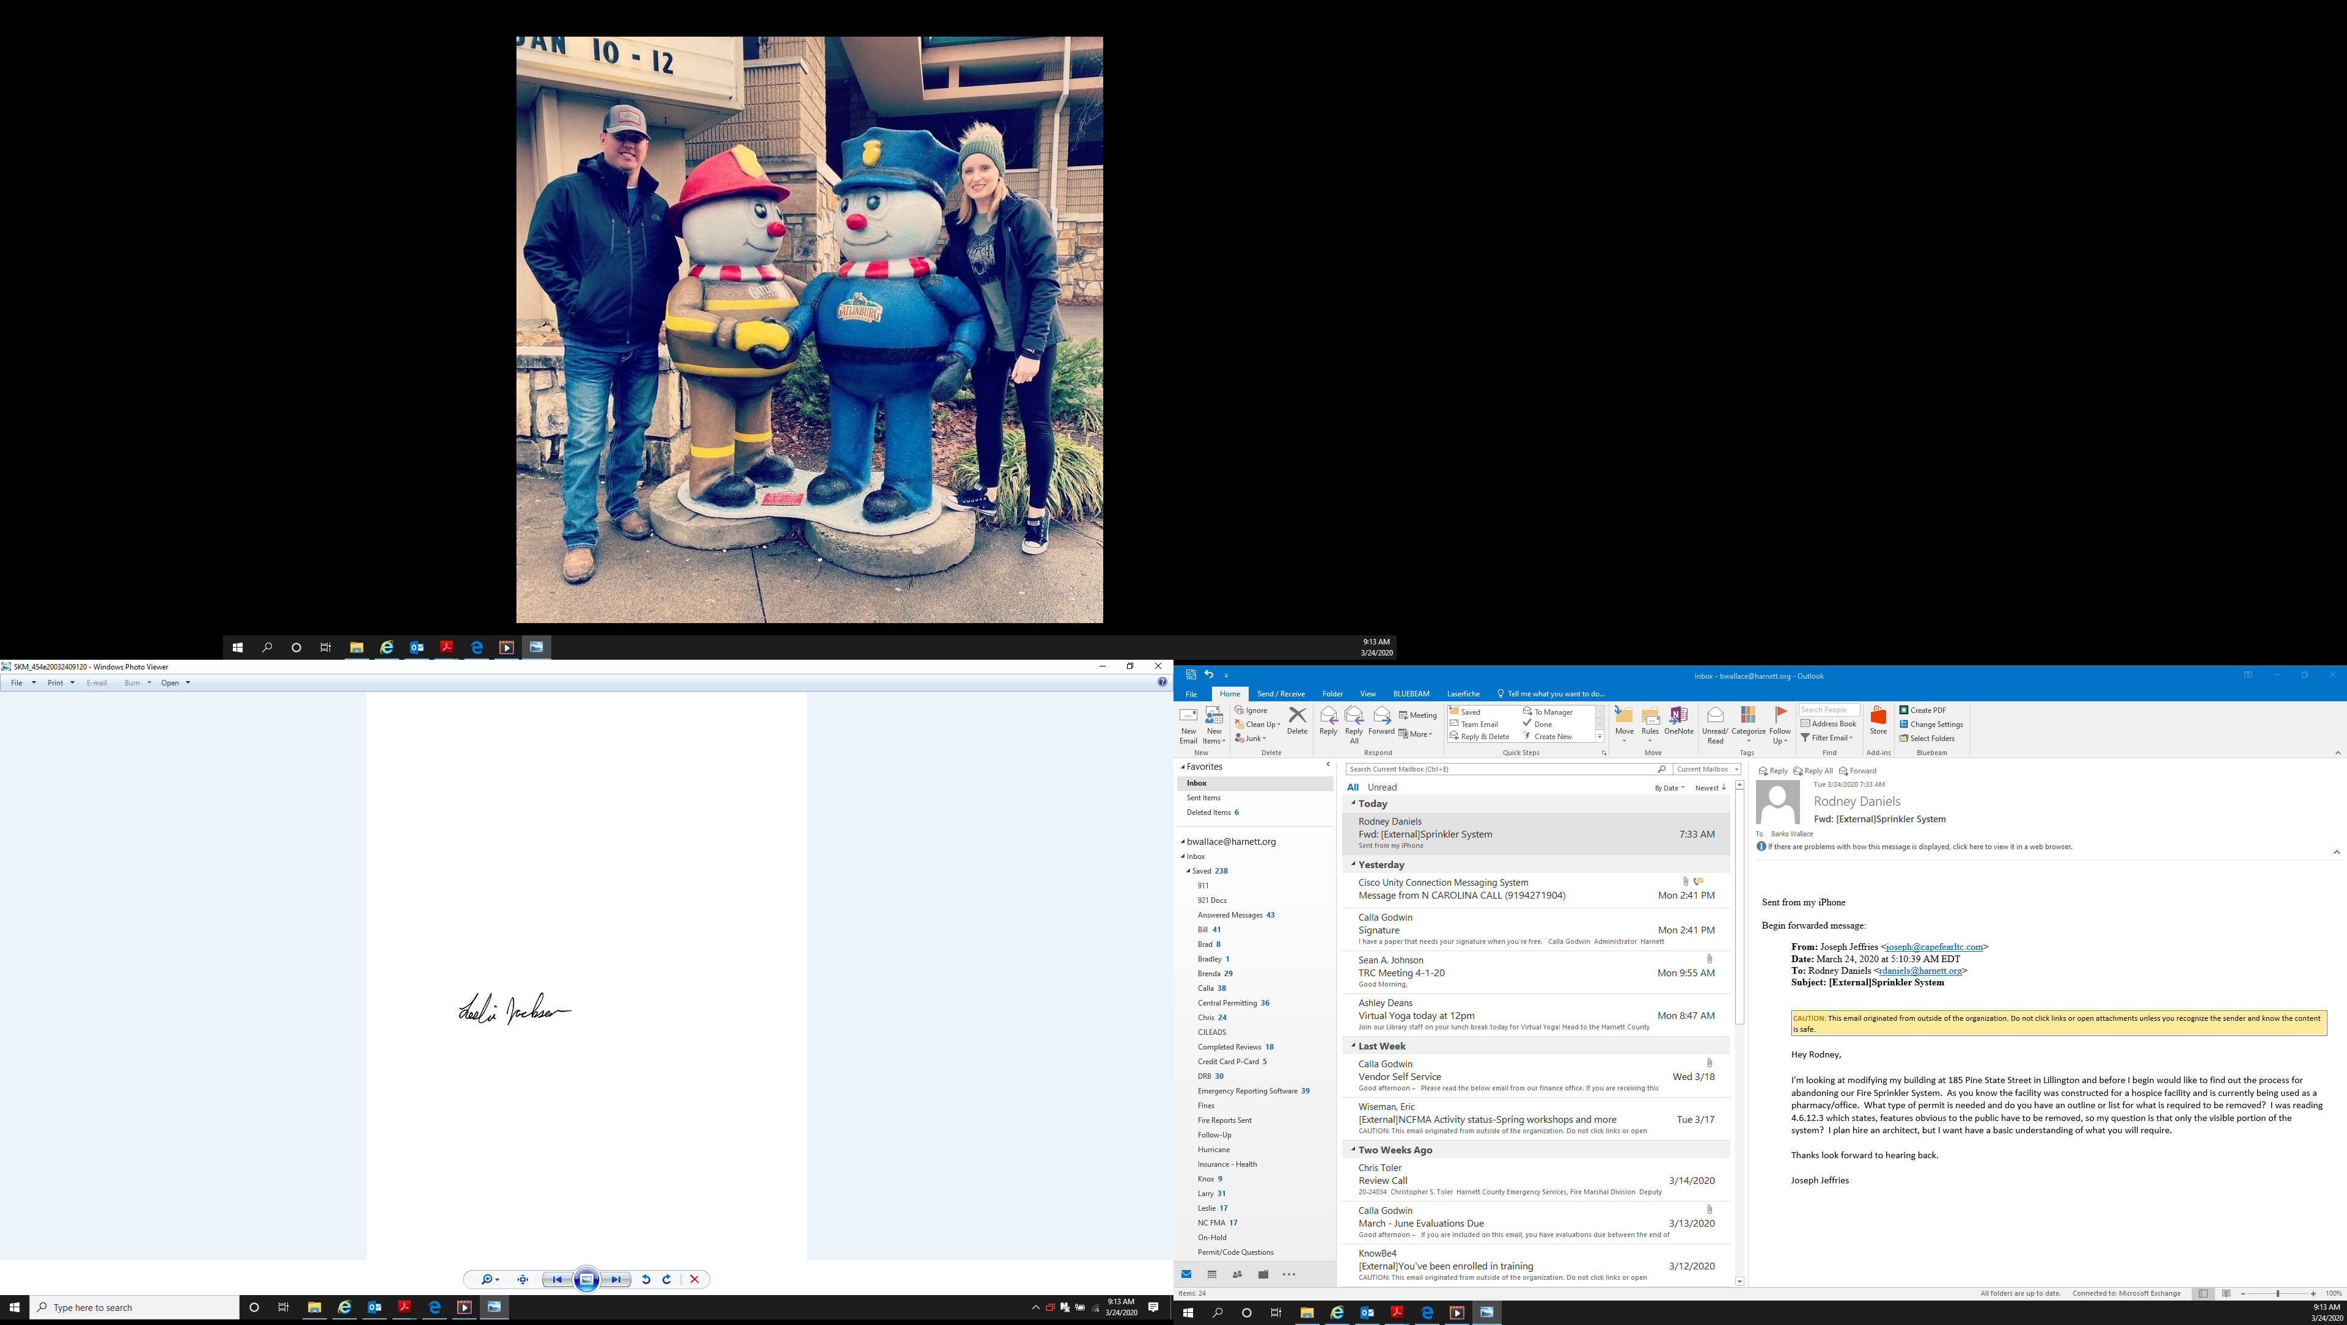

Leslie Jackson
Chief Deputy Fire Marshal

