Fire Marshal Division

May 13, 2021

Jerry Jones
51 Buttonwood Ct.
Fuquay Varina, NC 27526

Re: 51 Buttonwood Ct.
Fuquay Varina, NC 27526

Application Number FMFW2105-0001

Mrs. Jones,

Thank you for submitting the plans for the installation of the above ground flammable liquid storage tanks. The plans have been carefully reviewed by a qualified code enforcement official to examine for compliance with the North Carolina Fire Prevention Code and all other fire protection regulatory documents. There are some items that were found during the plan review process that need to be addressed before a permit to install the tanks can be granted. These items are outlined and described below.

Pending requirements before permit issuance:

- Submit engineered plans for the installation of each Aboveground Storage Tank (AGST) used for dispensing operations. Approved and listed piping systems and all ancillary equipment for a complete installation shall be indicated on the plans as prescribed in the NC State Fire Code and NFPA 30.
- It is also important to remember that the NC State Board of Registration for Professional Engineers and Land Surveyors require that a Professional Engineer (PE) seal all plans regarding ASTs/USTs Installations, piping, ancillary equipment upgrades, and vapor recovery system installations. Small tanks of 1,100 gals. or less capacity for commercial or noncommercial purposes and tanks used for storing heating oil for consumptive use on the premises where stored and the storage of Class IIIB combustibles are excluded from the PE rule.

- Supports, foundations and anchorage for above-ground tanks shall be designed and constructed in accordance with NFPA 30 and the NC State Building Code. Submit plans that show approved design for each tank.
- Submit an approved site plan showing tank locations in relation to property lines, distance from buildings and roadways.
- Provide a description of each tanks use and methods of dispensing from tanks.
- Provide information on dispenser piping, hoses and valves.
  - Dispensers used shall be approved and listed for appropriate fuel oil.
- Provide Safety Data Sheets from the manufacture of each type of flammable or combustible liquid stored or dispensed from each tank.
- Vehicle impact protection shall be installed in accordance with section 312 of NC FPC.
- Secondary containment for outdoor storage areas shall be design to contain a spill from the largest tank. If the area is open to rainfall, secondary containment shall be design to include the volume of a 24-hour rainfall as determined by a 25- year storm and provisions shall be made to drain accumulations of ground and rain water.
- Approved monitoring method shall be provided in accordance with section 5004.2.5 of the 2018 North Carolina Fire Code.

After permit is issued and before final approval:

- Installation shall be in accordance with all North Carolina Fire prevention codes and NFPA 30 standards.
- All hydrostatic and pressure tests for tanks and piping shall be witnessed by the Fire Marshal’s Office.
- Contact the Fire Marshal’s Office to witness the setting of tanks.
- A final Fire inspection is required at the end of the project.
- Call (910) 893-0740 to schedule all fire inspections.

Thank you again for submitting the plans for above ground storage tank installation. Please review the plans and adhere to any notes and alterations that were made in addition to the original drawings. These remarks are for the plans that were submitted and its original intent. These remarks do not apply if the original intent changes or what was submitted on the above date changes. If you have any questions, please do not hesitate to call this office.

Again, thank you and we look forward to working with you during the construction period!

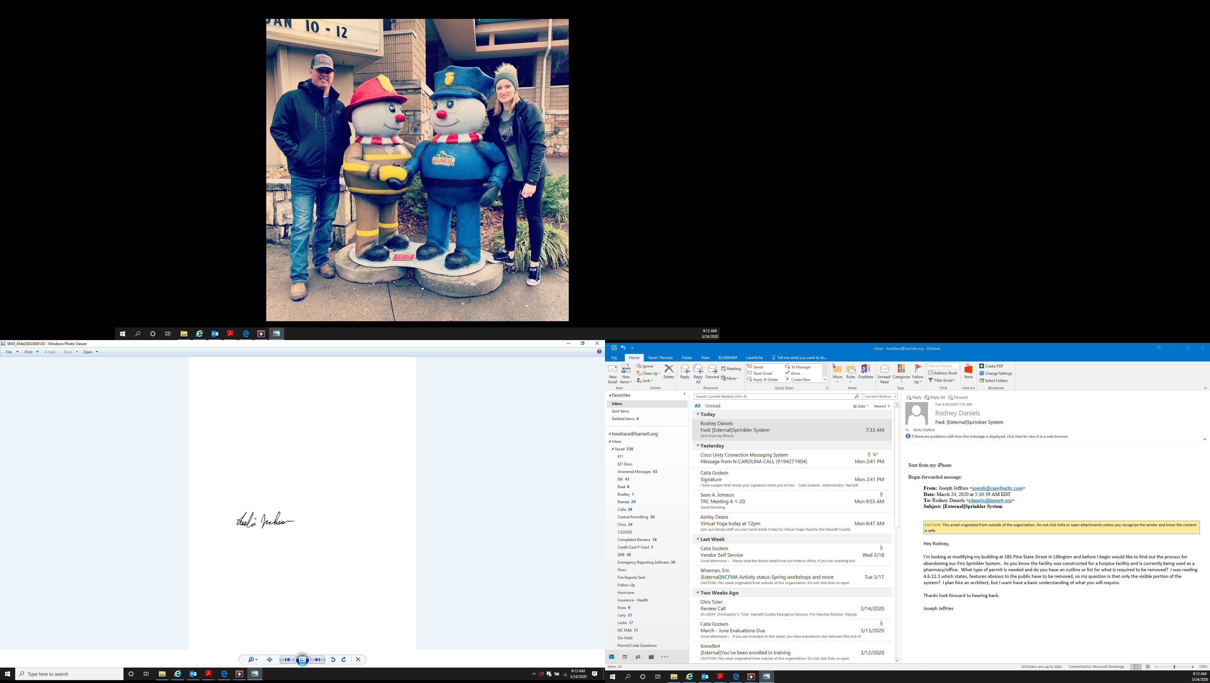
Sincerely,

Leslie Jackson
Deputy Fire Marshal

