Fire Marshal Division

April 5, 2021

Dan Denning
East Coast Pyrotechnics
P.O. Box 209
Catawba, SC 29704

Re: Anderson Creek Driving Range Fireworks Display
125 Whispering Pines Drive
Spring Lake, NC 28390

Application Number FMFW2103-0011

To Whom It May Concern,

The application for the outdoor public display of fireworks has been reviewed and approved as submitted. The public display shall be in accordance with the NC Fire Prevention Code and NFPA 1123.

Prior to the issuing permits for fireworks display, a compliance inspection of the display site and demonstration of the display operation shall be approved. The compliance inspection will be conducted before the time of the show.

- Fire Protection for Fireworks
  - Portable fire extinguisher shall be placed at the discharge area and standby fire apparatus shall be placed down range for fall out.
  - Contact shall be made with the local Fire Department to establish terms for standing by with apparatus and personnel.
  - Confirmation with the local fire department shall be returned to this office.
  - The shoot time has been established for July 2, 2021 at 9:15 pm. If changes are made contact needs to be made to this office by phone at 910-893-0743 (Rodney Daniels).
  - Fireworks must never be left unattended.

- Distance
  - At least 70 feet for diameter inch of shell must be provided between the shoot site and the public (5” largest mortar = 350 feet)
- Permits
  - Final inspection will be conducted that day of the event and the permit will be issued.

- Setup
  - You may contact our office for a representative to meet on site during setup or for any additional questions that may arise. (910) 893-7580.

- During the firing of the display, all personnel in the discharge site shall wear the following:
  - Head protection
  - Eye protection
  - Hearing protection
  - Foot protection
  - Cotton, wool, or similarly flame-resistant, long-sleeved, long-legged clothing

- The sponsor shall consult with the AHJ and the operator to determine the level of fire protection required.

- The following shall apply to crowd control:
  - Monitors whose sole duty is the enforcement of crowd control shall be located around the display site and at other locations as determined by the sponsor.
  - The AHJ and the operator shall approve the provisions for crowd control.

- Fireworks Display Supervision. Whenever in the opinion of the fire code official or the operator a hazardous condition exists, the fireworks display shall be discontinued immediately until such time as the dangerous situation is corrected.

Thank you again for submitting the plans for the fireworks display. Please review the plans and adhere to any notes and alterations that were made in addition to the original drawings. These remarks are for the plans that were submitted and its original intent. These remarks do not apply if the original intent changes or what was submitted on the above date changes. If you have any questions, please do not hesitate to call this office

Sincerely,

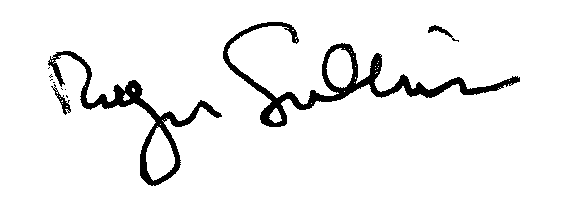
Roger Sullivan
Deputy Fire Marshal

