

11/19/2021

RE: Ali Mohamed Boumelhem; 55 Sedgefield Ln. Spring Lake, NC 28390

This letter is approval of the application for your company to install the 12.6 kW net metered solar array at 55 Sedgefield Ln. Spring Lake, NC 28390. South River EMC personnel have inspected the location and area facilities owned by South River EMC to ensure that the interconnection will be completed safely and successfully.

If you have any questions regarding this letter or the system, please contact Aaron Jackson at 919.820.1909 or myself at 919.820.7122.

Sincerely,

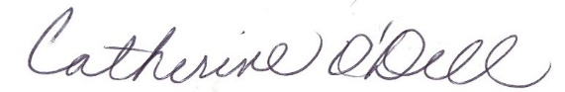

Catherine O’Dell  
VP of Member Services & PR