September 10, 2021

RE: Brian W McKinney – 152 Angel Oak Dr, Bunnlevel, NC 28323
This letter is approval of the application for Sigora Solar to install the 8.41 kW net metered solar array at 152 Angel Oak Dr, Bunnlevel, NC 28323. South River EMC personnel have inspected the location and area facilities owned by South River EMC to ensure that the interconnection will be completed safely and successfully.
If you have any questions regarding this letter or the system, please contact Eric Gainey at 919.820.4953 or myself at 919.820.7122.
Sincerely,
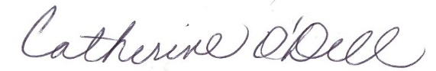
Catherine O’Dell
VP of Member Services & PR

