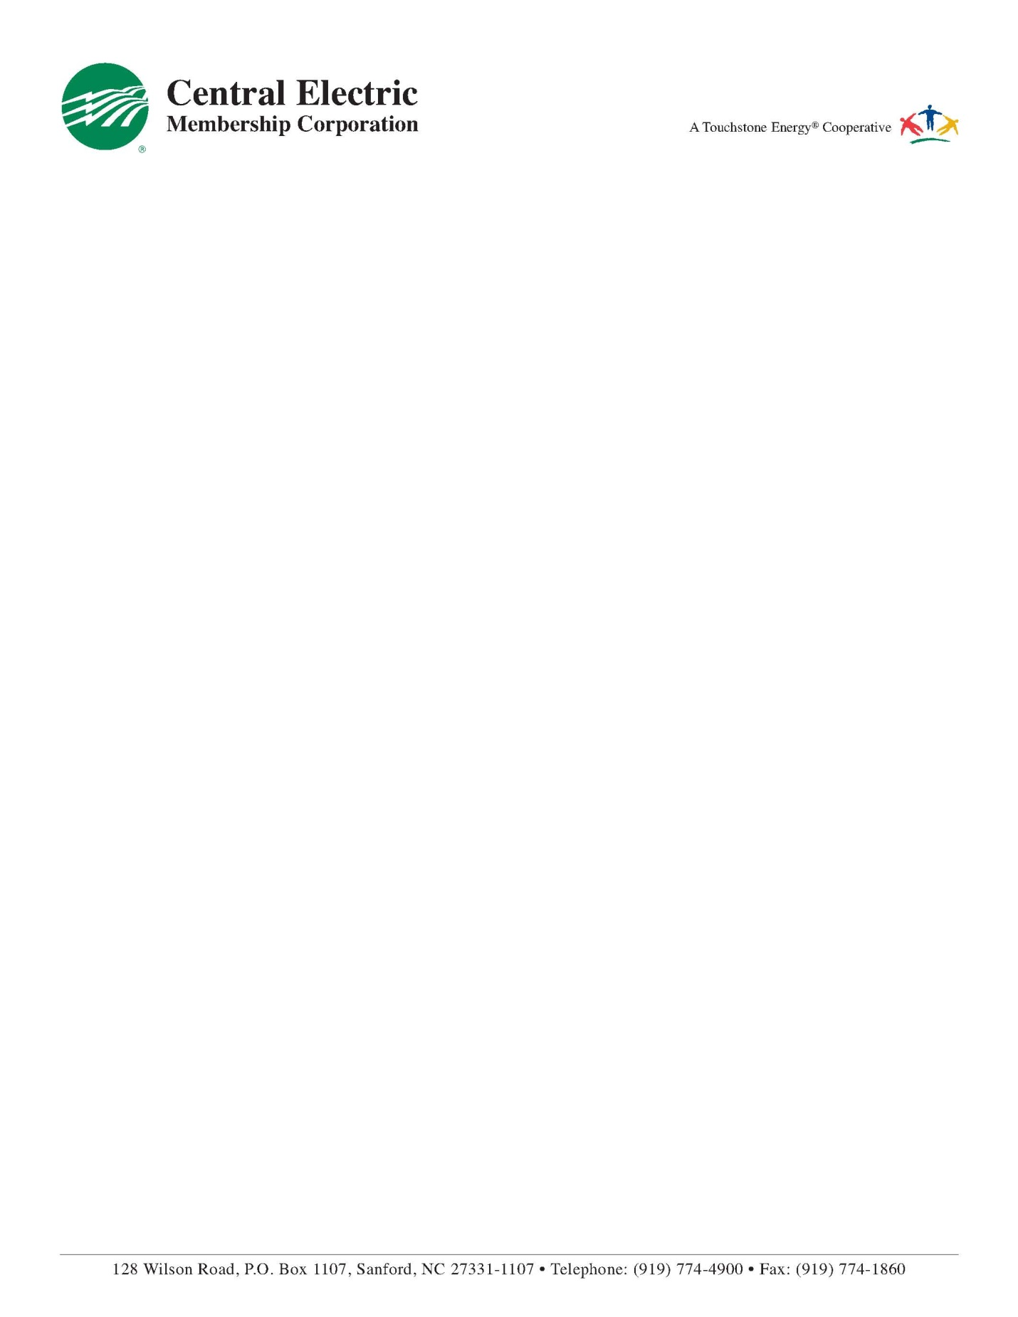

October 18, 2021

Michael Roginski

100 Tripoli Dr

Cameron NC, 28326

RE: Solar Generation Activation

Please accept this letter as confirmation that Michael Roginski has completed all forms and supplied adequate design information to install a solar project at his residence. Once installation and electrical inspections are complete the solar system can be interconnected with Central Electric Membership Corporation’s electric grid.

If you have any questions regarding this letter, please contact me at 919-708-1639.

Sincerely,



Ryley Osentoski

Key Accounts and Energy Information Representative

Central Electric Membership Corporation

P.O. Box 1107

Sanford, NC 27331-1107