

June 17, 2021

RE: Lisa Ayala 67 Folly Ct, Linden, NC 28356

This letter is approval of the application for NC Solar Now to install the 8.41 kW net metered solar array at 67 Folly Ct, Linden, NC 28356. South River EMC personnel have inspected the location and area facilities owned by South River EMC to ensure that the interconnection will be completed safely and successfully.

If you have any questions regarding this letter or the system, please contact Aaron Jackson at 919.820.1909 or myself at 919.820.7122.

Sincerely,

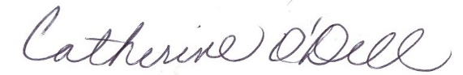

Catherine O’Dell  
VP of Member Services & PR