

June 18, 2021

RE: Jonathan Bienvenue: 553 Old Salem Dr. Spring Lake, NC 28390

This letter is approval of the application for Cape Fear Solar Systems to install the 6.631 kW net metered solar array at 553 Old Salem Dr. Spring Lake, NC 28390. South River EMC personnel have inspected the location and area facilities owned by South River EMC to ensure that the interconnection will be completed safely and successfully.

If you have any questions regarding this letter or the system, please contact Robert Talton III at 919.820.2904 or myself at 919.820.7122.

Sincerely,

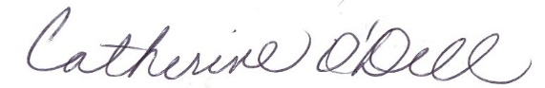

Catherine O’Dell  
VP of Member Services & PR