

May 26, 2021

RE: Carmen Perez: 104 Parkview Ln. Lillington, NC 27546

This letter is approval of the application for Sigora Solar to install the 9.86 kW net metered solar array at 104 Parkview Ln. Lillington, NC 27546. South River EMC personnel have inspected the location and area facilities owned by South River EMC to ensure that the interconnection will be completed safely and successfully.

If you have any questions regarding this letter or the system, please contact Robert Talton III at 919.820.2904 or myself at 919.820.7122.

Sincerely,

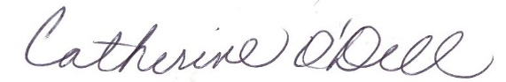

Catherine O’Dell  
VP of Member Services & PR