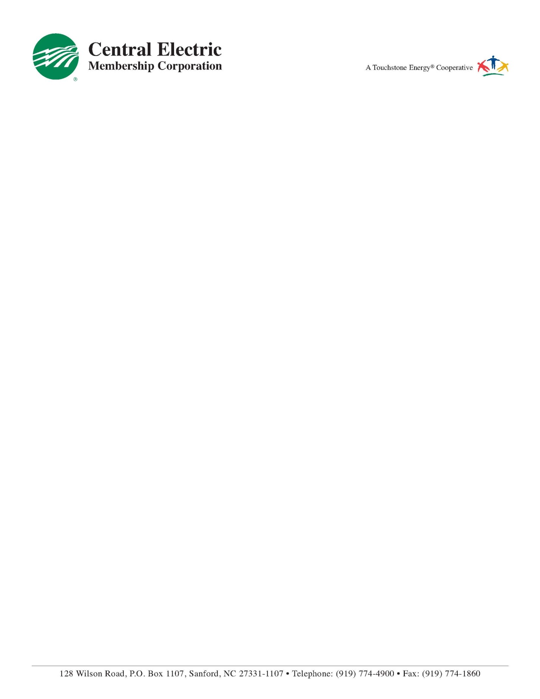

August 25, 2020

Jason Roseberry

95 Peachtree Lane

Sanford NC, 27332

RE: Solar Generation Activation

Please accept this letter as confirmation that Jason Roseberry has completed all forms and supplied adequate design information to install a solar project at his residence. Once installation and electrical inspections are complete the solar system can be interconnected with Central Electric Membership Corporation’s electric grid.

If you have any questions regarding this letter please contact me at 919-708-1612.

Sincerely,

Jody Albright

Vice-President of Member Services & Business Development

Central Electric Membership Corporation

P.O. Box 1107

Sanford, NC 27331-1107