Deck & Swim Spa Project

1. New deck off back of house (see survey and drawing of project)
   1. Raised to 4 ft. 16’ along side by 27’ wide.
   2. Looking at trex or treated wood, gray in color
   3. See pictures – spa will be open at the front of deck for easy access to equipment – the spa will at least 10’ away from edge of house.
   4. Three stairs coming down to ground level on front of screen in porch.
   5. Left side rail is 5’ privacy screen (see picture)
   6. Rest of deck will have wood/metal rail (see picture)
   7. Locking gate across steps for safety
2. PDC Swim Spa
3. 18.95’ length x 7.67’ width x 4.67’ height swim spa flush with front edge of deck.
4. Swim spa is white acrylic shell, Smoke Gray walls outside
5. Equipment housed within spa
6. Concrete Pad
7. Poured concrete pad 10’ x 20’ x 6” for under spa
8. (if concrete pad is disallowed we can do a gravel/paver foundation)
9. French Drains (see survey and drawing of project)
   1. See green line on drawing
   2. Tie in downspout on right side of screen porch to bring French drain out and around outside of deck and spa to drain into a French drain along the left side of house.
   3. Tie in downspout on left side of house to drain into French drain on left side of house
   4. All water drains into ditch in front of house
10. Upgraded Electrical
11. Add 2, 50amp connections to outside electrical box on right side of house
12. Connection will be brought to back of house and out 10 feet to connect to Spa.
13. An outlet already connected to back of house will be raised to make way for decking.

|  |  |
| --- | --- |
| Rail example | Privacy screen example |
|  |  |

Example of deck to edge of spa (not our actual deck)

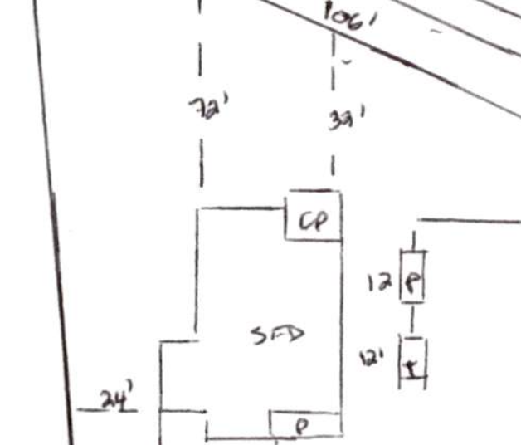

27ft length

16ft length

4ft length

56ft

3 stairs down

Swim spa

19 x 8 x 4.6

Deck & Swim spa

Deck

French Drain

4 ft height

