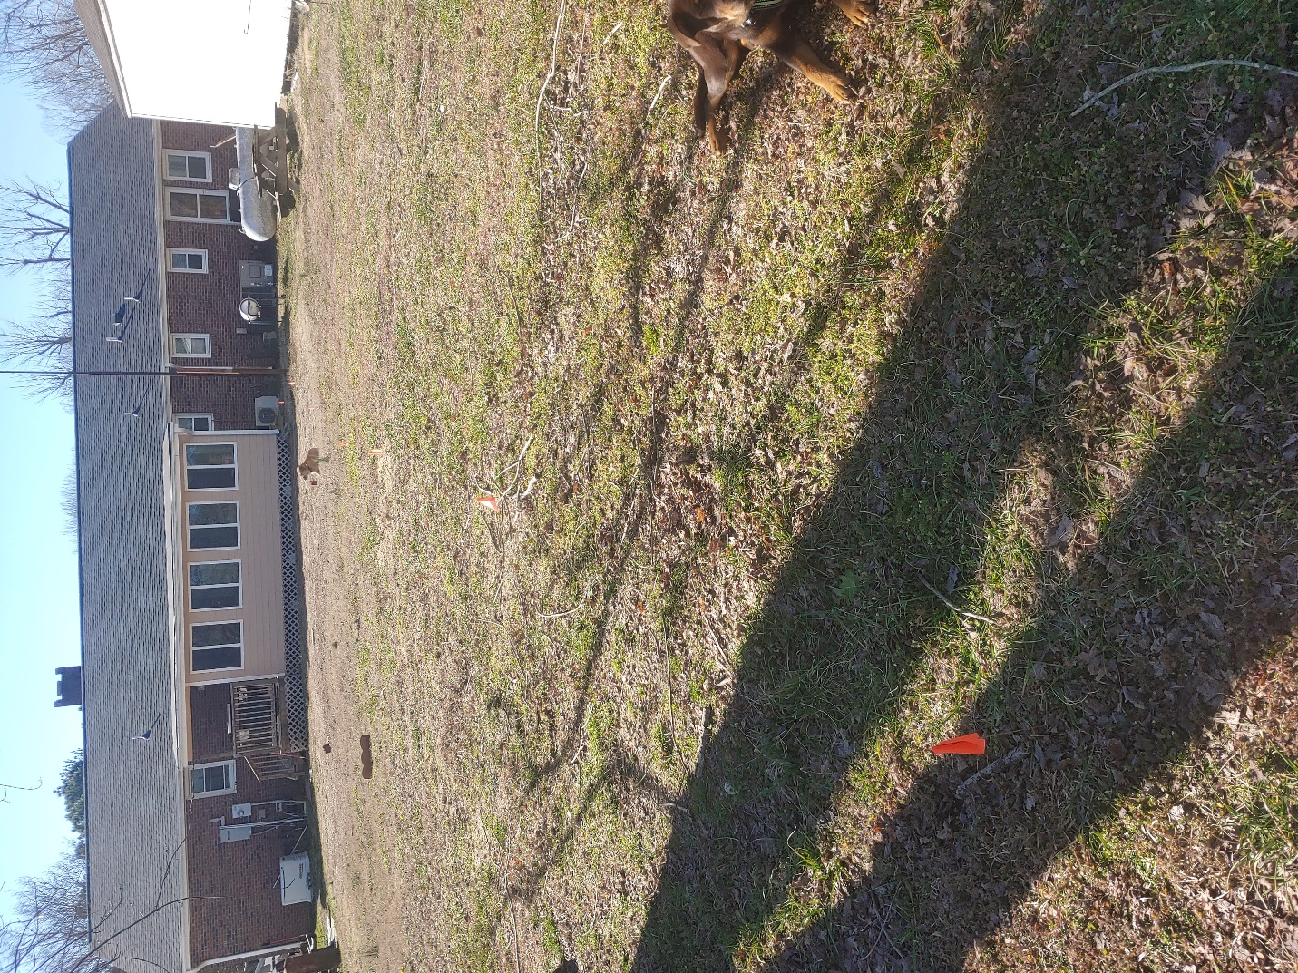

Supply line from house. Flags hard to see.

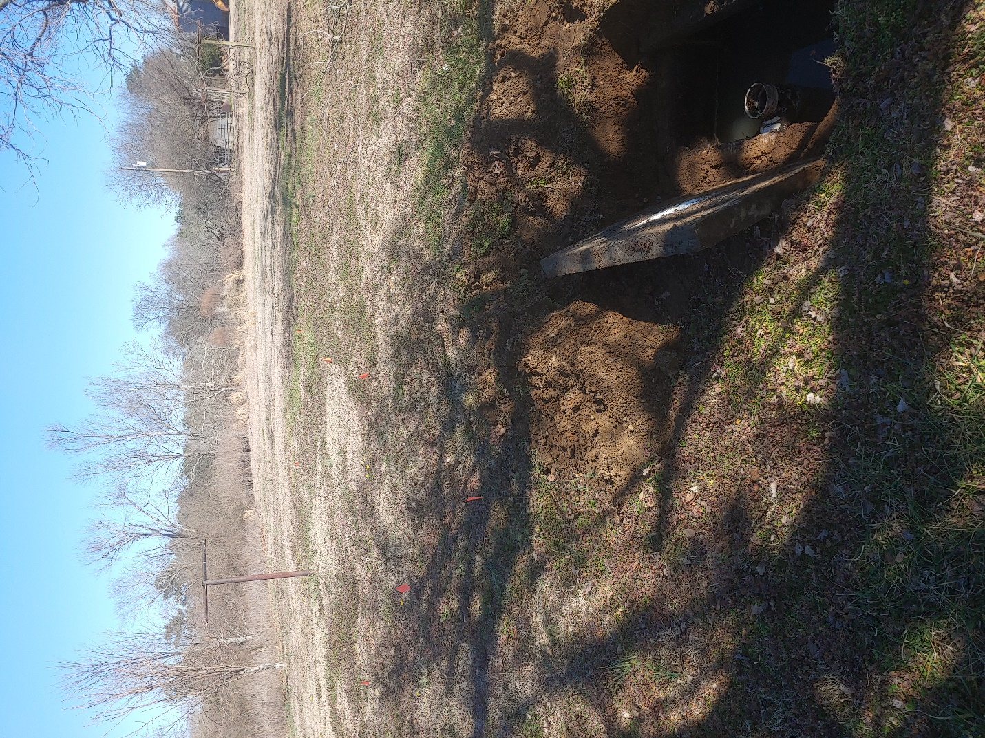

Drain lines run toward pasture. Flags hard to see.

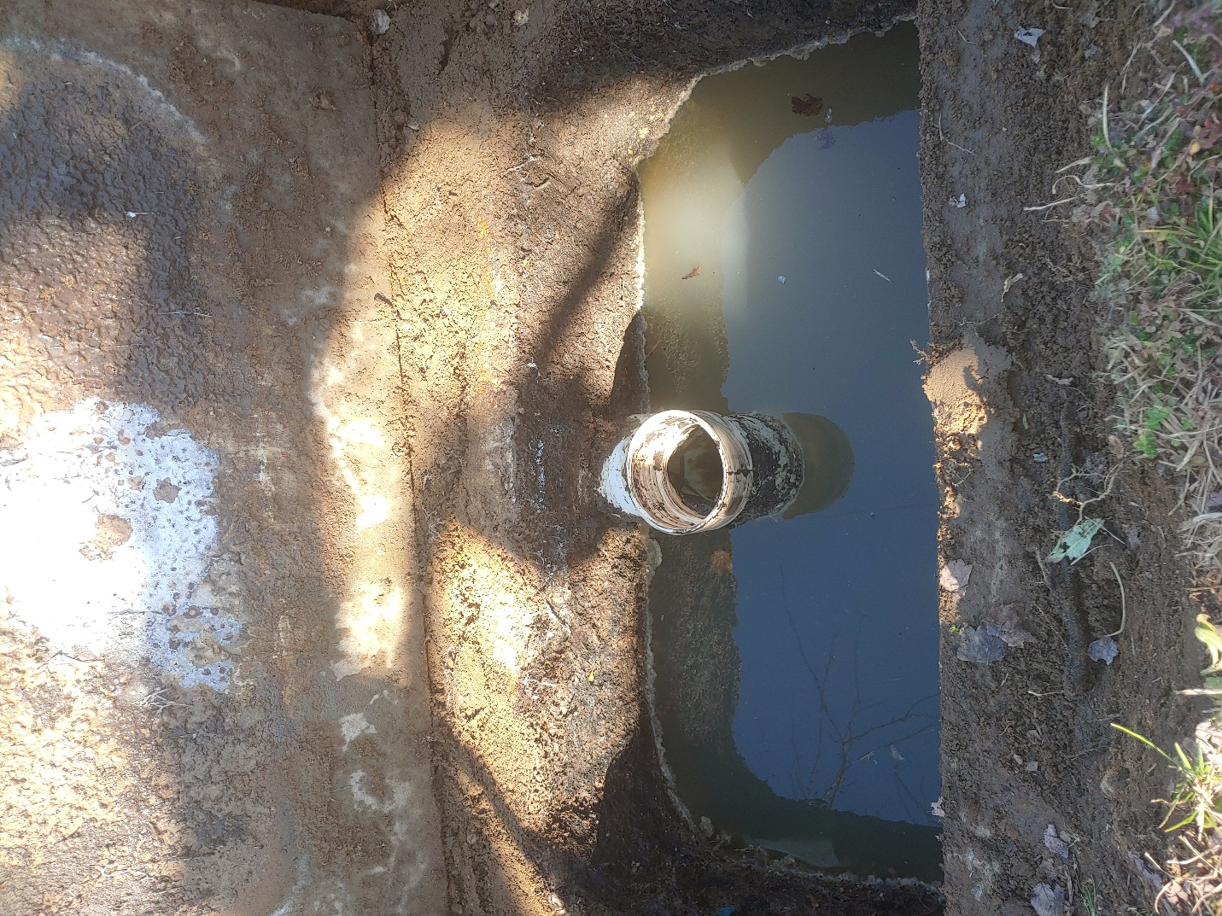

Sanitary Tee

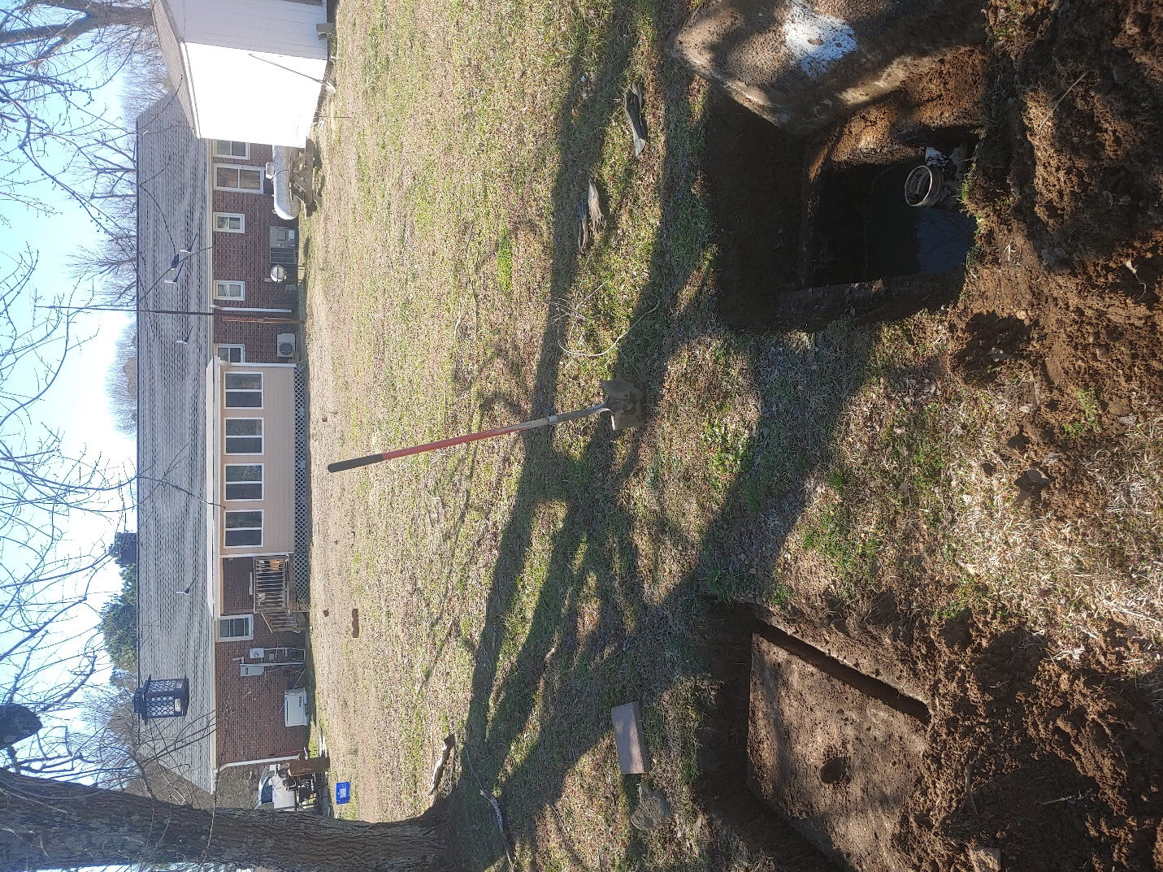

Tank in relation to house (showing tee)