Fire Marshal Division

July 28, 2025

Re: Tirado Truck Repair Center
US 421 S
Lillington, NC 27546

Application Number BCOM2507-0009

To Whom It May Concern,

Thank you for submitting the building plans. The plans have been carefully reviewed by a qualified code enforcement official to examine for compliance with the North Carolina Fire Prevention Code and all other fire protection regulatory documents. There are some items that were found during the plan review process that need to be addressed before a final inspection of the new facility can be given. These items are outlined and described below.

- Physical Address
- The physical address of the building shall be posted in a conspicuous place so that it can be seen on approach from the road, access road, and/or parking lot.
- The numbers used to make up the physical address shall be at least 5 inches in height.

- Fire Hydrant
- Where a portion of the facility or building hereafter constructed or moved into or within the jurisdiction is more than 400 feet from a fire hydrant on a fire access road, as measured by an approved route around the exterior of the facility or building, on-site fire hydrants and mains shall be provided where required by the fire code official.

- Fire Extinguishers
  - Fire extinguishers shall be placed in approved locations and may be field verified on final inspection. The fire extinguishers provided shall have a minimum rating of 2A 10 B: C.
  - Fire extinguisher shall be installed not to exceed 75’ distance of travel.

- Emergency Illumination
  - Emergency illumination is required to meet minimum foot candle illumination for all portions of the means of egress, including the exit discharge.

- Exit Signs
  - Exit signs shall be installed at all required exits. Exit signs shall meet all provisions of chapter 10.

Thank you again for submitting the plans for the building. Please review the plans and adhere to any notes and alterations that were made in addition to the original drawings. These remarks are for the plans that were submitted and its original intent. These remarks do not apply if the original intent changes or what was submitted on the above date changes. If you have any questions, please do not hesitate to call this office.

Sincerely,
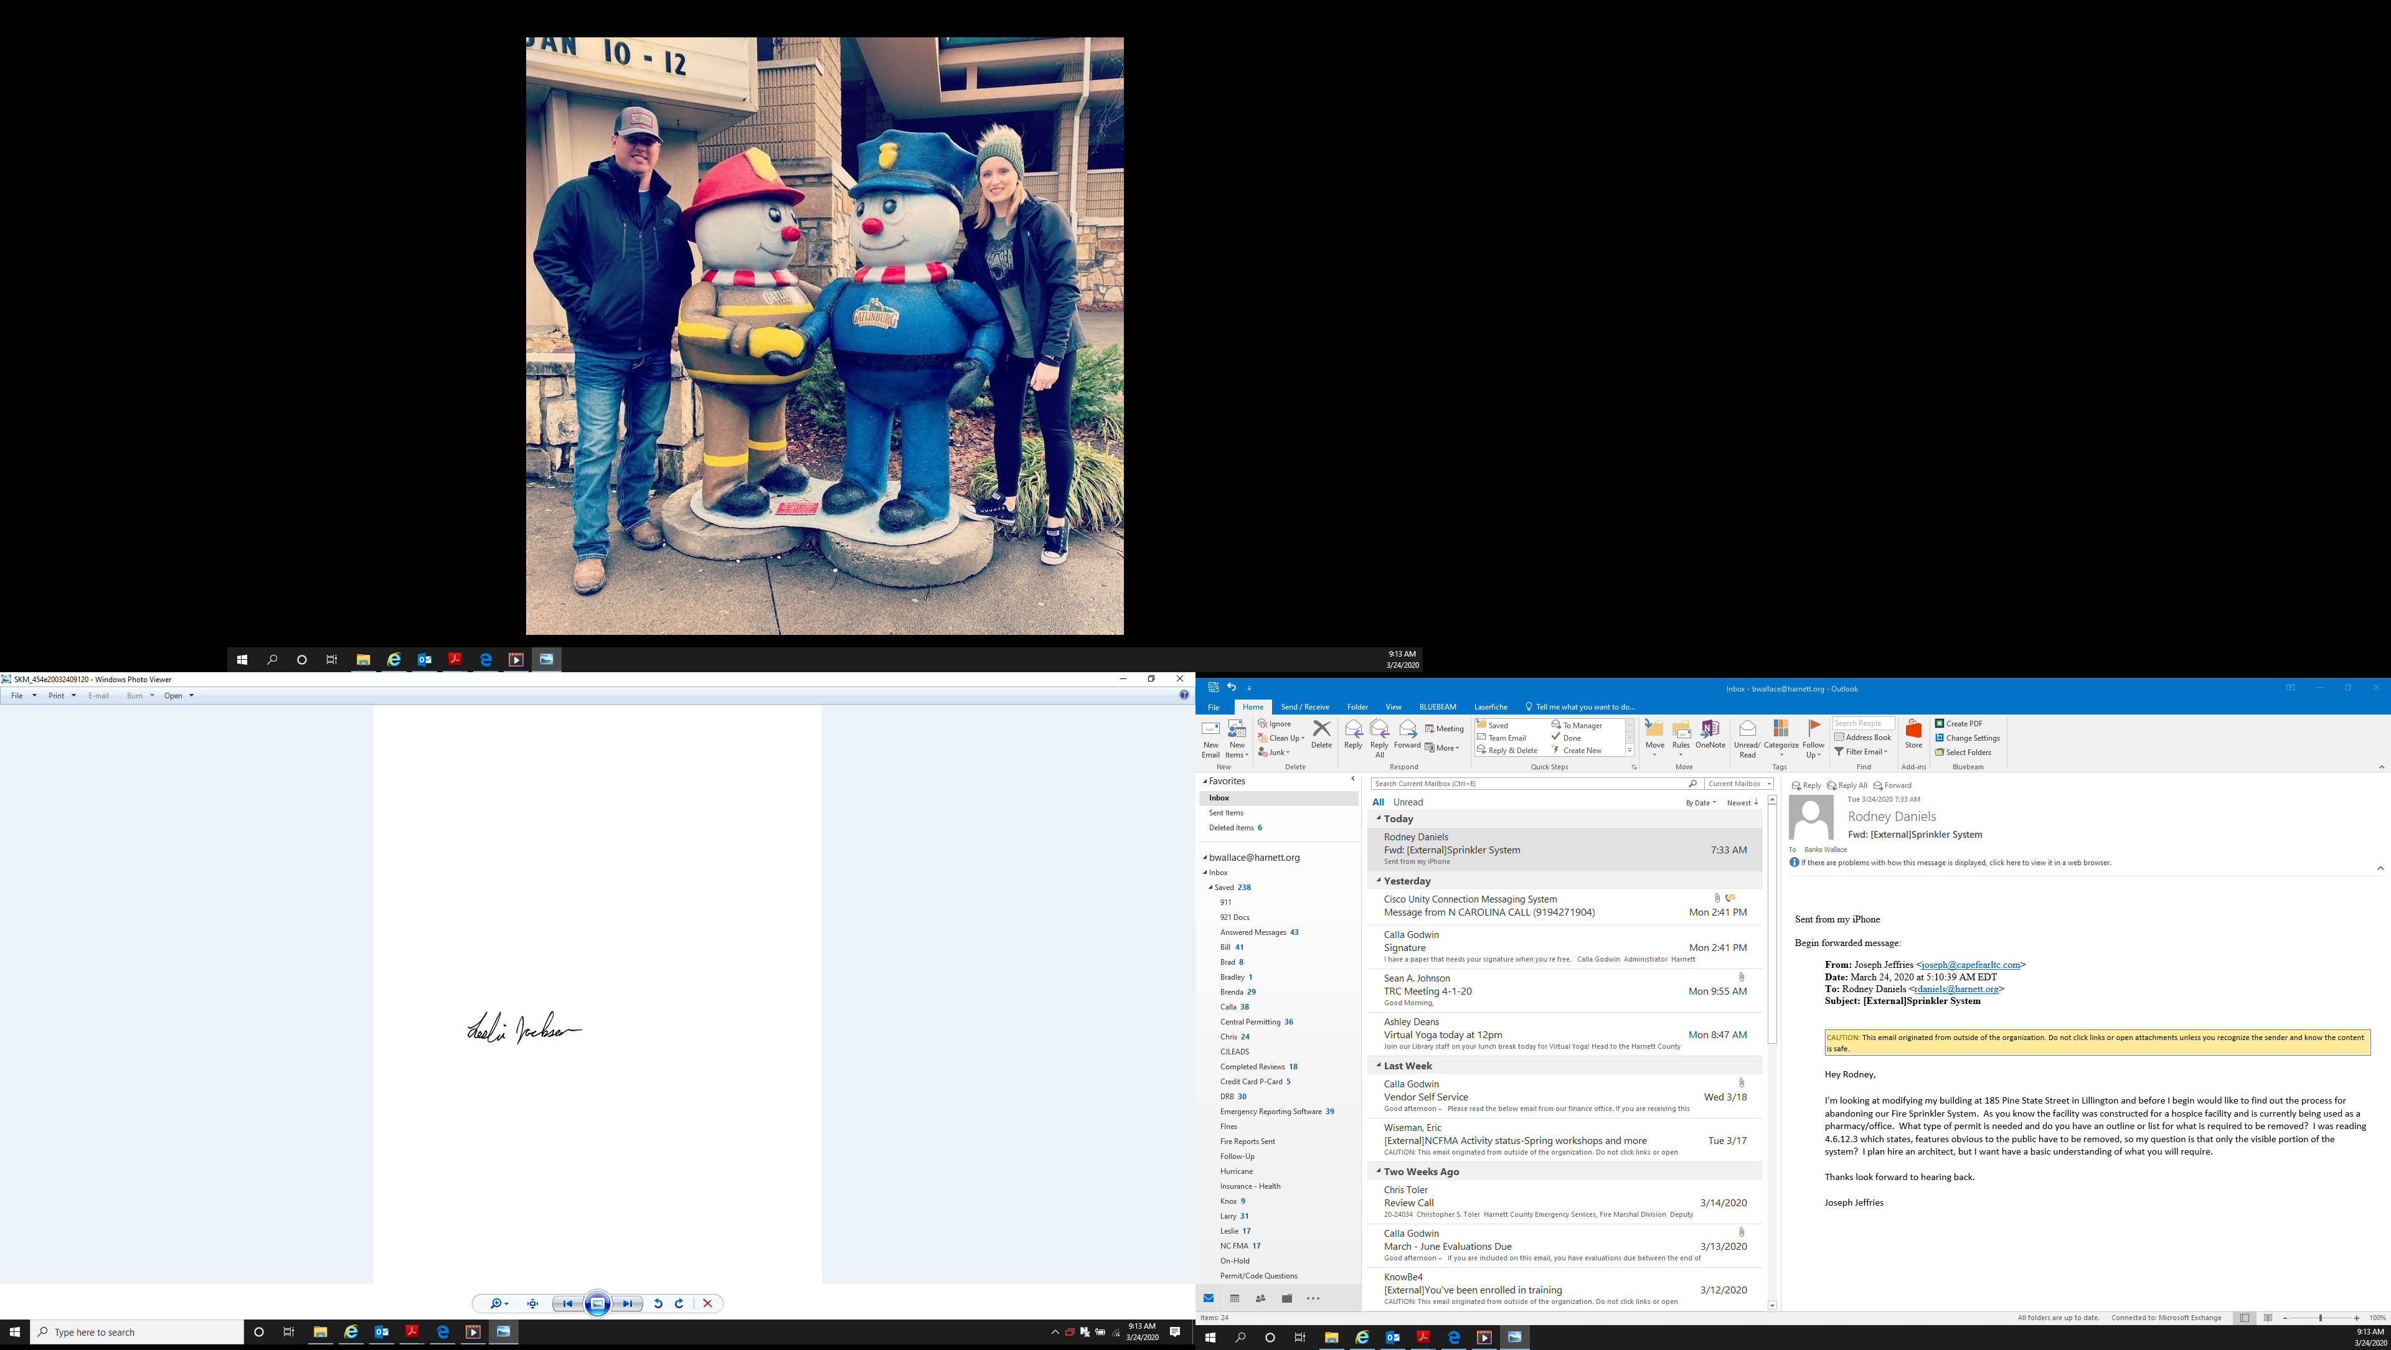

Leslie Jackson
Chief Deputy Fire Marshal
lrjackson@harnett.org

