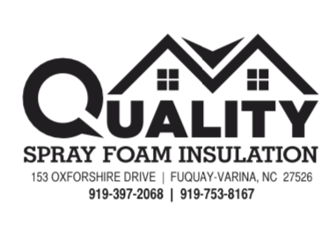

2/23/2026

Re. 3566 NC 210 S, Bunnlevel, NC 28323
To, Harnett County Inspection Dept.

I, Estanislao Villegas, of Quality Spray Foams Insulation LLC, attest that the above-referenced new construction building has been insulated with UPC OPEN CELL spray foam insulation.

The foam has been installed at a thickness of 8.5 to 9 inches in between rafters. (R-30 uncompressed above the top plate), and walls and gable ends have been insulated at a thickness of 4 to 4.5 inches (R15) to prescriptive code requirements.

All foam insulation will be separated from the interior of the building with drywall as required,
or may be left exposed in areas accessible only for service of utilities, in accordance with CCRR-0358, and no additional coatings are required for the foam.

Quality Spray Foams Insulation LLC is an approved contractor for UPC Polyurethane, and Estanislao Villegas has completed the mandatory training program required for certification.

UPC is an air-impermeable insulation and may be applied directly to the underside of the roof deck to create an unvented attic assembly in compliance with the code requirements.

Thank You for the attention to this matter.

Estanislao Villegas

Quality Spray Foams Insulation LLC.

President.

