Fire Marshal Division

September 10, 2024

RE: Blue Agave Mexican Grill
330 E Stewart St.
Coats, NC 27521

Application Number BCOM2408-0014

To Whom It May Concern,

Thank you for submitting the plans for the Blue Agave Mexican Grill. The plans have been carefully reviewed by a qualified code enforcement official to examine for full compliance with the North Carolina Fire Prevention Code and all other fire protection regulatory documents. There are some items that were found during the plan review process that need to be addressed before a final inspection of the new facility can be given. These items are outlined and described below.

- Fire Extinguishers
  - Fire extinguishers shall be placed in approved locations, one in the area of the rear storage space and one in the front entrance area.
  - The fire extinguishers provided shall have a minimum rating of 2A 10B: C and shall not be installed higher than 5 feet above the finished floor.
  - In addition to the above extinguishers, a portable fire extinguisher shall be provided within a 30-foot travel distance of commercial-type cooking equipment. Cooking equipment involving vegetable or animal oils and fats shall be protected by a Class K rated portable extinguisher.

- Emergency Lighting
  - All emergency lighting shall be in proper operating condition at time of final inspection.
  - Any changes made in illumination requirements, due to equipment placement or storage arrangements shall be addressed before final inspection.

- Knox Box
- Keys for front entrance door shall be provided to be placed in the Knox Box installed on the building.

- Physical Address ( ie: suite Number if Applicable )
- The physical address of the building shall be posted in a conspicuous place so that it can be seen on approach from the road, access road, and/or parking lot.

- The numbers used to make up the physical address shall be at least 6 inches in height.

- The physical address needs to be posted on the rear of the building also.

- Panic Hardware
- UL 305 listed panic hardware is required on exit doors serving a room/space with an occupant load >50.
- Acceptance Test of Commercial Hood System
- Submit kitchen hood fire suppression system plans and specifications for approval prior to installation.
- An acceptance test will be conducted by the Fire Marshal’s office once system has been installed and pre-tested.
- Installation shall be per architectural and system submittals and compliant with NFPA-17A.
- Manual system operation of Commercial Hood System
  - A manual actuation device shall be located at or near a means of egress from the cooking area, a minimum of 10 feet and a maximum of 20 feet from the kitchen exhaust system. The manual actuation device shall be located a minimum of 42inches and a maximum of 4 feet above the floor. The manual actuation shall require a maximum force of 40 pounds (178 N) and a maximum movement of 14 inches to actuate the fire suppression system.

System Interconnection of Commercial Hood System
  - The actuation of the fire suppression system shall automatically shut down the fuel or electrical power supply to the cooking equipment. The fuel and electrical supply reset shall be manual. The fire suppression system must be connected to the fire alarm system if applicable.

Note:
- All Fire Suppression system, indicated on master building plan review notes, must be met before Final C/O for the building can be issued. Contact 910-893-0740

Thank you again for submitting the plans for the Blue Agave Mexican Grill. Please review the plans and adhere to any notes and alterations that were made in addition to the original drawings. These remarks are for the plans that were submitted and its original intent. These remarks do not apply if the original intent changes or what was submitted on the above date changes. If you have any questions, please do not hesitate to call this office

Again, thank you and we look forward to working with you during the construction period!

Sincerely,
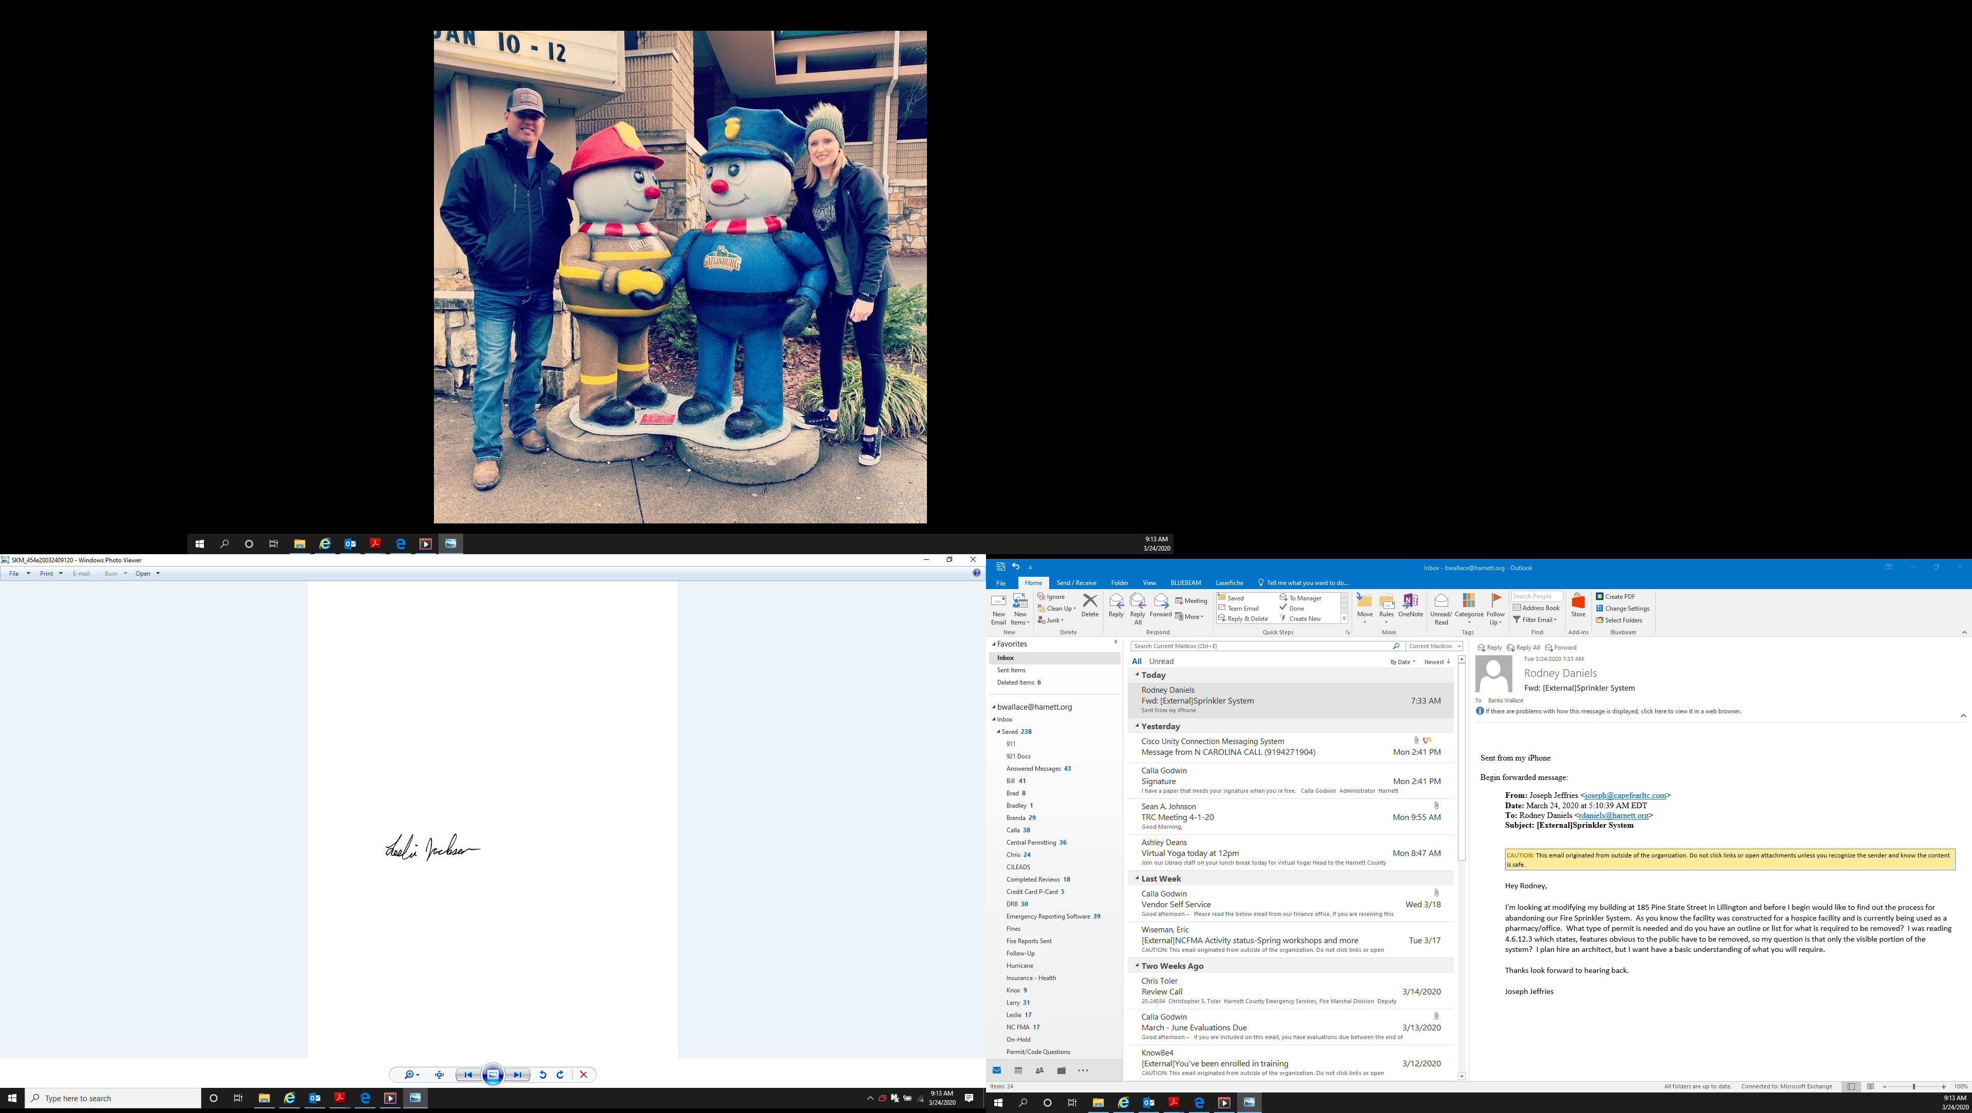

Leslie Jackson
Chief Deputy Fire Marshal
lrjackson@harnett.org
910-893-0740

