Fire Marshal Division
October 9, 2024

Thaddeus Christian Mclean
319 Great Northern Station
Apex, NC 27502

Re: Baucom Business Plaza Bldg. S1
11132 US 401 N
Fuquay Varina, NC 27526

Application Number BCOM2404-0010

To Whom It May Concern,

Thank you for submitting the plans for the storage building S1. The plans have been carefully reviewed by a qualified code enforcement official to examine for compliance with the North Carolina Fire Prevention Code and all other fire protection regulatory documents. There are some items that were found during the plan review process that need to be addressed before a final inspection of the new facility can be given. These items are outlined and described below.

Fire Extinguishers
  - Fire extinguishers shall be placed not to exceed 75’ travel distance.
  - The fire extinguishers provided shall have a minimum rating of 2A 10B: C and shall not be installed higher than 5 feet above the finished grade.

Fire Department Access
  - The fire department access shall extend to within 150 feet of all portions of the facility.
  - The fire department access road shall be of an unobstructed width of not less than 20 feet and shall have an unobstructed vertical clearance of not less the 13 feet 6 inches.
Knox Box
- The main entry gate must have a knox entry key system installed for fire department access, contact our office for further details if needed.

- Emergency Illumination
  - Emergency illumination is required to meet minimum foot candle illumination for all portions of the means of egress, including the exit discharge.

- Exit Signs
  - Exit signs shall be installed at all required exits. Exit signs shall meet all provisions of chapter 10.

903.4 Sprinkler system Plans Summit
  - All valves controlling the water supply for automatic sprinkler systems and water-flow switches on all sprinkler systems shall be electrically supervised according to the NC State Fire Code.

901.5 Installation acceptance testing.
  - All piping and attached appurtenances subjected to system working pressure shall be hydrostatically tested at 200 psi or 50 psi in excess of the system working pressure, whichever is greater, and shall maintain that pressure without loss for 2 hours. This test is required to be witnessed by a representative from the Harnett County Fire Marshal’s Office.
  - A contractor’s material and test certificate shall be furnished by the trained representative before approval.
  - A piping and hanger inspection is required before closure of ceiling system(s).
  - A sprinkler final inspection is required at completion of project.
  - Schedule all inspections with the Harnett County Permitting Office (910) 893-7525

- Fire Alarm System Shop Drawings
- Provide shop drawings from the installing fire alarm contractor.
- Provide copy of fire alarm contractor’s license.
- Shop drawing submittals shall include all information required by section 907.1.2 of the NCSFC.
- A fire alarm construction permit is required.

Thank you again for submitting the plans for the storage building. Please review the plans and adhere to any notes and alterations that were made in addition to the original drawings. These remarks are for the plans that were submitted and its original intent. These remarks do not apply if the original intent changes or what was submitted on the above date changes. If you have any questions, please do not hesitate to call this office

Again, thank you and we look forward to working with you during the construction period!

Sincerely,
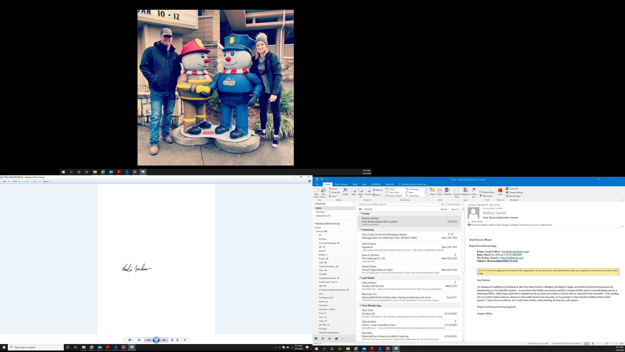

Leslie Jackson
Chief Deputy Fire Marshal
lrjackson@harnett.org

