Fire Marshal Division
October 2, 2023

Rebecca Maclead
2600 Maitland Center Parkway Ste 200
Maitland, FL 32751

Re: Food Lion #2594
3260 Ray Rd.
Spring Lake, NC 28390

Application Number BCOM2309-0002

To whom may concern,

Thank you for submitting the plans for the Food Lion renovations. The plans have been reviewed by a qualified code enforcement official to examine for compliance with the North Carolina Fire Prevention Code and all other fire protection regulatory documents. There are some items that were found during the plan review process that need to be addressed before a final inspection of the new facility can be given. These items are outlined and described below.

If any alterations to the systems listed below it will need to be summitted for review.

Fire Alarm Systems
- Provide shop drawings from the installing contractor.
- Shop drawings shall include all information listed in section of the North Carolina Fire Prevention Code.
- System additions and modifications shall be in accordance with NFPA 72.

Sprinkler Systems
- Provide sprinkler shop drawings from the installing contractor.
- System additions and modifications shall be in accordance with NFPA 13.

Fixed Fire Suppression Systems
- Provide system design/drawings for the hood suppression system from the installing contractor.
- Provide the detentions of the appliances that will be under hood
- System design and performance shall be in accordance with NFPA 17A.
- A system test and mechanical performance test is required.

Fire Extinguishers
- Fire extinguishers shall be installed per notes.
- A class K extinguisher is required in the deli/bakery area.

Notes
- Please call 910-893-0740 to schedule all Fire Marshal inspections.
- If life safety systems are required to be disabled during the project please notify the Fire Marshal’s office.

Thank you again for submitting the plans for the Food Lion. Please review the plan review notes and if you have any questions, please do not hesitate to call this office.

Sincerely,
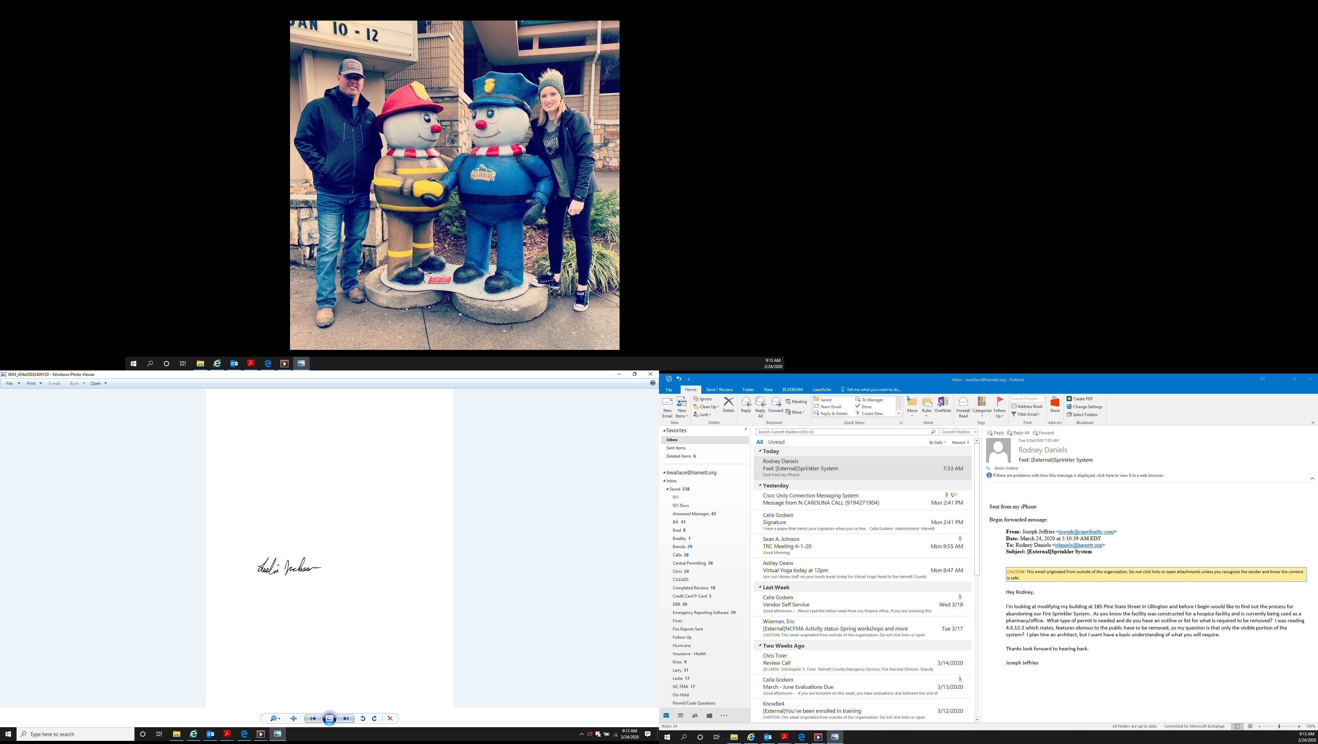

Leslie Jackson
Chief Deputy Fire Marshal
lrjackson@harnett.org

